C:\Users\NSales\AppData\Local\Microsoft\Windows\Temporary Internet Files\Content.IE5\BQMQVTLA\MC900303569[1].wmf

for Agricultural Research

C:\Users\NSales\AppData\Local\Microsoft\Windows\Temporary Internet Files\Content.IE5\BQMQVTLA\MC900303569[1].wmf

Statistical Tool

USER’S MANUAL

C:\Users\NSales\AppData\Local\Microsoft\Windows\Temporary Internet Files\Content.IE5\BQMQVTLA\MC900303569[1].wmf

Statistical Tool for Agricultural Research

Version 1.2.1

A NOTE TO THE READER:

An electronic copy of this user’s manual comes with the STAR installer. The STAR User’s Manual may be printed/copied and distributed to any number of users. STAR is a freeware developed for non-profit use. Hence, selling of either the software or the user’s manual is prohibited.

Biometrics and Breeding Informatics

Plant Breeding, Genetics and Biotechnology Division

INTERNATIONAL RICE RESEARCH INSTITUTE

Contents

[Introduction 1](#_Toc354749104)

[Feature Modules 1](#_Toc354749105)

[About the User’s Manual 1](#_Toc354749106)

[Getting Started 2](#_Toc354749107)

[Installation 2](#_Toc354749108)

[Launching STAR 8](#_Toc354749109)

[Project Explorer Panel 9](#_Toc354749110)

[Editor Panel 10](#_Toc354749111)

[Menu Bar 10](#_Toc354749112)

[Data Viewer 13](#_Toc354749113)

[Result Viewer 13](#_Toc354749114)

[Project and File Management 16](#_Toc354749115)

[Creating New Project 16](#_Toc354749116)

[Open Existing Project 18](#_Toc354749117)

[Renaming Project 19](#_Toc354749118)

[Exporting Project 20](#_Toc354749119)

[Deleting Project 21](#_Toc354749120)

[Importing Project 23](#_Toc354749121)

[Importing Data from External Source 24](#_Toc354749122)

[Importing Data from Other Project 26](#_Toc354749123)

[Importing Data from Package 28](#_Toc354749124)

[Creating New Folder 30](#_Toc354749125)

[Copying File/Folder 32](#_Toc354749126)

[Renaming File/Folder 34](#_Toc354749127)

[Moving File/Folder 36](#_Toc354749128)

[Deleting File/Folder 38](#_Toc354749129)

[Data Manipulation 40](#_Toc354749130)

[Insert Row(s) 40](#_Toc354749131)

[Delete Row(s) 42](#_Toc354749132)

[Inserting Column(s) 43](#_Toc354749133)

[Deleting Column(s) 45](#_Toc354749134)

[Create New Variables 46](#_Toc354749135)

[Edit Variable Information 50](#_Toc354749136)

[Sorting 52](#_Toc354749137)

[Merge Datasets 55](#_Toc354749138)

[Append Datasets 59](#_Toc354749139)

[Creating Data Subset 62](#_Toc354749140)

[Reshaping 64](#_Toc354749141)

[Reshaping Data from Long (Serial) to Wide (Parallel) Format 64](#_Toc354749142)

[Reshape Data from Wide to Long Format 67](#_Toc354749143)

[Aggregate 71](#_Toc354749144)

[Randomization for Basic Experimental Design 75](#_Toc354749145)

[Completely Randomized Design 75](#_Toc354749146)

[Randomized Complete Block Design 80](#_Toc354749147)

[Latin Square Design 86](#_Toc354749148)

[Split Plot Design 90](#_Toc354749149)

[Strip Plot Design 97](#_Toc354749150)

[Split-Split Plot Design 101](#_Toc354749151)

[Strip-Split Plot Design 109](#_Toc354749152)

[Split-Split-Split Plot Design 114](#_Toc354749153)

[Strip-Split-Split Plot Design 118](#_Toc354749154)

[Balanced Incomplete Block Design 120](#_Toc354749155)

[Lattice Design 123](#_Toc354749156)

[Alpha Lattice Design 128](#_Toc354749157)

[Augmented Design in Randomized Complete Block 132](#_Toc354749158)

[Augmented Design in Latin Square 136](#_Toc354749159)

[Graphs 140](#_Toc354749160)

[Bar Graph 140](#_Toc354749161)

[Box Plot 146](#_Toc354749162)

[Histogram 153](#_Toc354749163)

[Line Graph 157](#_Toc354749164)

[Pie Chart 163](#_Toc354749165)

[Scatter Plot 167](#_Toc354749166)

[Descriptive Statistics 172](#_Toc354749167)

[Cross Tabulation 178](#_Toc354749168)

[Normality Test 182](#_Toc354749169)

[Homogeneity of Variance 188](#_Toc354749170)

[Fitting Distributions 194](#_Toc354749171)

[t-Test 198](#_Toc354749172)

[One Sample *t*-test 198](#_Toc354749173)

[Paired Sample *t*-tests 202](#_Toc354749174)

[Independent Sample *t*-tests 206](#_Toc354749175)

[Chi-Square Test 212](#_Toc354749176)

[Goodness of fit Test 212](#_Toc354749177)

[Test of Independence 214](#_Toc354749178)

[Test on Proportion 219](#_Toc354749179)

[Analysis of Variance 222](#_Toc354749180)

[Completely Randomized Design 224](#_Toc354749181)

[Randomized Complete Block Design 231](#_Toc354749182)

[Latin Square Design 241](#_Toc354749183)

[Split Plot Design 249](#_Toc354749184)

[Strip Plot Design 258](#_Toc354749185)

[Split-Split Plot Design 267](#_Toc354749186)

[Strip-Split Plot Design 274](#_Toc354749187)

[Split-Split-Split Plot Design 276](#_Toc354749188)

[Strip-Split-Split Plot Design 279](#_Toc354749189)

[Pairwise Mean Comparison 281](#_Toc354749190)

[Partitioning Sum of Squares 288](#_Toc354749191)

[Group Comparison 288](#_Toc354749192)

[Trend Comparison 293](#_Toc354749193)

[Incomplete Block Design 297](#_Toc354749194)

[Balanced Incomplete Block Design 297](#_Toc354749195)

[Augmented Randomized Complete Block Design 304](#_Toc354749196)

[Augmented Latin Square Design 312](#_Toc354749197)

[Alpha Lattice Design 320](#_Toc354749198)

[Row-Column Design 327](#_Toc354749199)

[Correlation Analysis 336](#_Toc354749200)

[Linear Regression Analysis 343](#_Toc354749201)

[Nonparametric Tests 349](#_Toc354749202)

[One Sample 349](#_Toc354749203)

[Two Related Samples 349](#_Toc354749204)

[Two Independent Samples 349](#_Toc354749205)

[Test for Several Related Samples 349](#_Toc354749206)

[Test for Several Independent Samples 349](#_Toc354749207)

[Appendix 351](#_Toc354749208)

[Data From STAR Package 351](#_Toc354749209)

[AugLS 351](#_Toc354749210)

[AugRCB 351](#_Toc354749211)

[Corr 352](#_Toc354749212)

[CropStatRCBDOverSite 353](#_Toc354749213)

[Dule\_AlphaGxE 353](#_Toc354749214)

[Fertilizer 354](#_Toc354749215)

[Gerua 355](#_Toc354749216)

[GomezMaizeCross 355](#_Toc354749217)

[GomezMaizeCrossSummary 356](#_Toc354749218)

[GomezSplitRCBD 357](#_Toc354749219)

[GomezSplit2RCBD 357](#_Toc354749220)

[GomezStrip 358](#_Toc354749221)

[GomezStripSplit 359](#_Toc354749222)

[GomezTenureStatus 360](#_Toc354749223)

[GomezTwoCropSeasonRCB 360](#_Toc354749224)

[grp\_pss 361](#_Toc354749225)

[IASRICorrReg 361](#_Toc354749226)

[IASRILSD 362](#_Toc354749227)

[IASRITomar 363](#_Toc354749228)

[IASRITomar2 364](#_Toc354749229)

[Inoculation 364](#_Toc354749230)

[Insecticides 365](#_Toc354749231)

[KemptonRowCol 365](#_Toc354749232)

[Maize 366](#_Toc354749233)

[Nurul2012 367](#_Toc354749234)

[OP\_pss 367](#_Toc354749235)

[PGTYPIC 368](#_Toc354749236)

[SeedingRate 368](#_Toc354749237)

[Sensors 369](#_Toc354749238)

[soil\_var 369](#_Toc354749239)

[Survival 370](#_Toc354749240)

[tf\_rcb 370](#_Toc354749241)

[White\_heads 371](#_Toc354749242)

[upland 371](#_Toc354749243)

[Year 372](#_Toc354749244)

[Yield94 372](#_Toc354749245)

# Introduction

Statistical Tool for Agricultural Research (STAR) is a computer program for data management and basic statistical analysis of experimental data. It has a user-friendly graphical interface where items are accessible via drop-down menus. Its graphical interface was created using the Eclipse Rich Client Platform (RCP) and uses the R language and environment for statistical computing and graphics.

STAR has been developed primarily for the analysis of data from agricultural field trials, but many of the features can be used for analysis of data from other sources.

## Feature Modules

STAR has the following modules:

* Data management with a spreadsheet
* Descriptive statistics
* Analysis of variance for basic experimental designs
* Correlation and linear regression analysis
* Graphics
* Utilities for randomization and electronic field book
* Non-parametric data analysis

## About the User’s Manual

The STAR user’s manual provides step-by-step instructions on how to perform certain tasks of interest to users. Screen images have been included as deemed helpful.

Menu items, names of dialogs and form controls are in **bold** letters. Project names, filenames, variable names and directories are *italicized*. Menus appear in the form **File | Open**, which means “choose **Open** from the **File** menu”. All of the examples used in this manual are included when the STAR package is installed.

# Getting Started

## Installation

The installer of STAR 1.2.1 and its required R packages can be downloaded from *bbi.irri.org*. To download the installers, click the links labeled as *STAR 1.2.1* and *R-Packages* at the right-hand side of the page.



User need to install *R-Packages* first before installing *STAR 1.2.1*. The steps to install the required R packages are as follows:

* Double-click the installer icon  to launch the setup. A dialog as shown below is displayed. Click the **OK** button.

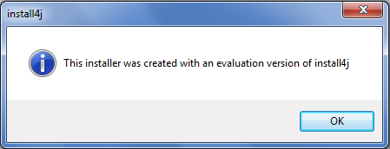

* The next step is the preparation of the wizard. A dialog with progress bar is displayed. Wait until the preparation is completed.

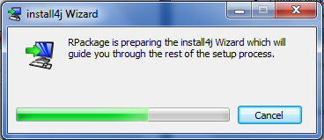

* When installing R Packages for the first time, the **Welcome** dialog as shown below is displayed. Click the **Next** button.

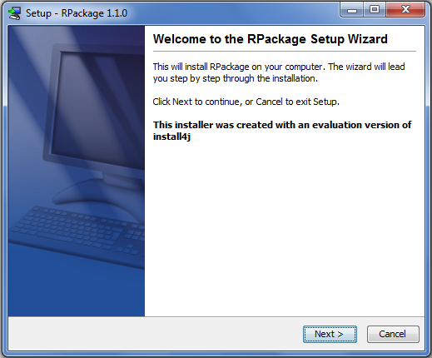

* Wait until the installation is completed.

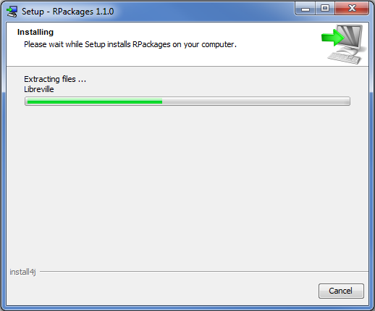

* Click the **Finish** button to exit Setup.

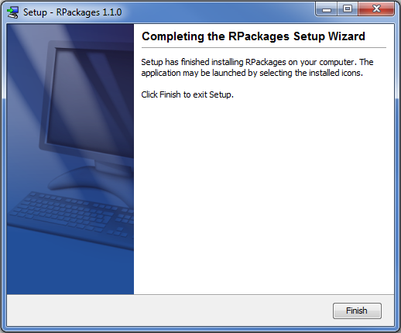

The steps to install STAR are as follows:

* Double-click the installer icon  to launch the setup. A dialog as shown below is displayed. Click the **OK** button.

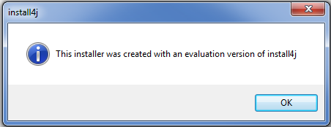

* The next step is the preparation of the wizard. A dialog with progress bar is displayed. Wait until the preparation is completed.

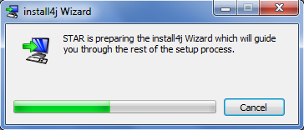

* When installing STAR for the first time, the **Welcome** dialog as shown below is displayed. Click the **Next** button.

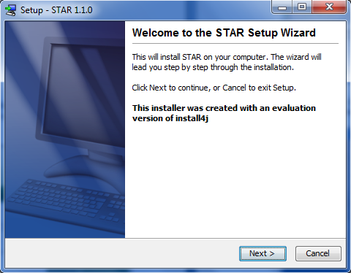

* Select the destination folder and click the **Next** button.

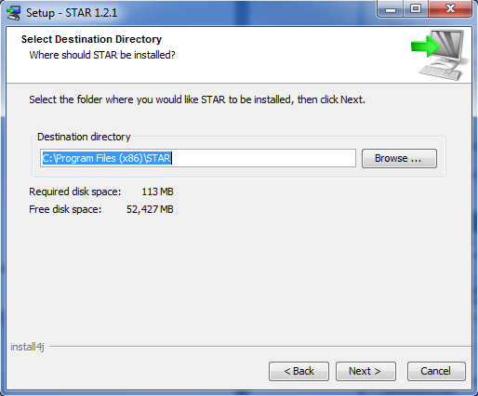

* Select which start menu folder you want to place the STAR icons in and click the **Next** button.

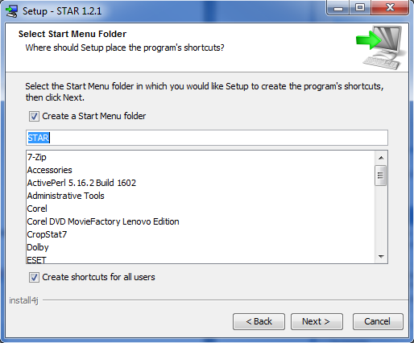

* Wait until the installation is completed.

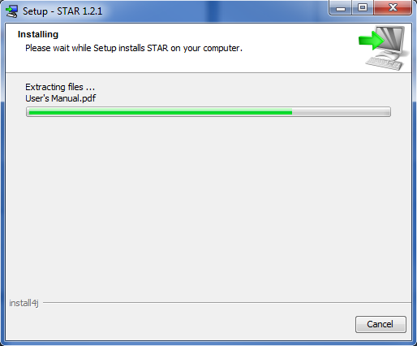

* Finally, specify if you want to create a desktop icon and run STAR. Click the **Finish** button.

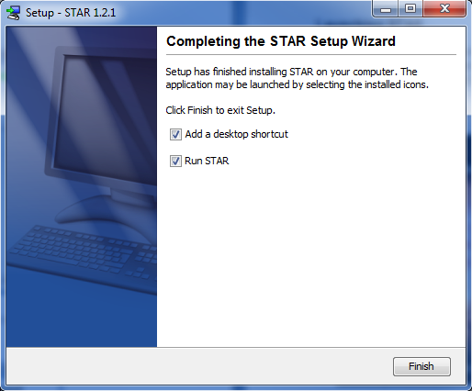

## Launching STAR

To launch STAR, the user can either double-click the STAR shortcut icon on the desktop (if there is one) or click Start on the Windows task bar, choose All Programs, then click on the *STAR* folder and click the STAR icon.

Upon launching, the splash image then the main window will appear.

****

**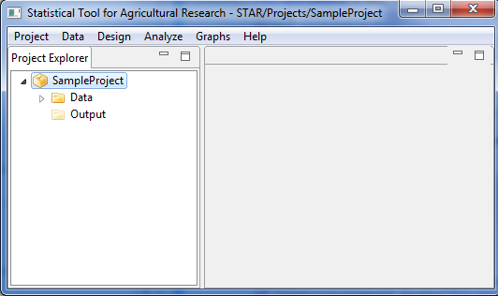**

STAR main window has a menu bar and is divided into two panels, the **Project Explorer** panel located on the left-hand side and the **Editor Panel** on the right-hand side.

## Project Explorer Panel

Project Explorer can be seen at the left-hand side of the main window. It serves as a file manager of the active project, where data and results of the analysis are displayed in a tree. It displays the last opened project from the previous STAR session. When STAR is opened for the first time, a default project names *SampleProject* is displayed with *Data* folder and *Output* folder inside it. The *Data* folder contains some sample datasets that will be used in this manual. The *Output* folder, on the other hand, will contain all output files that will be created when an analysis is performed.

****

## Editor Panel

Editor panel is located at the right-hand side of the main window. It consists of **Data Viewer** tab and the **Result Viewer** tab. By default, the editor panel is empty.

****

**Editor Panel**

## Menu Bar

Most of the tasks that you perform in STAR start with menu selections. There are six drop-down menus available and this are:



**Project** Menu contains functions for creating and managing project. This menu can also be used to quit or terminate sessions in STAR. It contains the following submenu items:

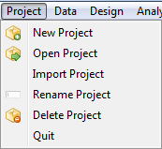

**Data** Menu contains functions for reading, managing and manipulating datasets. Items under this menu become visible only when a data in CSV format is displayed in the active tab of the editor panel. It contains the following submenu items:

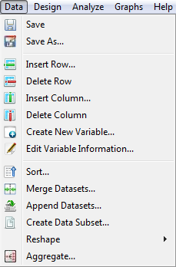

**Design** Menu contains functions for generating random assignment of factor levels for commonly used experimental design. It contains the following submenu items:

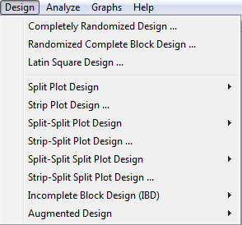

**Graph** Menu contains functions for creating the basic graphs. It contains the following submenu items:

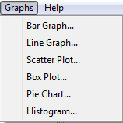

**Analyze** Menu contains functions to perform statistical analysis. Items under this menu become visible only when a data in CSV format is displayed in the active tab of the editor panel. It contains the following submenu items:

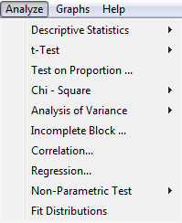

**Help** Menu used to access STAR’s Help System or User’s Manual. It contains the following submenu items:

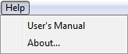

## Data Viewer

Data Viewer tab is displayed in the editor panel when a data in CSV format is double-clicked from the Project Explorer tree. It is used for viewing data in spread-sheet format, editing data values and performing data management. Several **Data Viewer** tabs can be seen simultaneously inside the **Editor Panel**. Each Data Viewer tab contains toolbars which can be used for managing the data. The toolbars have the same functionalities as the options under the **Data** menu.

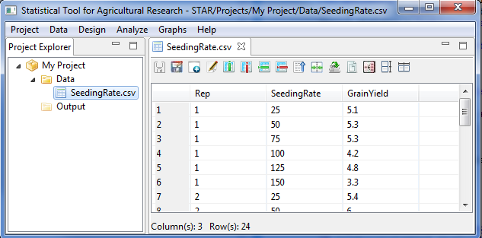

The name of the tab indicates the name of the dataset. When an asterisk appears in the tab name  it indicates that there has been modification made in the dataset and user needs to save the dataset for the modification to take effect. If a data with unsaved changes is used in an analysis or used in creating graphs, the original dataset will be used not the modified one. If a Data Viewer with unsaved changes is closed, the user will be prompted to save the changes.

## Result Viewer

Results Viewer tab is displayed in the editor panel when an analysis is performed or by double-clicking a results folder inside the *Output* folder. Depending on the contents of the results folder, the Result Viewer may have an *Output* page and/or the *Graph* page.

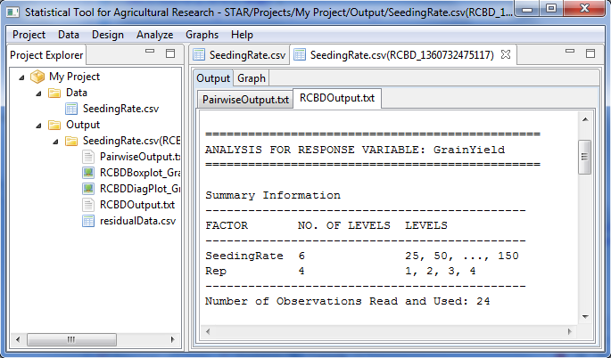

All outputs in *txt* format are displayed in the *Output* page while all graphical outputs in *png* format are displayed in the *Graph* page. The *Graph* page has toolbars that can be used to minimize, maximize, and view the graph to normal size and to export graph to external sources. To view other graphs in the page, the left and right arrow keys can be used.

*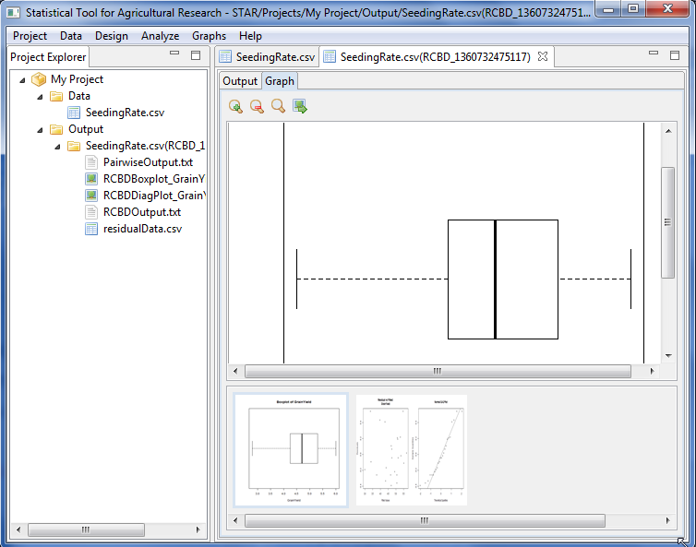*

# Project and File Management

## Creating New Project

The user can create several projects in STAR. However, only one project can be considered as the active project and is visible in the Project Explorer panel. The steps for creating new project are listed below.

* Select **Project | New Project** from the main menu.

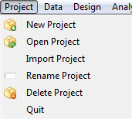

* The **Create New Project** dialog box will appear. In the **Project Name** field, specify a name of the new project.

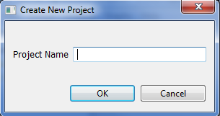

In naming a project, the following rules apply:

* + The name must start with a letter. The remaining characters can be any letter, any digit, a period, underscore, blank or dash.
  + The last character of the name should not be a period, underscore, blank or dash
  + The length of the name should not be less than 4 characters.
  + The name must be different from the existing project names.
  + The name is not case sensitive.

For the example, type *Demo Project*. The completed dialog box will appear as shown below:

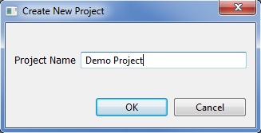

* Click the **OK** button. The new project named *Demo Project*, will now be displayed in the **Project Explorer** panel. By default, two empty folders under the project name will be automatically created, the *Data* and *Output* folders. Note that these folders cannot be deleted, rename or move to another location.

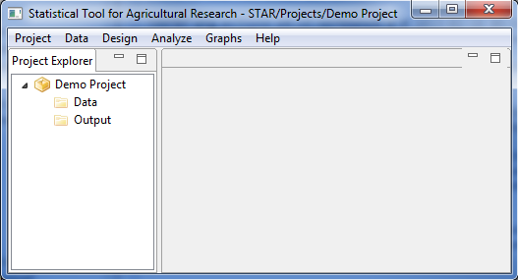

Note: As part of the examples, create another folder named *My Project*.

## Open Existing Project

The steps for opening existing project inside the STAR workspace are listed below.

* Select **Project | Open Project** from the main menu.
* The **Open Existing Project from the Workspace** dialog box will appear. The list of all existing projects in the workspace can be seen.

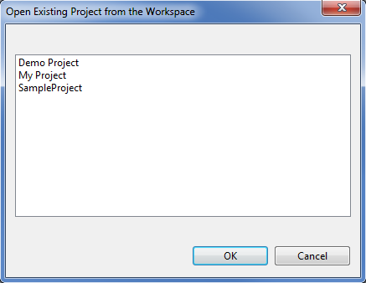

For the example, select the project named *Demo Project*. Click the **OK** button. *Demo* *Project* should now be the active project in the **Project Explorer**.

## Renaming Project

The steps for renaming the active project are listed below.

* Right-click on the active project, say *Demo Project*, then select **Rename Project** or select **Project | Rename Project** from the main menu.

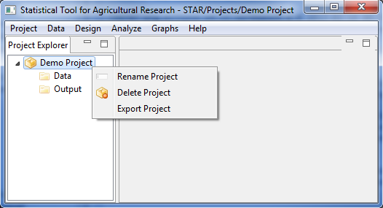

* The **Rename Project** dialog box will appear. In the **New Project Name** field, specify a new project name, say *Trial Project*. Click the **OK** button.

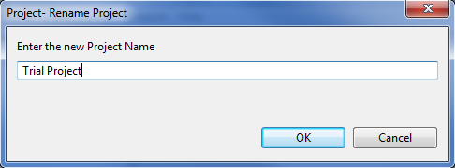

* The project should be displayed in the **Project Explorer** with the new name.

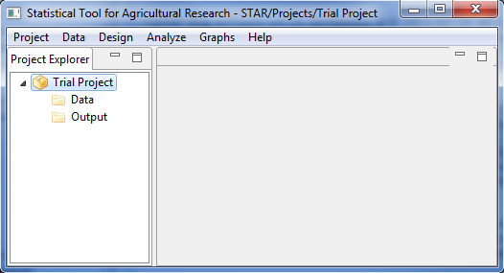

## Exporting Project

If the user wants to save the active project to a different directory, the export project feature can be used. The steps are listed below.

* Right-click on the active project, say *Trial Project*, then select **Export Project**.
* Select the directory where the active project will be saved. For the example, choose *Desktop*. Click the **OK** button.

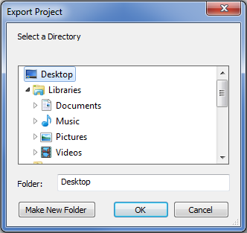

* The *Trial Project* folder is now on the desktop.

## Deleting Project

The steps for deleting an existing project inside the STAR workspace are listed below.

* Right-click on the active project, say *Trial Project* then select **Delete Project** or select **Project | Delete Project** from the main menu.

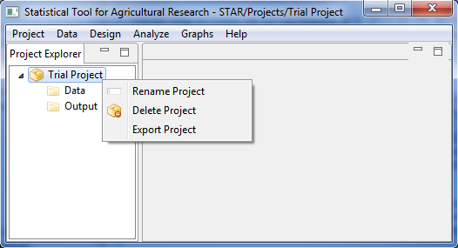

* Another dialog will be displayed. If the user wants to delete multiple projects, click on the check box labeled **I want to delete multiple** projects then select from the list the projects to be deleted. For the example, delete only *Trial Project* by clicking **OK**.

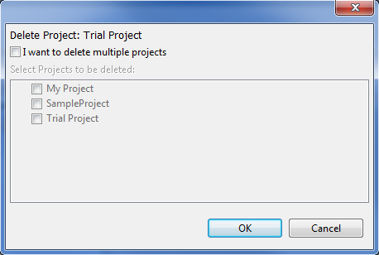

* Since *Trial Project* is now deleted from the STAR workspace, there is no active project displayed in the Project Explorer as shown below.

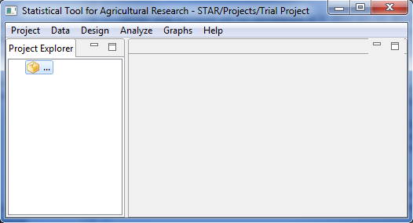

## Importing Project

Projects, as long as it is a valid STAR project, can be saved inside the STAR workspace by using the import project feature. The steps are listed below.

* Click **Project | Import Project** from the main menu.

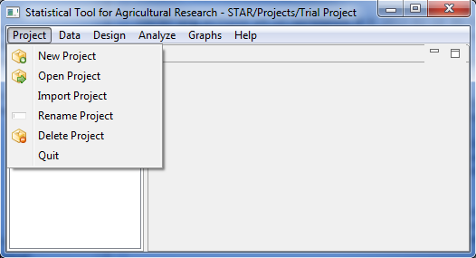

* Select the project folder that will be imported. For the example, select *Trial Project* folder on the desktop. Click the **OK** button.

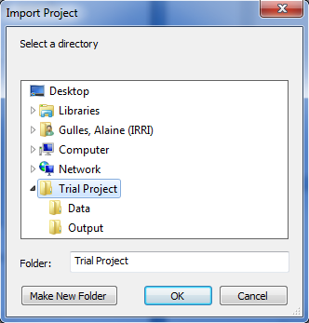

* The *Trial Project* is now the active project in the **Project Explorer**.

## Importing Data from External Source

There are three file formats that STAR accepts to import from external source namely:

1. R datasets. These are datasets that were saved in the R environment and have an extension .rda, .Rda, .RDA, or .Rdata;
2. text files. These are datasets with extension .txt whose file delimiter can be a tab, space, comma or a semi-colon; and
3. comma-separated value files. These are datasets with extension .csv.

The general steps for importing data from external source are listed below:

* On the **Project Explorer** panel, right-click the *Data* folder of the project named *Trial Project*. A pop-up menu will appear. Choose **Import Data**.

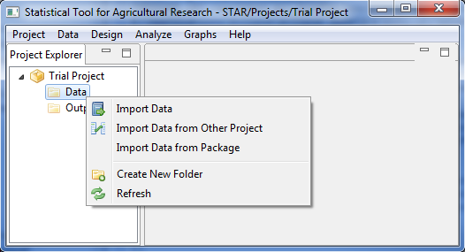

* The **Import** dialog box will appear. Choose the appropriate file type to be imported in the File of Types drop-down box. The default file type is **\*.csv**. Go to the directory where the file to be imported is located. Select the file or type the file name on the **File name** text box.

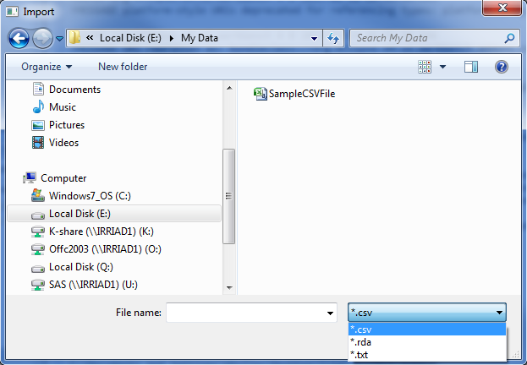

* Click the **Open** button.

If the **\*.txt** or the **\*.rda** file type is chosen, a message dialog box will appear that will prompt the user that the text or r data files will be automatically converted to a csv file. Click the **OK** button.

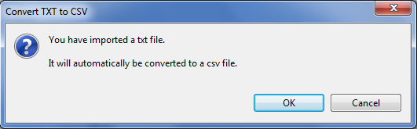

Further, if the **\*.txt** file type is chosen, the **Specify Delimiter** dialog box will appear. Choose the appropriate delimiter of the text file to be open then click the **OK** button.

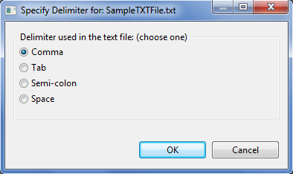

* The newly imported data will now be displayed inside the *Data* folder of the active project in the **Project Explorer**. To view the data in a spreadsheet format, double-click the icon of the data file.

## Importing Data from Other Project

The steps for importing data from other project are listed below:

* On the **Project Explorer** panel, right-click the *Data* folder of the project named *Trial Project*. A pop-up menu will appear. Choose **Import Data from Other Project**.



* The **Import from Other Project** dialog box will appear. This dialog box contains all existing projects in STAR. The user can select one or several project folders, one or several folders within projects or one or several data files. Choose the data files to be imported.

For the example, choose *MasterData.csv* from *Projects | SampleProject | Data*.

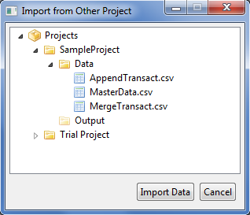

* Click the **Import Data** button. The new imported data file will now be displayed inside the *Data* folder of the active project in the **Project Explorer** panel. To view the data in a spreadsheet format, double-click the icon of the data file.

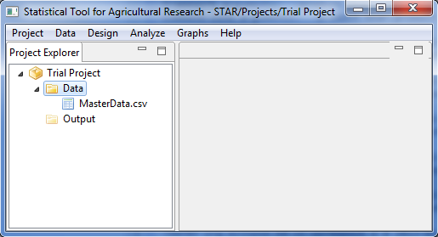

## Importing Data from Package

Datasets in STAR package of R can be imported. The steps to import data from R package are listed below:

* On the **Project Explorer** panel, right-click the *Data* folder of the project named *Trial Project*. A pop-up menu will appear. Choose **Import Data from Package**.



* The **Import Data from R** dialog box will appear. This dialog box contains all existing data file in STAR R package. The user can select one or several data files. Choose the data files to be imported.

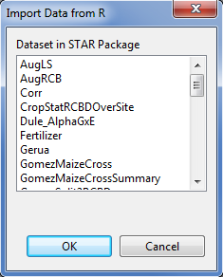

For the example, choose *SeedingRate*.

* Click the **OK** button. The new imported data file will now be displayed inside the *Data* folder of the active project in the **Project Explorer** panel. To view the data in a spreadsheet format, double-click the icon of the data file

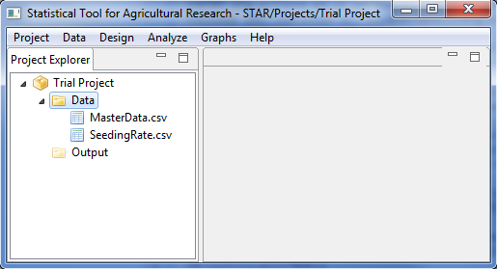

## Creating New Folder

To organize the data files imported in a project or results of an analysis, user may want to create a sub folder inside the *Data* folder or inside the *Output* folder.

The steps in creating a sub folder are listed below:

* On the **Project Explorer** panel, right-click the folder where you want to create the subfolder.

For the example, right-click the *Data* folder of the project named *Trial Project*. A pop-up menu will appear. Choose **Create New Folder.**

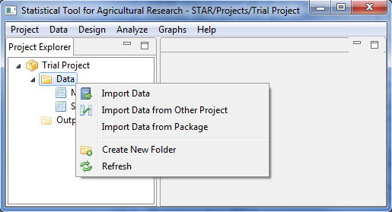

* The **New Folder** dialog box will appear**.** In the **Enter the new folder name** field, user can specify other name for the new folder. If the sub folder will be created within the *Data* folder, the default folder name is *Data*. If the sub folder will be created within the *Output* folder, the default folder name is *Output*.

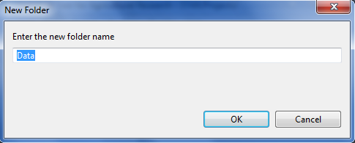

In naming a folder, the following rules apply:

* + The name must start with a letter. The remaining characters can be any letter, any digit, a period, underscore, blank or dash.
  + The last character of the name should not be a period, underscore, blank or dash.
  + The length of the name should not be less than 4 characters.
  + The name must be different from the existing folder names inside a parent folder.
  + The name is not case sensitive.

For the example, type *Lecture Data* as the new folder name.

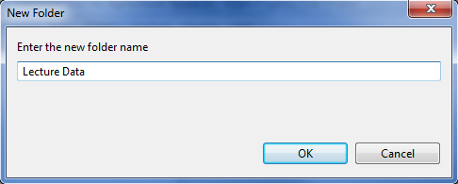

* A new sub-folder inside *Data* folder is now created and can be seen in the Project Explorer.

**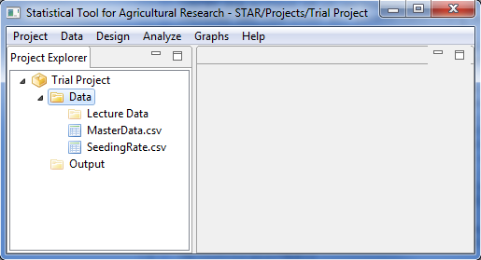**

The user can create several sub folders within the *Data* folder or *Output* folder. If the sub folders are created within the Data folder, user can import data set to the sub folder, rename, copy, delete and move the sub folder.

## Copying File/Folder

The steps to copy data files to other location are listed below:

* On the **Project Explorer** panel, right-click the file you want to copy.

For the example, right-click *SeedingRate.csv* inside the *Data* folder of the project named *Trial Project*. Choose **Copy**.

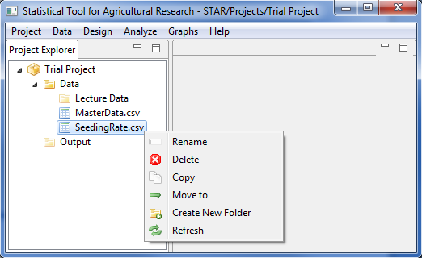

* Go to the desired destination folder, which can be within or outside STAR workspace, then right-click then choose **Paste.**

For the example, right-click on the *Lecture Data* folder then choose **Paste.**

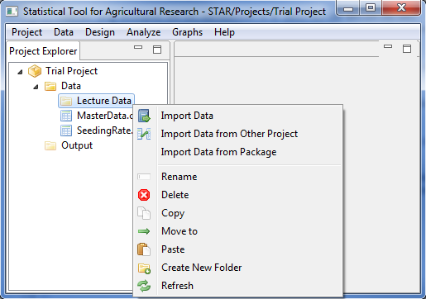

* The file is now copied inside the destination folder.

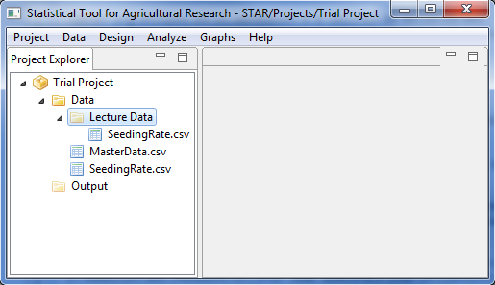

These steps also apply when copying the sub- folders within the *Data* and *Output* folders.

## Renaming File/Folder

The steps to rename files are listed below:

* On the **Project Explorer** panel, right click the file to rename.

For the example, right-click *SeedingRate.csv* inside the *Data* folder of the project named *Trial Project*. Choose **Rename**.

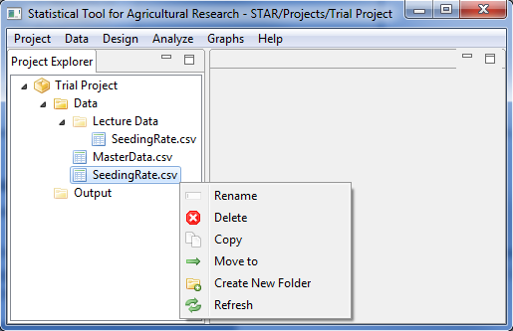

* The **Rename File** dialog box will appear. In the **Enter the new file name** field, user can specify the new filename.

For the example, set the new filename to *SeedingRate\_old.csv*. The completed dialog box should appear as shown below:

*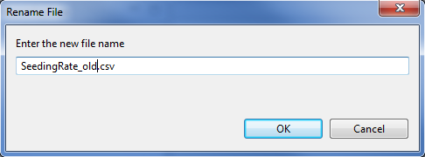*

* Click the **OK** button. The renamed data file should appear in the **Project Explorer** panel.

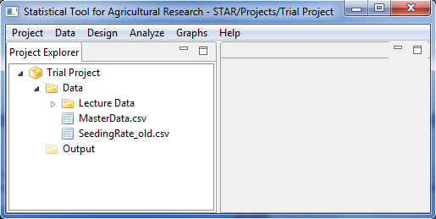

These steps also apply when renaming the sub- folders within the *Data* and *Output* folders.

## Moving File/Folder

The steps to move data files to other location in the STAR workspace are listed below:

* On the **Project Explorer** panel, right click the file to you want to move.

For the example, right-click *SeedingRate\_old.csv* inside the *Data* folder of the project named *Trial Project*. Choose **Rename**.

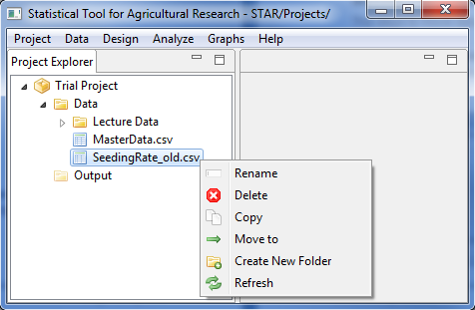

* The **Move to** dialog box will appear. Select the destination folder.

For the example, choose the *Lecture Data* folder inside the *Data* folder.

*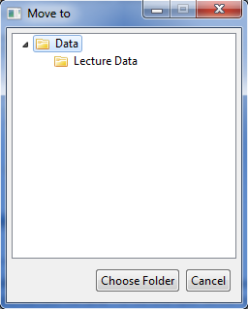*

* Click the **Choose Folder** button. The file is now moved to the destination folder.

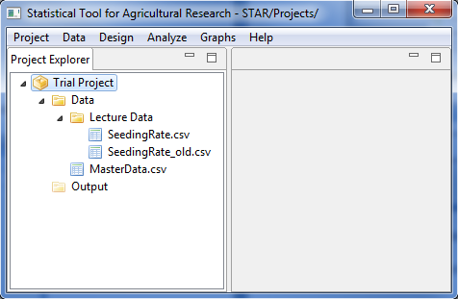

These steps also apply when moving the sub-folders within the *Data* and *Output* folder.

## Deleting File/Folder

Files to be deleted must be close before following the steps listed below. However, if a user wants to delete a folder, all items inside the folder to be deleted must be close before deleting the folder. Note that the default folders created (*Data* folder and *Output* folder) cannot be deleted.

The steps to delete data files are listed below:

* On the **Project Explorer** panel, right click the file to you want to delete.

For the example, right-click *SeedingRate\_old.csv* inside the *Lecture Data* of the *Data* folder of the project named *Trial Project*. Choose **Delete**.

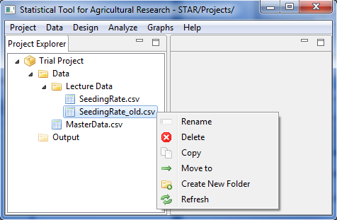

* The **Confirm Delete** message box will appear.

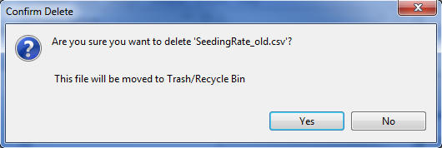

* Click the **Yes** button to delete.

These steps also apply when deleting the sub-folders within the *Data* and *Output* folder.

# Data Manipulation

## Insert Row(s)

The steps to insert row(s) are listed below:

* On the **Project Explorer** panel, using the project named *My Project*, import the data *MasterData.csv* from the *Data* folder of the project named *SampleProject*. Double-click the file to open it and view it in the Data Viewer.

To import data from the *SampleProject*, see *Importing Data from Other Project* sectionof this user manual.

* Select any row(s) or any cell in the row(s) where the user wants to insert new row(s) above it. To select several cells/rows, click any cell/row, then hold the **Ctrl** key and click on another cell/row. The number of selected rows is the number of row that will be inserted.

For the example, select the 4th row.

* Click **Data** | **Insert Row…** from the menu bar of the main window or click on the Insert Row icon  in the **Data Viewer** toolbar.

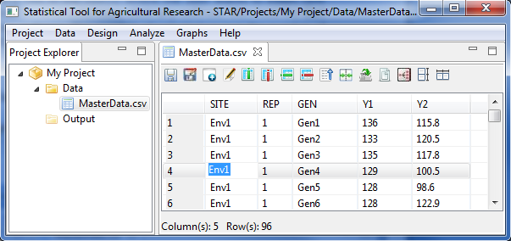

* The data now contains the newly inserted row.

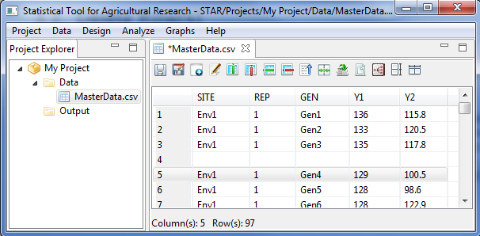

If there is no row selected before executing the Insert Row function, the user will be prompted if the user wants to insert a row after the last row of the data or not.

## Delete Row(s)

The steps to delete row(s) are listed below:

* On the **Project Explorer** panel, locate the file where rows will be deleted in the active project. Double-click the file to open it and view it in the Data Viewer.

For the example, use the modified and unsaved *MasterData.csv* in the project named *My Project* created from the previous section that is displayed in the Data Viewer.

* Select any row(s) or any cell in the row(s) that the user wants to delete. To select several cells/rows, click any cell/row, then hold the Ctrl key and click on another cell/row. The number of selected rows is the number of row that will be deleted.

For the example, select the 4th row.

* Click **Data | Delete Row** from the menu bar of the main window or click on the Delete Row icon  in the Data Viewer tool bar.



* The **Delete Row** dialog box will appear. Confirm that the row deletion is desired by clicking the **Yes** button.
* The changes made should be reflected in the Data Viewer.

For the example, close the modified *MasterData.csv* and do not save the changes.

## Inserting Column(s)

The steps to delete row(s) are listed below:

* On the **Project Explorer** panel, using the project named *My Project*, import the data *MasterData.csv* from the *Data* folder of the project named *SampleProject*. Double-click the file to open it and view it in the Data Viewer.

To import data from the *SampleProject*, see *Importing Data from Other Project* sectionof this user manual.

* Select a column where the user wants a new column to be inserted before it by clicking on the column name. A check icon will appear on the column header.

For the example, select the column named *Y1*.

* Click **Data | Insert Column…** from the menu bar of the main window or click on the Insert Column icon  in the Data Viewer tool bar.

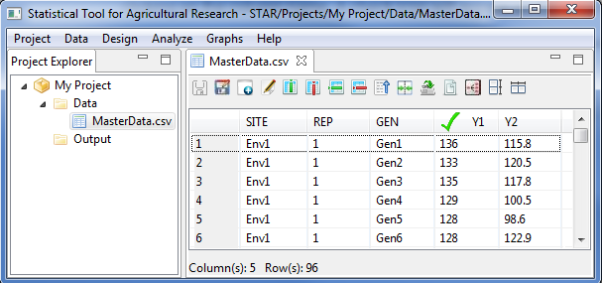

* The **Insert Column** dialog box will appear. In the **Insert New Column Name** field, user can specify a new name for the inserted column. The default new column name is *NewColumn*.

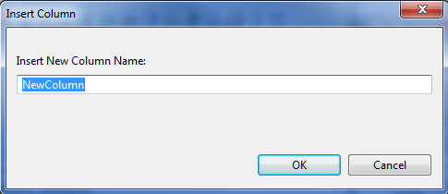

In naming the column, the following rules apply:

* The name must start with a letter while the remaining characters can be any letter, any digit, a period or underscore.
* The name must be different from the existing column names in the data.
* The name is case sensitive.

For the example, type *Plot*. The completed dialog box will appear as shown below:

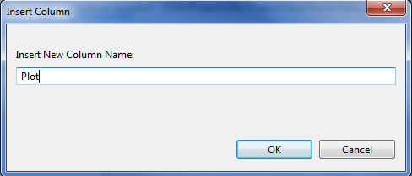

* Click the **OK** button.

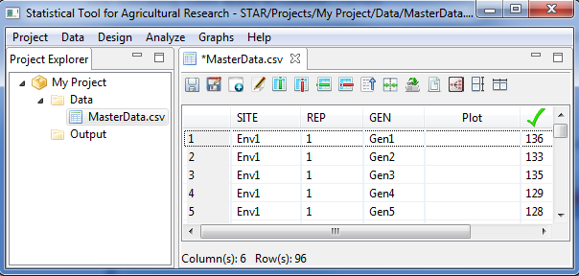

* The data now contains the newly inserted column named *Plot.*

## Deleting Column(s)

The steps to delete row(s) are listed below:

* On the **Project Explorer** panel, locate the file where column(s) will be deleted in the active project. Double-click the file to open it and view it in the Data Viewer.

For the example, use the modified and unsaved *MasterData.csv* in the project named *My Project* created from the previous section that is displayed in the Data Viewer.

* Select the column or one of the columns to be deleted by clicking on the column name. A check icon will appear on the column header.

For the example, select the column named *Plot*.

* Click **Data | Delete Column…** from the main window or click on the Insert Column icon  in the Data Viewer tool bar.
* Click the **OK** button.

## Create New Variables

The user can create new variables in the active data set by transforming existing variables or collapsing categories of two or more existing variables.

For transformations, there are six available functions, namely: logarithm, natural logarithm, square root, power, exponential and standardized. For logarithm, natural logarithm, square root and power transformation, the variables to be transformed should not contain negative values. For logarithm and natural logarithm transformation, values of the variable to be transformed will be incremented by 1 if it contains values equal to 0. For square root and power transformation, values of the variable will be incremented by 0.5 if it contains values equal to 0.

The steps to create new variables are listed below:

* On the **Project Explorer** panel, using the project named *My Project*, import the data *MasterData.csv* from the *Data* folder of the project named *SampleProject*. Double-click the file to open it and view it in the Data Viewer.

To import data from the *SampleProject*, see *Importing Data from Other Project* sectionof this user manual.

* To create new variables, click **Data | Create New Variable** from the main window or click on the Create New Variable icon  in the Data Viewer toolbar.

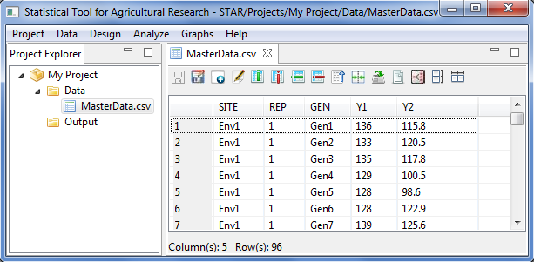

The **Create New Variable** dialog box will appear.

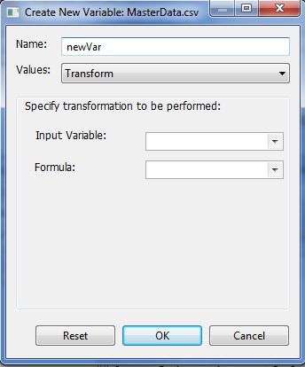

* Specify the required fields and appropriate options.

**Name**

This is the name of the new variable to be created. The default variable name is *newVar*. In naming the column, the following rules apply:

* The name must start with a letter while the remaining characters can be any letter, any digit, a period or underscore.
* Each column name must be unique; duplication is not allowed.
* Column name is case sensitive

**Values**

There are two options to determine the values of the new variable. The user can either transform any existing numeric variables or concatenate the values of any variables in the data set. The default is *Transform*.

**Input Variable**

If *transformation* is selected in the **Value** drop-down box, this drop-down box will be visible. This box pertains to the variable where the transformation will be performed. All numeric variables of the active data will be displayed in the drop-down box.

**Formula**

If *transformation* is selected in the **Value** drop-down box, this drop-down box will be visible. This box pertains to the formula that will be used when the value in the **Input Variable** is transformed. Transformation options available are logarithm, natural logarithm, square root, power, exponential and standardized.

**Checkbox Table**

If *Concatenate Columns* is selected in the **Value** drop-down box, this table will be visible. This table lets the user specify the columns to concatenate by ticking at least two column names. All columns of the active data will be displayed in the table.

For the example, suppose we want to transform the variable *Y1*. The completed dialog box should appear as shown below:

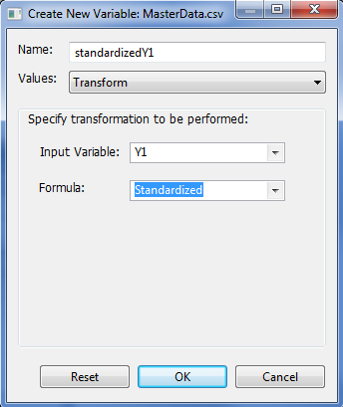

* Click the **OK** button. The data set with the transformed variable is displayed in the Data Viewer tab.

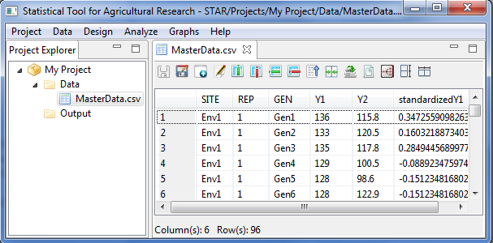

Suppose we want to create a new variable by concatenating the values of two variables. The completed dialog box should appear as shown below:

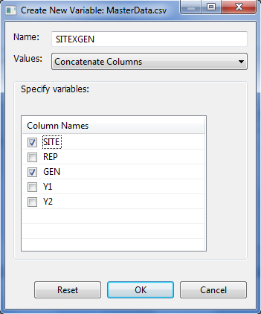

* Click the **OK** button. The transform variable is displayed in the Data Viewer tab.

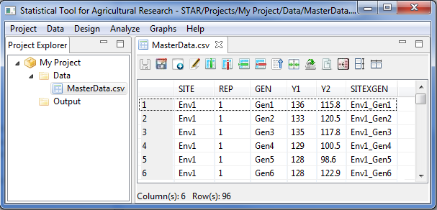

## Edit Variable Information

The steps to edit the variable information are listed below:

* On the **Project Explorer** panel, using the project named *My Project*, import the data *MasterData.csv* from the *Data* folder of the project named *SampleProject*. Double-click the file to open it and view it in the Data Viewer.

To import data from the *SampleProject*, see *Importing Data from Other Project* sectionof this user manual.

* To edit variable information, click **Data | Edit Variable Information** from the main window of STAR or click on the Edit Variable Information icon  in the Data Viewer toolbar.



* The **Edit Variable Information** dialog box will appear. The variables in the active data set are classified as either a factor or numeric variable. The user can modify the variable type of the variables in the data set.

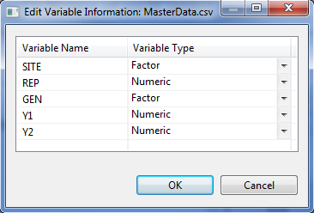

For the example, change the Variable Type of *REP* from Numeric to Factor. The complete dialog box should appear as shown below:

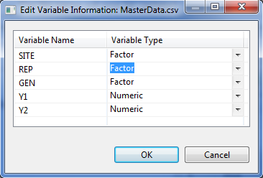

* Click the **OK** button.

## Sorting

Re-arranging or sorting the rows or cases of the data file is often useful and sometimes necessary for certain types of analysis. The **Sort Cases Menu** can be used to sort rows based on the value of one or more sorting variables.

The steps to re-arrange the data set based on the value of one or more sorting variable are listed below:

* On the **Project Explorer** panel, using the project named *My Project*, import the data *MasterData.csv* from the *Data* folder of the project named *SampleProject*. Double-click the file to open it and view it in the Data Viewer. The data file is arranged by *SITE*, *REP* then by *GEN*.

To import data from the *SampleProject*, see *Importing Data from Other Project* sectionof this user manual.

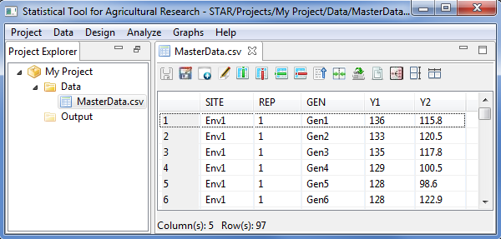

* Choose **Data** | **Sort…** from the main window or click on the Sort icon  in the Data Viewer tool bar. The **Sort** dialog box will appear.

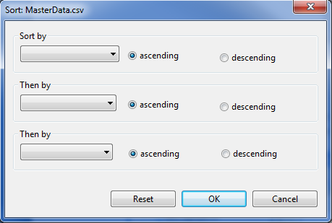

* The user can specify up to three variables as the basis for sorting and the order of sorting. Click the drop-down list box to identify the sorting variables. The rows can be re-arranged or sorted in ascending or descending order, with ascending order as the default option. If two or three variables are selected, rows are sorted for each variable within categories of the preceding variables. For character variables, uppercase letters precede their lowercase counterparts.

For the example, suppose we want to re-arrange the content of the data *MasterData.csv*, by ascending order of the variable *GEN* then by descending order of the variable *SITE*. The completed dialog box should appear as illustrated below:

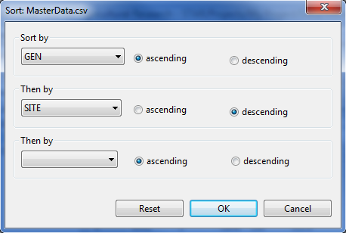

* Click the **OK** button to sort the active data. The **Sort** dialog box is closed and the sorted data is saved in the parent folder of the active data and displayed in the Data Viewer tab.

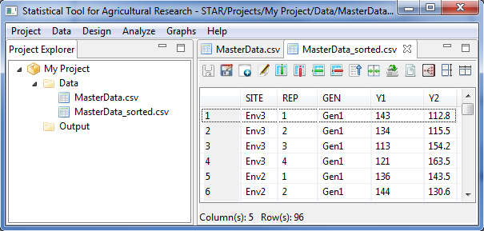

## Merge Datasets

The **Merge submenu** can be used to combine the active data file (known as the master data) with another data file (referred as the transaction data) that contains the same cases or rows but different variables.

The steps to merge datasets are listed below:

* On the **Project Explorer** panel, using the project named *My Project*, import the data files *MasterData.csv* and *MergeTransact.csv* from the *Data* folder of the project named *SampleProject*. Double-click the file *MasterData.csv* to open it and view it in the Data Viewer.

To import data from the *SampleProject*, see *Importing Data from Other Project* sectionof this user manual.

* Choose **Data | Merge Datasets…** or click on the MergeDatasets icon  in the Data Viewer toolbar. The **Merge Data** dialog box will appear.

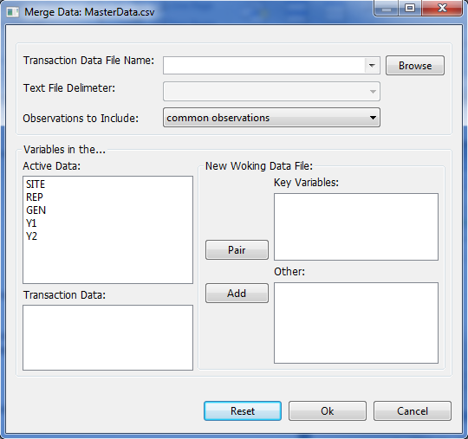

* Specify the required fields and appropriate options.

**Transaction File Name**

Specify this file by selecting a file using the drop-down combo box or by locating it using the **Browse** button. The files included in the drop-down combo box are files inside the *Data* folder not in its sub-folder. Only *.txt* and *.csv* data file format can be selected as the transaction file.

**Text File Delimeter**

If the transaction file selected is a text file, the delimeter should be specified. Four delimeters are available, namely: comma, space, tab and semi-colon.

**Observations to Include**

This option pertains to how rows or cases will be included in the new merged data file. The options available are to include common observations (default value), all observations in the active data, all observations in the transaction data and all observations.

**Key Variables**

These are pair(s) of variables that are present in the active and transaction files and will be the basis for the merging. Variables can be paired by clicking one variable in the active data and clicking one variable in the transaction data then clicking the **Pair** button. If the pair of variables has different column names, the new merged data file that will be created will use the column name of the active data.

**Other**

These are the other variables the user wants to include in the merged data file. Variables can be added by selecting at least one variable in the active data and/or in the transaction data then clicking the **Add** button. If columns in this list have the same name, **.1** will be appended to the column name coming from the active data and **.2** to the one from the transaction data.

For the example, select *MergeTransact.csv* file as the transaction data file from the drop-down combo box. The completed dialog box should appear as illustrated below:

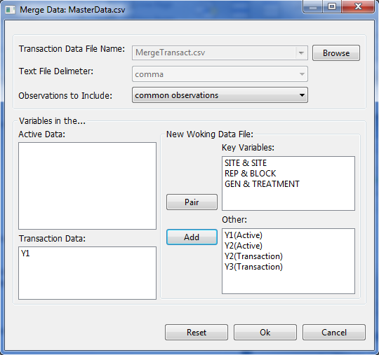

* Click the **OK** button. The merged data is saved in the parent folder of the active data and displayed in the Data Viewer tab. The default filename of the merged data set follows the format *<activeDataFilename>\_<TransactionDataFilename>\_merge.csv*.

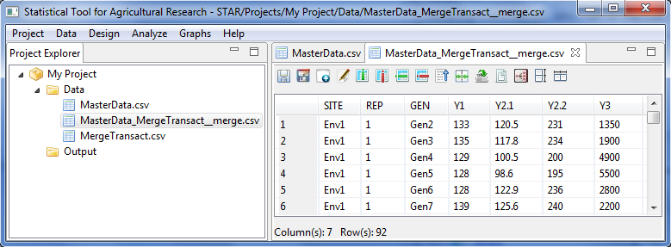

## Append Datasets

The Append submenu can be used combine two data files with the same variables but different cases.

* On the **Project Explorer** panel, using the project named *My Project*, import the data files *MasterData.csv* and *AppendTransact.csv* from the *Data* folder of the project named *SampleProject*. Double-click the file *MasterData.csv* to open it and view it in the Data Viewer.

To import data from the *SampleProject*, see *Importing Data from Other Project* sectionof this user manual.

* Choose **Data | Append Datasets…** or click on the AppendDatasets icon  in the Data Viewer toolbar. The Append Data dialog box will appear.

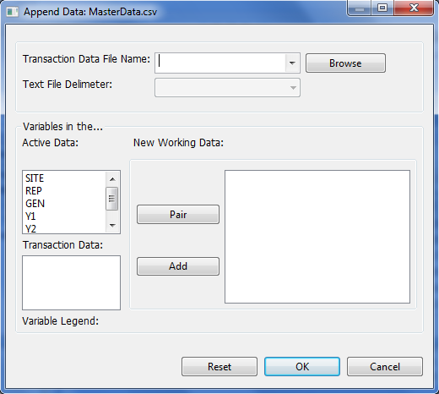

* Specify the required fields and appropriate options.

**Transaction File Name**

Specify this file by selecting a file using the drop-down combo box or by locating it using the **Browse** button. The files included in the drop-down combo box are files inside the *Data* folder not in its sub-folder. Only *.txt* and *.csv* data file format can be selected as the transaction file.

**Text File Delimeter**

If the transaction file selected is a text file, the delimeter should be specified. Four delimeters are available, namely: comma, space, tab and semi-colon

**New Working Data**

This is the list of variables or paired variables that will be included in the new data set. Variables can be paired by clicking one variable in the active data and clicking one variable in the transaction data then clicking the **Pair** button. Other variables can be added to this list by clicking the variable then clicking the **Add** button. For paired variables in this list, the appended data file that will be created will use the column name of the active data. For non-paired variables, **.1** will be appended to the column name coming from the active data and **.2** to the one from the transaction data.

For the example, select *AppendTransact.csv* file as the transaction data file from the drop-down combo box. The completed dialog box should appear as illustrated below:

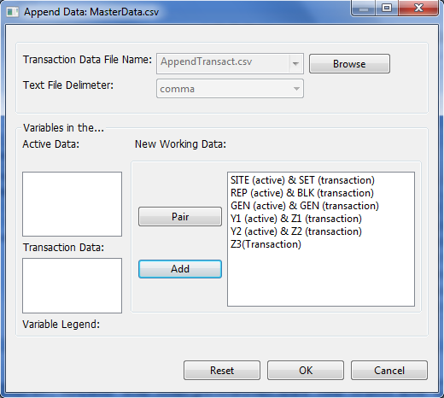

* Click the **OK** button. The appended data is saved in the parent folder of the active data and displayed in the Data Viewer tab. The appended data will contain an additional column named *Source* which indicates where the data came from. The default filename of the appended data set follows the format *<activeDataFilename>\_<TransactionDataFilename>\_merge.csv*.

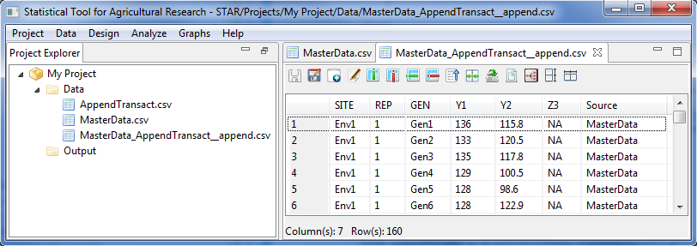

## Creating Data Subset

The steps in creating a subset of a dataset are listed below:

* On the **Project Explorer** panel, using the project named *My Project*, import the data file *MasterData.csv* from the *Data* folder of the project named *SampleProject*. Double-click the file to open it and view it in the Data Viewer.

To import data from the *SampleProject*, see *Importing Data from Other Project* sectionof this user manual.

* Choose **Data | Create Data Subset…** or click on the Create Data Subset icon  in the Data Viewer toolbar. The **Create Data Subset** dialog box will appear.

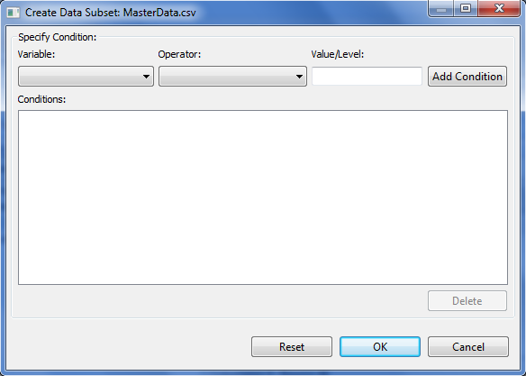

* Specify the required fields and appropriate options.

**Variable**

This drop-down list box lists all the variables in the active data set. User can specify the variable by clicking the drop-down list box and selecting the variable of interest.

**Operator**

This drop-down list box lists the available relational operators that can be used. The seven available operators that can be used are: equal (==), not equal (!=), at least (>=), at most (<=), greater than (>), less than (<) and within the range. User can specify the variable by clicking the drop-down list box and selecting the operator of interest.

**Value/Level**

Specify the level or value of the variable specified. If the operator specified is *within range*, user must specify two values separated by comma. Otherwise, user should specify only one value/level.

**Add Condition**

After specifying the conditional expression, user needs to click this button for the expression to be included in the **Conditions** list box.

**Conditions**

All the conditional expressions specified in this list box will be used when sub setting the active data set.

For the example, the completed dialog box should appear as illustrated below:

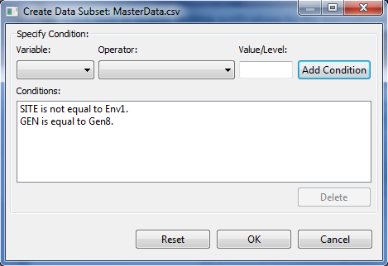

* Click the **OK** button. The new data is saved in the parent folder of the active data and displayed in the Data Viewer tab. The default filename of the new data set follows the format *<activeDataFilename>\_subset.csv*

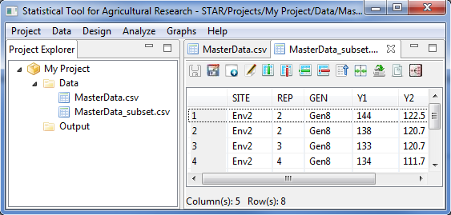

## Reshaping

The **Reshape submenu** can be used to restructure or reshape your active data set to follow the structure of the data set appropriate for the STAR procedure you want to use.

### Reshaping Data from Long (Serial) to Wide (Parallel) Format

Reshaping data from long (serial) to wide (parallel) involves re-arranging a data file, such that, repeated measurements are in separate columns.

The steps for reshaping the data from long to wide format are listed below:

* On the **Project Explorer** panel, using the project named *My Project*, import the data files *Year* from package. Double-click the file to open it and view it in the Data Viewer.

To import data from the *SampleProject*, see *Importing Data from Other Project* sectionof this user manual.

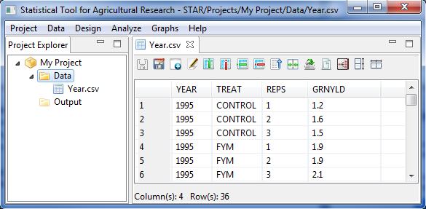

* Click **Data** **| Reshape | Long (Serial) to Wide (Parallel) …** from the main window or click on the Reshape to Wide icon  in the Data Viewer tool bar. The **Reshape Data (Long to Wide)** dialog boxwill automatically appear as shown below.

**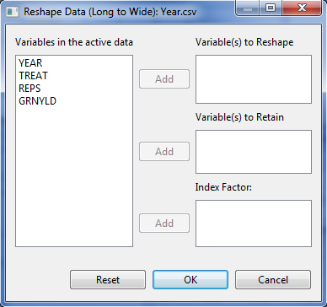**

* Specify the required fields and appropriate options.

**Variables to be Reshape**

This pertains to the list of variable(s) which is to be divided into two or more columns and saved to different variables in terms of the levels of the index factor.

**Variables to be Retained**

This pertains to variable(s) to be retained to describe the individual cases or observations.

**Index Factor**

This pertains to variable(s) which will determine the groupings of the values of the variable(s) to be transposed

For the example, the completed **Reshape Data (Long to Wide)** dialog box should now look like this:

**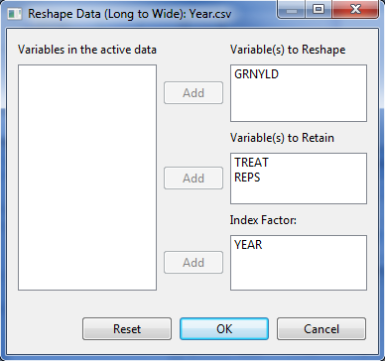**

* Click the **Ok** button. The restructured data set is saved in the parent folder of the active data and displayed in the Data Viewer tab. The default filename of the restructured data set follows the format *<activeDataFilename>\_ReshapeToWide.csv*.

**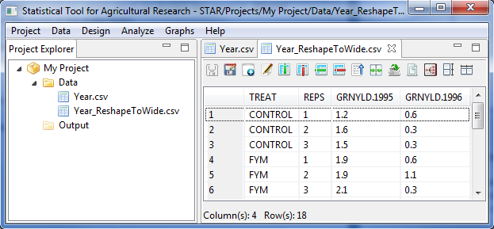**

### Reshape Data from Wide to Long Format

Manipulating data from wide (parallel) to long (serial) refers to re-arranging a multivariate into a univariate data. For instance, different columns representing measurements taken for a response variable over a period of time can be combined to form a single column, with the time variable used as an additional identifier variable.

The steps for reshaping the data from wide to long format are listed below:

* On the **Project Explorer**, locate the *Year\_ReshapeToWide.csv* file (the generated file from section *Reshape Data from Long to Wide Format*) from the *Data* folder of the project named *My Project*. Double-click the file to view it in the Data Viewer.
* Click **Data** **| Reshape | From Wide (Parallel) to Long (Serial) …** from the main window or click on the Reshape to Long icon  in the Data Viewer tool bar. The **Reshape Data (Wide to Long)** dialog box will appear.

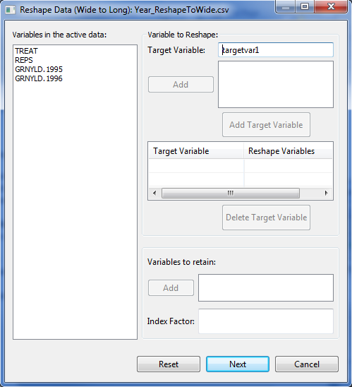

* Specify the required fields and appropriate options:

**Variable to be Reshape**

These are the variables that will be combined to form one variable. Click the variables in the list of variables in the active data while holding the Ctrl key then click the **Add** button. Moreover, the user should specify as the target variable the name of the variable to be created. The default target variable name is *targetvar1*.Then click the **Add Target Variable**. In specifying the name of the target variable, the following rules apply:

* The name must start with a letter. The remaining characters can be any letter, any digit, a period or underscore.
* Each column name must be unique; duplication is not allowed.
* Column name is case sensitive

User can create at least one target variable. This target variable should be unique and the length of the *Reshape Variables* should be the equal for all target variables to be created.

**Variables to be Retained**

These are the variables that will be included in the restructured data set and pertains to variables that describe the individual cases.

**Index Factor**

This is the name of the grouping variables that will be created.

For the *example*, the completed dialog box should appear as illustrated below:

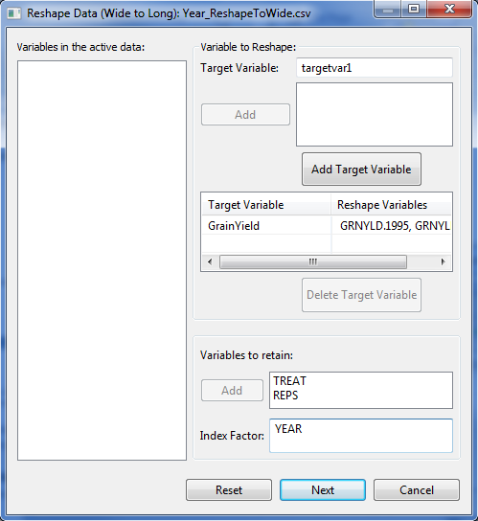

* Click the **Next** button to proceed. The **Define Levels** dialog box will appear.

**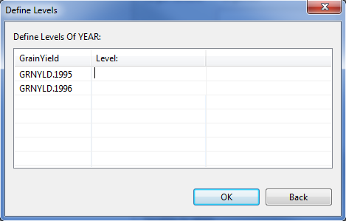**

* Specify the required fields.

For the example, the complete dialog box should appear as shown below:

**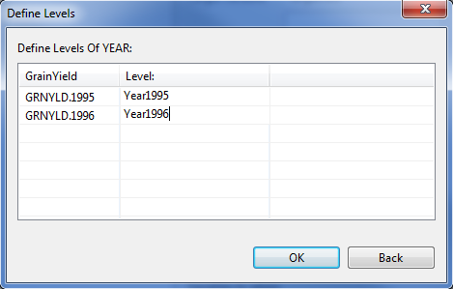**

* Click the **OK** button. The restructured data set is saved in the parent folder of the active data and displayed in the Data Viewer tab. The default filename of the restructured data set follows the format *<activeDataFilename>\_ReshapeToLong.csv*.

**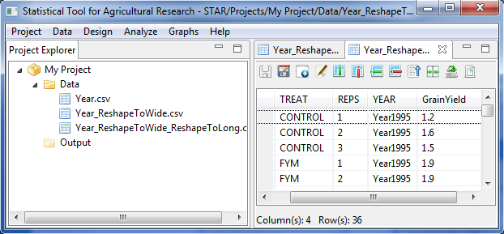**

## Aggregate

The **Aggregate submenu** aggregates group of observations into single observation and creates a new, aggregated data file or creates new columns in the active data file that contain the aggregated data. Observations are aggregated based on the value of one or more grouping variables.

The steps for aggregating the data are listed below:

* On the **Project Explorer** panel, using the project named *My Project*, import the data file *MasterData.csv* from the *Data* folder of the project named *SampleProject*. Double-click the file to open it and view it in the Data Viewer.

To import data from the *SampleProject*, see *Importing Data from Other Project* sectionof this user manual.

Opening the data for the first-time, *REP* field is regarded by STAR as numerical variable. To change its type, go to **Data | Edit Variable Information** and change the *Variable Type* of *REP* from *Numeric* to *Factor*.

* Choose **Data | Aggregate…** or click on the Aggregate Data icon in the Data Viewer tool bar.

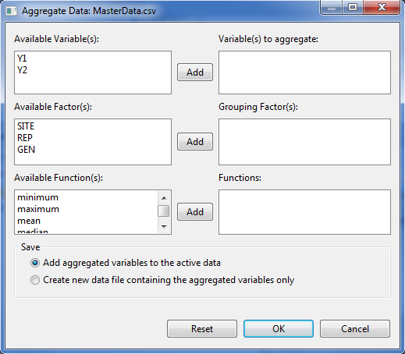

* Specify the required fields and appropriate options.

**Variable(s) to Aggregrate**

This is the list of variables whose values will be summarized using the selected functions.

**Grouping Factor(s)**

Specify this grouping factor, if the user wants to summarize the values per level of a grouping factor.

**Functions**

Available functions are minimum, maximum, mean, median, sum, variance and standard deviation.

**Save**

Specify how the aggregated data will be saved. User can either add aggregated variables to the active data (default options) or create a new data file containing the aggregated variables only. If user chooses the default option, the resulting data file is not aggregated. Each observations with the save value(s) of the grouping variable(s) will receive the same values of the new aggregated variables. If user chooses the option create a new data file containing the aggregated variables only, the new data files contains one observation for each category of the grouping variables.

For the *example*, suppose we want to compute the mean of the variables suppose we want to compute the mean of the variables *Y1* and *Y2* for each level of *REP*. The completed dialog box should appear as illustrated below:

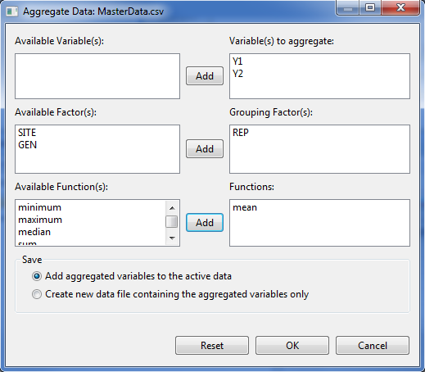

* Click the **OK** button.

If the user chooses the save option: *add aggregated variables to the active data* (default option), the active data is saved with the additional column(s) and displayed in the Data Viewer. The default column name(s) which contain the aggregate data follows the format *<Function>.< Variable to aggregate >*.

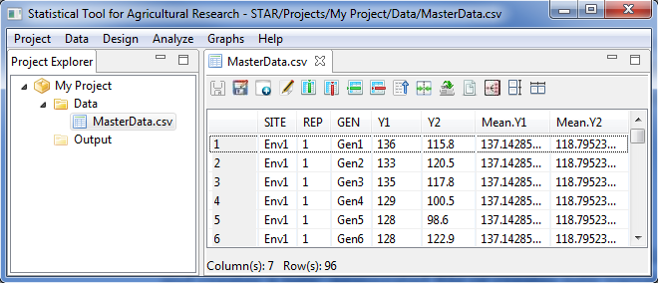

If the user chooses the save option: *create a new data file containing the aggregated variables only*, the aggregated data file is saved in the parent folder of the active data and displayed in the Data Viewer. The default column name(s) which contain the aggregate data follows the format *<Function>.<Variable name to aggregate>* and the default filename of the aggregated data set follows the format *<activeDataFilename>\_aggregate.csv*.

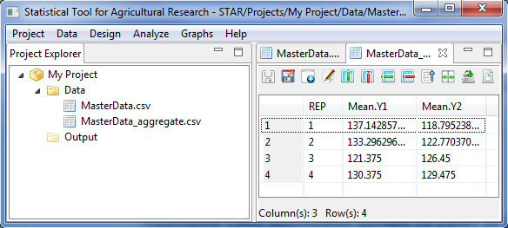

# Randomization for Basic Experimental Design

The **Design Menu** allows user to generate randomization for single- and multi-factor designs. If the menu is used for the first-time in the active project, a *Randomization* folder will be created inside the *Output* folder. Sub-folders will be created inside the *Randomization* folder where the generated field book in *csv* format and a text file will be saved. The default sub-folder name follows the format *<design>\_<time stamp>*.

## Completely Randomized Design

The randomization that will be generated is for balanced design. Equal number of replicates will be generated for each level of the factor or treatment combination.

The steps to generate randomization are listed below:

* To perform randomization, click **Design | Completely Randomized Design…**. The **Randomization** dialog box will appear.

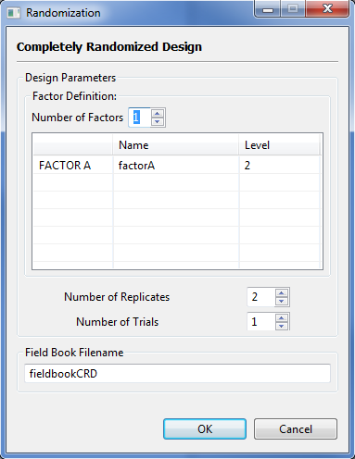

* Specify the required fields and appropriate options.

**Number of Factors**

Define the number of factors to be generated with default and minimum value accepted value equal to 1 and maximum value equal to 10. The number of factors specified will define the number of rows of the table inside the **Factor Definition** frame. To change the default value, user can either type a value inside the spin box or click the up-arrow key of the spin box to increase the value, down-arrow key, otherwise.

**Factor Definition Frame**

It lets the user define the name of the factor(s), under the *Name* column, and its levels, under the *Level* column.

The *Name* column contains the default name for the factor. User can change the factor name by typing the desired factor name. In specifying the factor name, the following rules apply: the name should not contain any space; must begin with a letter or a period (.); succeeding characters can be a combination of letters, numbers, period (.) and underscore (\_); and the name must be different from other factor names already specified.

The *Level* column contains the level of the factor. User can change the level of the factor by either typing a value inside the spin box or clicking the up-arrow key of the spin box to increase the value, down-arrow key, otherwise. The default value and minimum value of the levels is equal to 2.

**Number of Replicates**

Define the number of replicates to be generated for each level of the factor or for each treatment combination. The default value and minimum value is equal to 2.

**Number of Trial**

Define the number of trials to be generated. The default value and minimum value is equal to one.

**Field Book Filename**

This field is required and it specifies the file name where the result of the randomization will be saved. The default filename is *fieldbookCRD*.

For the example, suppose we want to generate a randomization for an experiment whose aim is to compare the effects of seven different foliar and granular insecticides on the grain yield which will be conducted in Completely Randomized Design with four replicates. The completed dialog box should appear as illustrated:

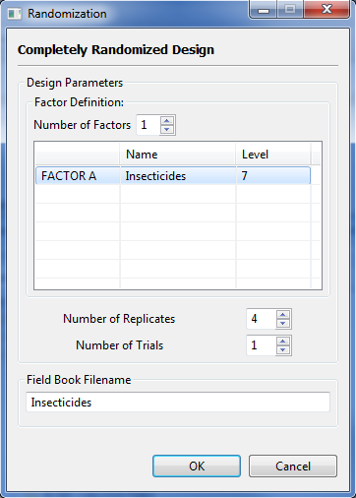

* Click the **OK** button to generate the randomization. The **Randomization** dialog box will be minimized and STAR will automatically display the *csv* data file created in the Data Viewer.

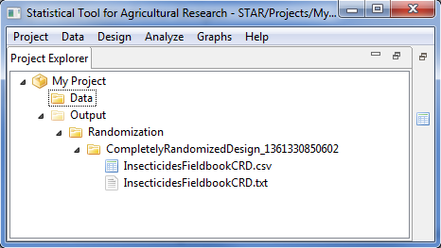

Sample *csv* data file displayed in the Data Viewer is shown below:

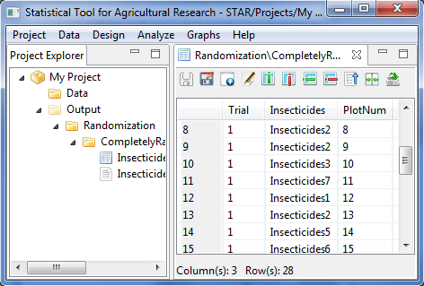

To view the text file created, double click the text file to view it in the **Result Viewer**. Sample *txt* file that was created is shown below:

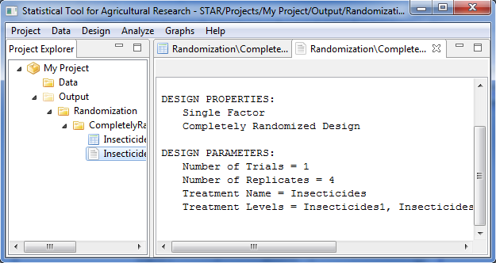

## Randomized Complete Block Design

The steps to generate randomization in are listed below:

* To perform randomization, click **Design | Randomized Complete Block Design** **…**. The **Randomization** dialog box will appear.

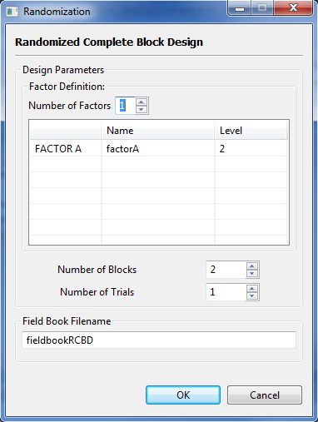

* Specify the required fields and appropriate options.

**Number of Factors**

Define the number of factors to be generated with default and minimum value accepted value is 1. The number of factors specified will define the number of rows of the table inside the **Factor Definition** frame. To change the default value, user can either type a value inside the spin box or click the up-arrow key of the spin box to increase the value, down-arrow key, otherwise.

**Factor Definition Frame**

This table is required. It lets the user define the name of the factor(s), under the *Name* column, and its levels, under the *Level* column.

The *Name* column contains the default name for the factor. User can change the factor name by typing the desired factor name. In specifying the factor name, the following rules apply: the name should not contain any space; must begin with a letter or a period (.); succeeding characters can be a combination of letters, numbers, period (.) and underscore (\_); and the name must be different from other factor names already specified.

The *Level* column contains the level of the factor. User can change the level of the factor by either typing a value inside the spin box or clicking the up-arrow key of the spin box to increase the value, down-arrow key, otherwise. The default value and minimum value of the levels is equal to 2.

**Number of Blocks**

Define the number of blocks to be generated. The default value and minimum value is equal to 2.

**Number of Trial**

Define the number of trials to be generated. The default value and minimum value is equal to one.

**Field Book Filename** **Textbox**

This field is required and it specifies the file name where the result of the randomization will be saved. The default filename is *fieldbookRCBD*.

For the example, suppose we want to generate a randomization for an experiment whose aim is to compare the effects of five seeding densities on the on grain yield of three rice varieties which will be conducted in an randomized complete block design with four blocks and one trial. The completed dialog box should appear as illustrated:

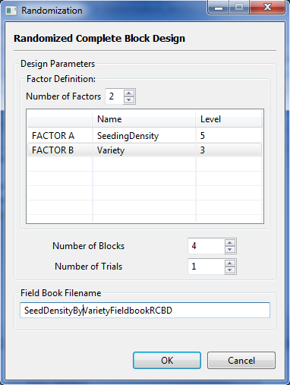

* Click the **OK** button to generate the randomization. The **Randomization** dialog box will be minimized and STAR will automatically display the *csv* data file created in the Data Viewer.

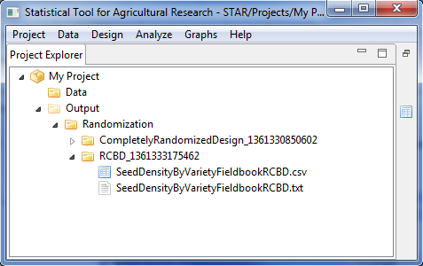

Sample *csv* data file displayed in the Data Viewer is shown below:

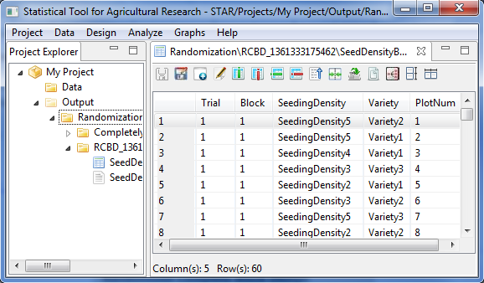

To view the text file created, double click the text file to view it in the **Result Viewer**. Sample *txt* file that was created is shown below:

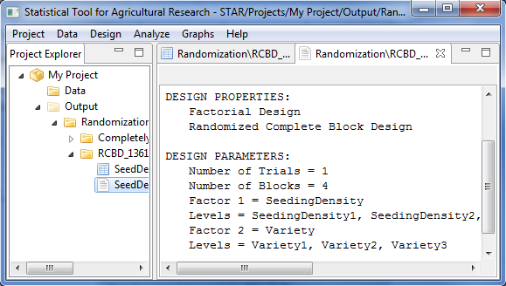

## Latin Square Design

The steps to generate randomization are listed below:

* To perform randomization, click **Design | Randomized Complete Block Design** **…**. The **Randomization** dialog box will appear.

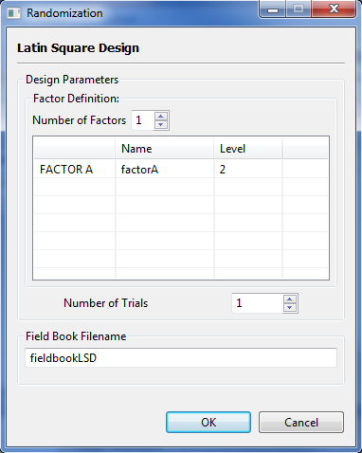

* Specify the required fields and appropriate options.

**Number of Factors**

Define the number of factors to be generated with default and minimum value accepted value is 1. The number of factors specified will define the number of rows of the table inside the **Factor Definition** frame. To change the default value, user can either type a value inside the spin box or click the up-arrow key of the spin box to increase the value, down-arrow key, otherwise.

**Factor Definition Frame**

This table is required. It lets the user define the name of the factor(s), under the *Name* column, and its levels, under the *Level* column.

The *Name* column contains the default name for the factor. User can change the factor name by typing the desired factor name. In specifying the factor name, the following rules apply: the name should not contain any space; must begin with a letter or a period (.); succeeding characters can be a combination of letters, numbers, period (.) and underscore (\_); and the name must be different from other factor names already specified.

The *Level* column contains the level of the factor. User can change the level of the factor by either typing a value inside the spin box or clicking the up-arrow key of the spin box to increase the value, down-arrow key, otherwise. The default value and minimum value of the levels is equal to 2.

**Number of Trial**

Define the number of trials to be generated. The default value and minimum value is equal to one.

**Field Book Filename**

This field is required and it specifies the file name where the result of the randomization will be saved. The default filename is *fieldbookLSD*.

For the example, suppose we want to generate a randomization for an experiment to be laid out in Latin Square Design whose aim is to compare the effects of five promising maize hybrids and a check variety on the grain yield. The completed dialog box should appear as illustrated:

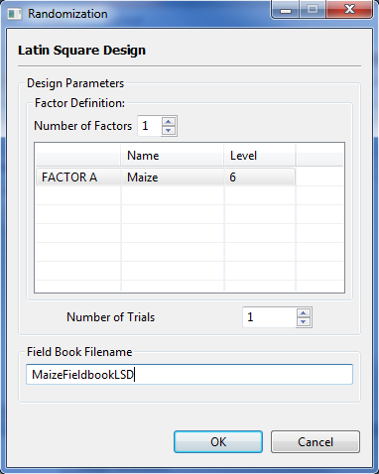

* Click the **OK** button to generate the randomization. The **Randomization** dialog box will be minimized and STAR will automatically display the *csv* data file created in the Data Viewer.

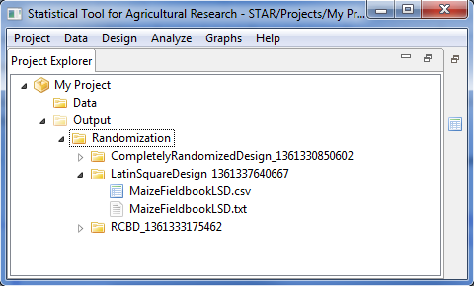

Sample *csv* data file displayed in the Data Viewer is shown below:

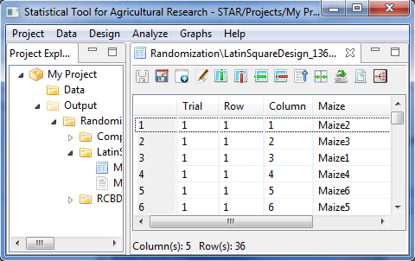

To view the text file created, double click the text file to view it in the **Result Viewer**. Sample *txt* file that was created is shown below:

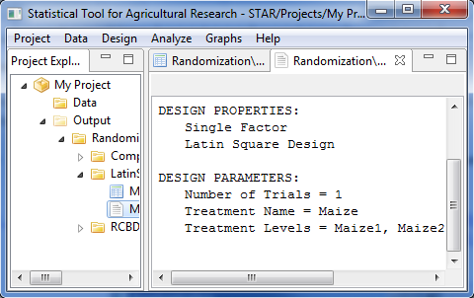

## Split Plot Design

This design can be generated for Completely Randomized Design, Randomized Complete Block Design and Latin Square Design.

The steps to generate randomization are listed below:

* Click **Design | Split Plot Design** from the main window. Choose the appropriate design structure that will be used.
* The **Randomization** dialog box will appear. For Completely Randomized Design, the default **Randomization** dialog box is shown below:

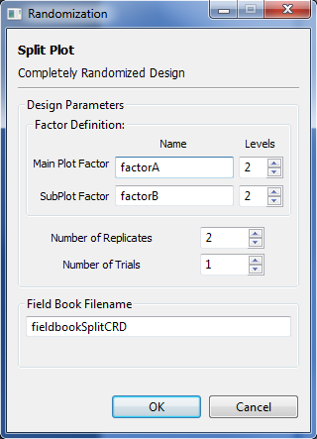

For Randomized Complete Block Design, the default **Randomization** dialog box is shown below:

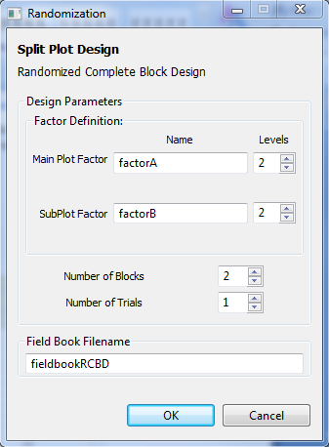

For Latin Square Design, the default **Randomization** dialog box is shown below:

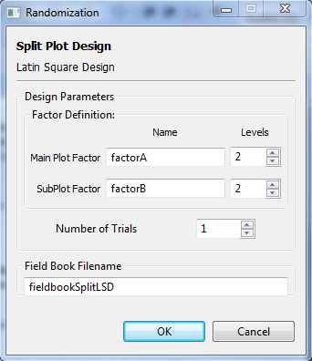

* Specify the required field and appropriate options.

**Main Plot Factor and SubPlot Factor**

**Name**

Contain the default name for the main plot factor. User can change the factor name by typing the desired factor name. In specifying the factor name, the following rules apply: the name should not contain any space; must begin with a letter or a period (.); succeeding characters can be a combination of letters, numbers, period (.) and underscore (\_); and the name must be different from other factor names already specified.

**Levels**

Contain the level of the main plot factor. User can change the level of the factor by either typing a value inside the spin box or clicking the up-arrow key of the spin box to increase the value, down-arrow key, otherwise. The default value and minimum value of the levels is equal to 2.

**Number of Replicates**

Applicable only if Completely Randomized Design is chosen. These define the number of replicates to be generated. The default value and minimum value is equal to 2.

**Number of Blocks**

Applicable only if Randomized Complete Block Design is chosen. These define the number of blocks to be generated. The default value and minimum value is equal to 2.

**Number of Trial**

Define the number of trials to be generated. The default value and minimum value is equal to one.

**Field Book Filename**

This field is required and it specifies the file name where the result of the randomization will be saved.

For this example, suppose we want to generate a randomization for an experiment whose aim is to compare the effects of four nitrogen rates on the on grain yield of five rice varieties which will be conducted in randomized complete block design using Split Plot with four blocks. Nitrogen rates will be assigned as the main plot factor and the varieties as the sub plot factor. The completed dialog box should appear as illustrated:

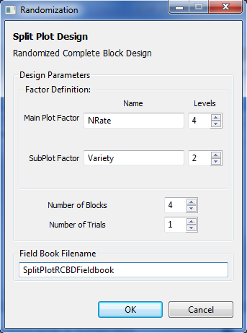

* Click the **OK** button to generate the randomization. The **Randomization** dialog box will be minimized and STAR will automatically display the *csv* data file created in the Data Viewer.

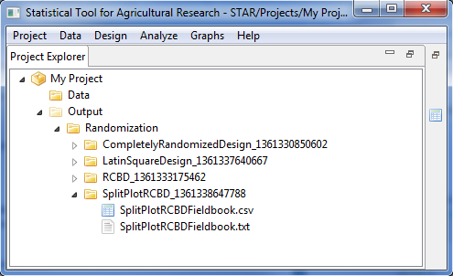

Sample *csv* data file displayed in the Data Viewer is shown below:

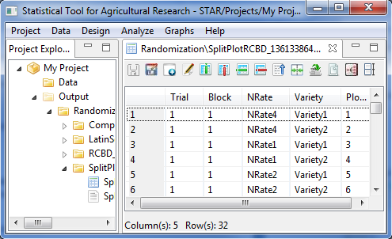

To view the text file created, double click the text file to view it in the **Result Viewer**. Sample *txt* file that was created is shown below:

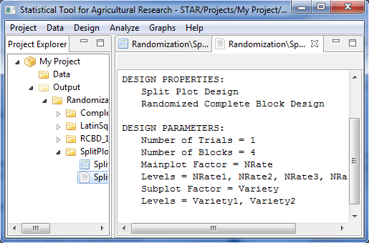

## Strip Plot Design

The steps to generate randomization are listed below:

* Choose **Design | Strip Plot Design**… from the main window. The **Randomization** dialog box will appear.

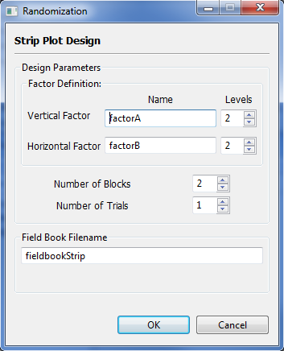

* Specify the required fields and appropriate options.

**Vertical Factor and Horizontal Factor**

**Name**

Contain the default name for the main plot factor. User can change the factor name by typing the desired factor name. In specifying the factor name, the following rules apply: the name should not contain any space; must begin with a letter or a period (.); succeeding characters can be a combination of letters, numbers, period (.) and underscore (\_); and the name must be different from other factor names already specified.

**Levels**

Contain the level of the main plot factor. User can change the level of the factor by either typing a value inside the spin box or clicking the up-arrow key of the spin box to increase the value, down-arrow key, otherwise. The default value and minimum value of the levels is equal to 2.

**Number of Blocks**

These define the number of blocks to be generated. The default value and minimum value is equal to 2.

**Number of Trial**

Define the number of trials to be generated. The default value and minimum value is equal to one.

**Field Book Filename**

This field is required and it specifies the file name where the result of the randomization will be saved. The default filename is *fieldbookStrip*.

For this example, suppose we want to generate a randomization for an experiment to be conducted using Strip Plot, with land preparation (with 3 levels) as the horizontal factor and water stress (with four levels) as the vertical factor. Three blocks will be used. The completed dialog box should appear as illustrated:

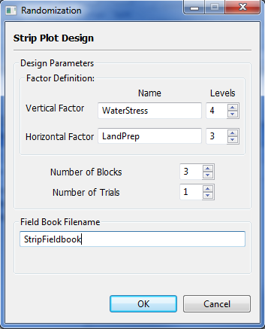

* Click the **OK** button to generate the randomization. The **Randomization** dialog box will be minimized and STAR will automatically display the *csv* data file created in the Data Viewer.

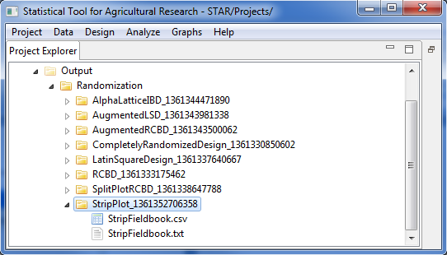

Sample *csv* data file displayed in the Data Viewer is shown below:

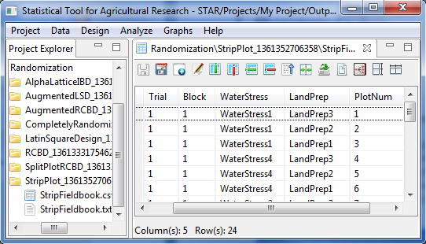

To view the text file created, double click the text file to view it in the **Result Viewer**. Sample *txt* file that was created is shown below:

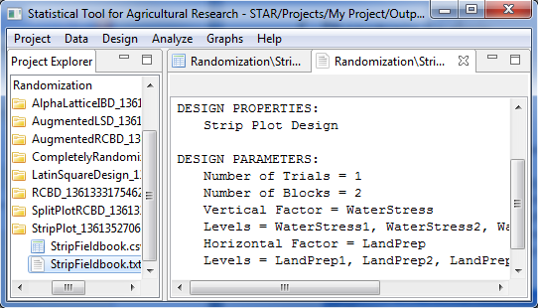

## Split-Split Plot Design

This design can be generated for Completely Randomized Design, Randomized Complete Block Design and Latin Square Design.

The steps to generate randomization are listed below:

* Click **Design | Split-Split Plot Design** from the main window. Choose the appropriate design structure that will be used.
* The **Randomization** dialog box will appear. For Completely Randomized Design, the default **Randomization** dialog box is shown below:

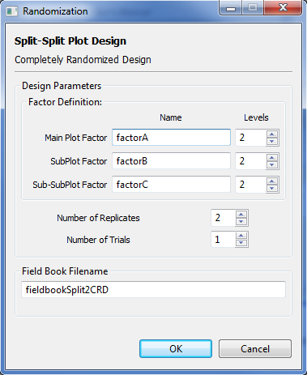

For Randomized Complete Block Design, the default **Randomization** dialog box is shown below:

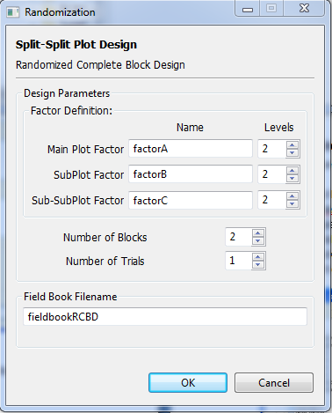

For Latin Square Design, the default **Randomization** dialog box is shown below:

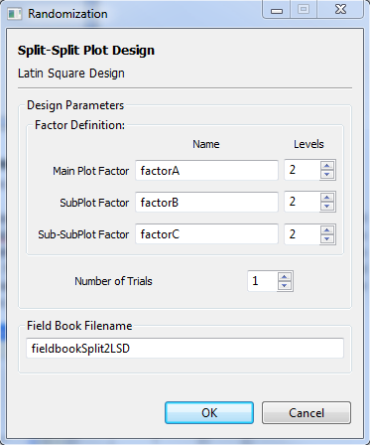

* Specify the required field and appropriate options.

**Main Plot Factor, SubPlot Factor and Sub-SubPlot Factor**

**Name**

Contain the default name for the main plot factor. User can change the factor name by typing the desired factor name. In specifying the factor name, the following rules apply: the name should not contain any space; must begin with a letter or a period (.); succeeding characters can be a combination of letters, numbers, period (.) and underscore (\_); and the name must be different from other factor names already specified.

**Levels**

Contain the level of the main plot factor. User can change the level of the factor by either typing a value inside the spin box or clicking the up-arrow key of the spin box to increase the value, down-arrow key, otherwise. The default value and minimum value of the levels is equal to 2.

**Number of Replicates**

Applicable only if Completely Randomized Design is chosen. These define the number of replicated to be generated. The default value and minimum value is equal to 2.

**Number of Blocks**

Applicable only if Randomized Complete Block Design is chosen. These define the number of blocks to be generated. The default value and minimum value is equal to 2.

**Number of Trial**

Define the number of trials to be generated. The default value and minimum value is equal to one.

**Field Book Filename**

This field is required and it specifies the file name where the result of the randomization will be saved.

For this example, suppose we want to generate a randomization for an experiment whose aim is to compare the effects of five nitrogen rates on the grain yield of three management practices and three rice varieties which will be conducted in randomized complete block design using Split-Split Plot with three blocks. Nitrogen rates will be assigned as the main plot factor, management practices as the subplot factor and varieties as the sub-subplot factor. The completed dialog box should appear as illustrated:

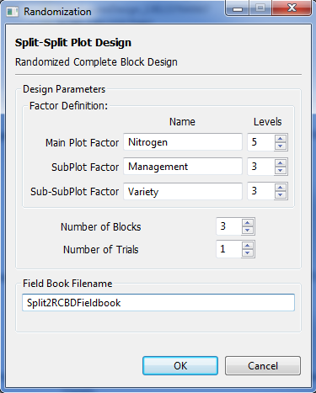

* Click the **OK** button to generate the randomization. The **Randomization** dialog box will be minimized and STAR will automatically display the *csv* data file created in the Data Viewer.

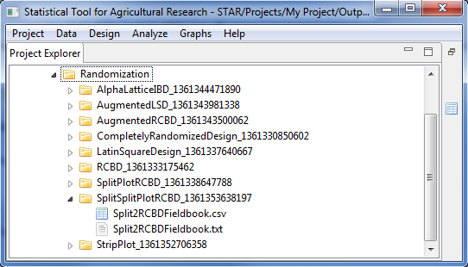

Sample *csv* data file displayed in the Data Viewer is shown below:

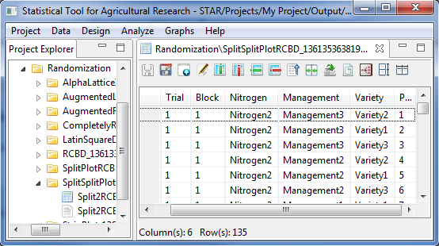

To view the text file created, double click the text file to view it in the **Result Viewer**. Sample *txt* file that was created is shown below:

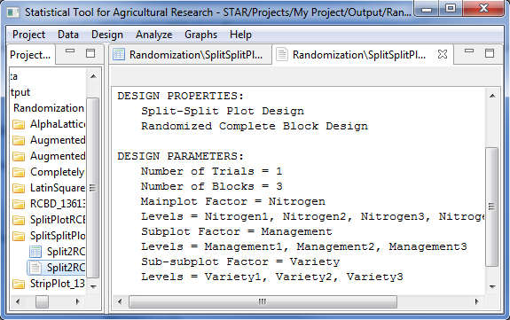

## Strip-Split Plot Design

The steps to generate randomization are listed below:

* Choose **Design | Strip-Split Plot Design…** from the main window. The **Randomization** dialog box will appear.

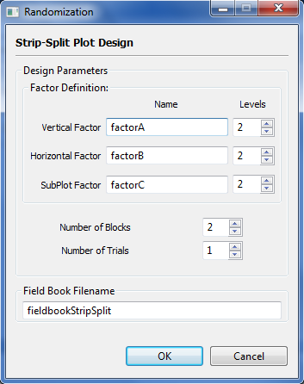

* Specify the required fields and appropriate options.

**Vertical Factor, Horizontal Factor and SubPlot Factor**

**Name**

Contain the default name for the main plot factor. User can change the factor name by typing the desired factor name. In specifying the factor name, the following rules apply: the name should not contain any space; must begin with a letter or a period (.); succeeding characters can be a combination of letters, numbers, period (.) and underscore (\_); and the name must be different from other factor names already specified.

**Levels**

Contain the level of the main plot factor. User can change the level of the factor by either typing a value inside the spin box or clicking the up-arrow key of the spin box to increase the value, down-arrow key, otherwise. The default value and minimum value of the levels is equal to 2.

**Number of Blocks**

Applicable only if Randomized Complete Block Design is chosen. These define the number of blocks to be generated. The default value and minimum value is equal to 2.

**Number of Trial**

Define the number of trials to be generated. The default value and minimum value is equal to one.

**Field Book Filename**

This field is required and it specifies the file name where the result of the randomization will be saved.

For this example, suppose we want to generate a randomization for an experiment to be conducted using Strip-Split Plot, with nitrogen rates (with 3 levels) as the horizontal factor, rice variety (with 6 levels) as the vertical factor and planting methods (with 2 levels) as the subplot factor. Three blocks will be used. The completed dialog box should appear as illustrated below:

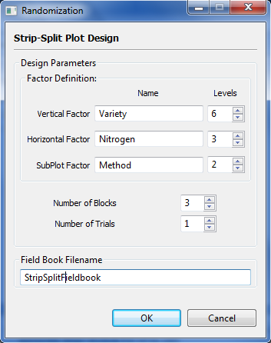

* Click the **OK** button to generate the randomization. The **Randomization** dialog box will be minimized and STAR will automatically display the *csv* data file created in the Data Viewer.

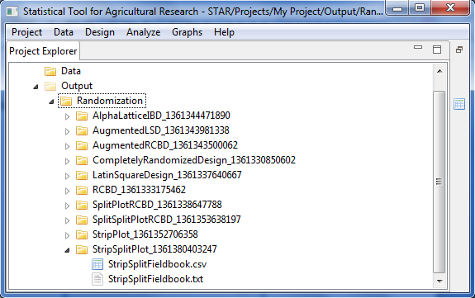

Sample *csv* data file displayed in the Data Viewer is shown below:

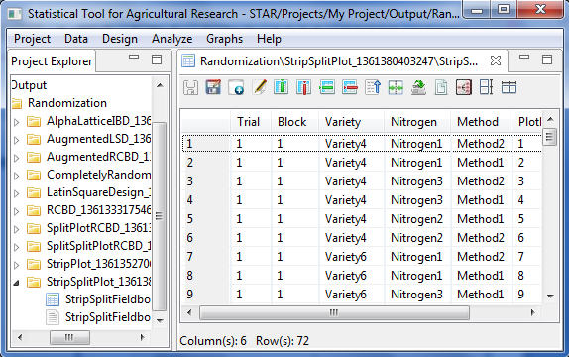

To view the text file created, double click the text file to view it in the **Result Viewer**. Sample *txt* file that was created is shown below:

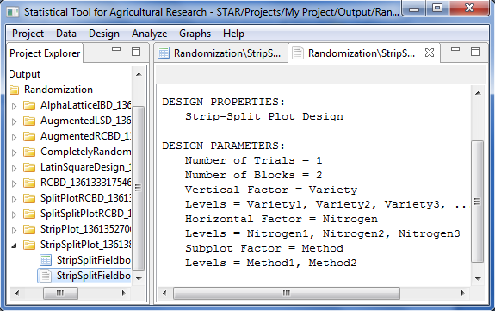

## Split-Split-Split Plot Design

This design can be generated for Completely Randomized Design, Randomized Complete Block Design and Latin Square Design.

The steps to generate randomization are listed below:

* Click **Design | Split-Split-Split Plot Design** from the main window. Choose the appropriate design structure that will be used.
* The **Randomization** dialog box will appear. For Completely Randomized Design, the default **Randomization** dialog box is shown below:

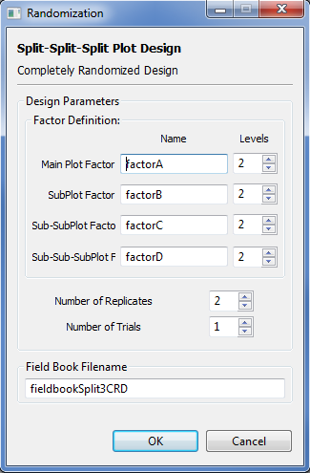

For Randomized Complete Block Design, the default **Randomization** dialog box is shown below:

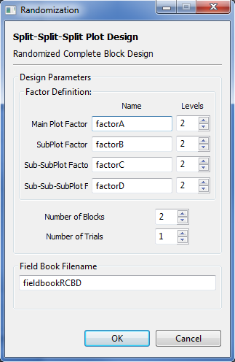

For Latin Square Design, the default **Randomization** dialog box is shown below:

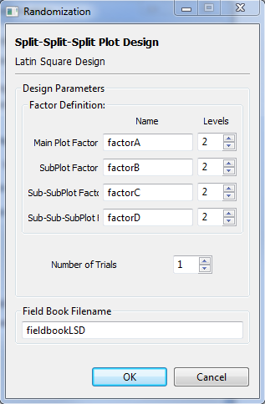

* Specify the required field and appropriate options.

**Main Plot Factor, SubPlot Factor, Sub-SubPlot Factor and**

**Sub-Sub-SubPlot Factor**

**Name**

Contain the default name for the main plot factor. User can change the factor name by typing the desired factor name. In specifying the factor name, the following rules apply: the name should not contain any space; must begin with a letter or a period (.); succeeding characters can be a combination of letters, numbers, period (.) and underscore (\_); and the name must be different from other factor names already specified.

**Levels**

Contain the level of the main plot factor. User can change the level of the factor by either typing a value inside the spin box or clicking the up-arrow key of the spin box to increase the value, down-arrow key, otherwise. The default value and minimum value of the levels is equal to 2.

**Number of Replicates**

Applicable only if Completely Randomized Design is chosen. These define the number of replicated to be generated. The default value and minimum value is equal to 2.

**Number of Blocks**

Applicable only if Randomized Complete Block Design is chosen. These define the number of blocks to be generated. The default value and minimum value is equal to 2.

**Number of Trial**

Define the number of trials to be generated. The default value and minimum value is equal to one.

**Field Book Filename**

This field is required and it specifies the file name where the result of the randomization will be saved.

* Click the **OK** button to generate the randomization. The **Randomization** dialog box will be minimized and STAR will automatically display the *csv* data file created in the Data Viewer. To view the text file created, double click the text file to view it in the **Result Viewer**.

## Strip-Split-Split Plot Design

The steps to generate randomization are listed below:

* Choose **Design | Strip-Split-Split Plot Desig**n from the main window. The Randomization dialog box will appear.

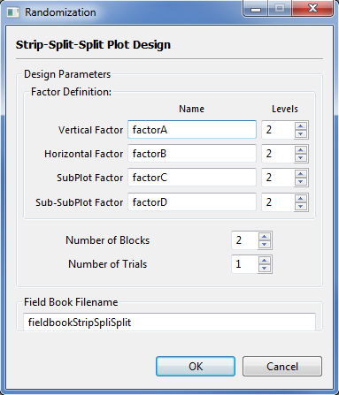

* Specify the required fields and appropriate options.

**Vertical Factor, Horizontal Factor, SubPlot Factor and**

**Sub-SubPlot Factor**

**Name**

Contain the default name for the main plot factor. User can change the factor name by typing the desired factor name. In specifying the factor name, the following rules apply: the name should not contain any space; must begin with a letter or a period (.); succeeding characters can be a combination of letters, numbers, period (.) and underscore (\_); and the name must be different from other factor names already specified.

**Levels**

Contain the level of the main plot factor. User can change the level of the factor by either typing a value inside the spin box or clicking the up-arrow key of the spin box to increase the value, down-arrow key, otherwise. The default value and minimum value of the levels is equal to 2.

**Number of Blocks**

Applicable only if Randomized Complete Block Design is chosen. These define the number of blocks to be generated. The default value and minimum value is equal to 2.

**Number of Trial**

Define the number of trials to be generated. The default value and minimum value is equal to one.

**Field Book Filename**

This field is required and it specifies the file name where the result of the randomization will be saved.

* Click the **OK** button to generate the randomization. The **Randomization** dialog box will be minimized and STAR will automatically display the *csv* data file created in the Data Viewer. To view the text file created, double click the text file to view it in the **Result Viewer**.

## Balanced Incomplete Block Design

The steps to generate randomization for Balanced Incomplete Block Design are listed below:

* Click **Design | Incomplete Block Design | Balanced Incomplete Block Design…** from the main window. The **Randomization** dialog box will appear.

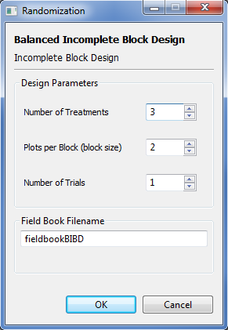

* Specify the required field and appropriate options.

**Number of Treatments**

Define the number of treatments (trmt) to be included in the randomization. The default and minimum value is 3. The entry should be a greater than the entry for the plots per block.

**Plots per Block (block size)**

These define the number of replicates to be generated. The default value and minimum value is equal to 2. The entry should be less than the number of treatments.

**Number of Trial**

Define the number of trials to be generated. The default value and minimum value is equal to one.

**Field Book Filename**

This field is required and it specifies the file name where the result of the randomization will be saved.

For the example, the completed dialog box should appear as illustrated below:

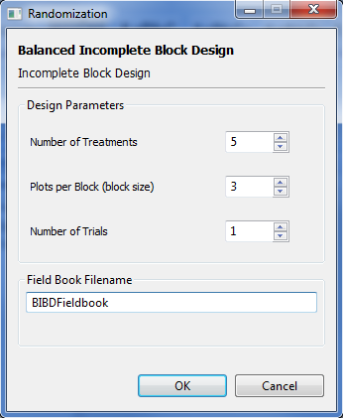

* Click the **OK** button to generate the randomization. The **Randomization** dialog box will be minimized and STAR will automatically display the *csv* data file created in the Data Viewer.

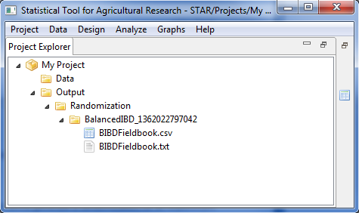

Sample csv file displayed in the Data Viewer is shown below:

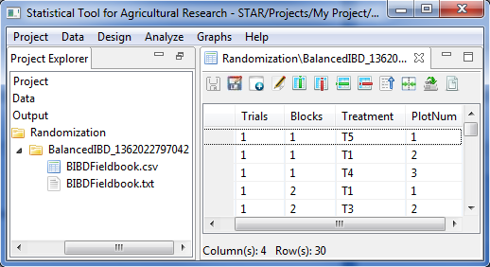

To view the text file created, double click the text file to view it in the **Result Viewer**. Sample *txt* file that was created is shown below:

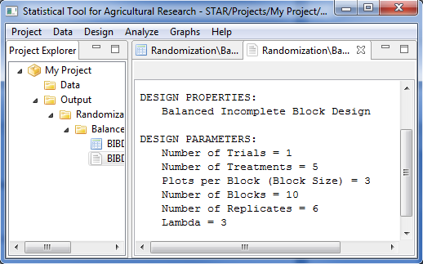

## Lattice Design

The steps to generate randomization for Lattice Design are listed below:

* Click **Design | Incomplete Block Design | Lattice Design…** from the main window. The **Randomization** dialog box will appear.

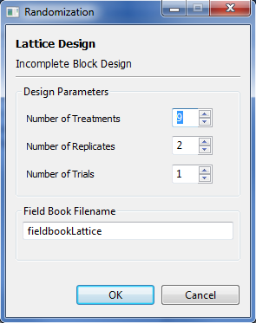

* Specify the required fields and appropriate options.

**Number of Treatments**

Define the number of treatments (trmt) to be included in the randomization. The default and minimum value is 9 while the maximum value is 144. The entry should be a perfect square.

**Number of Replicates**

These define the number of replicates to be generated. The default value and minimum value is equal to 2. If the $\sqrt{trmt}$ s is odd, the maximum number of replicates is $\sqrt{trmt}+ 1$.

**Number of Trial**

Define the number of trials to be generated. The default value and minimum value is equal to one.

**Field Book Filename**

This field is required and it specifies the file name where the result of the randomization will be saved.

For this example, suppose we want to generate a randomization for an experiment that will be conducted using Lattice design with 49 treatments in three replicates. The completed dialog box should appear as illustrated below:

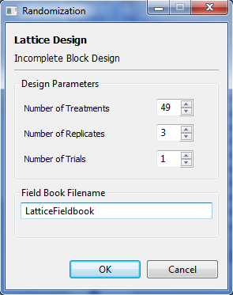

* Click the **OK** button to generate the randomization. The **Randomization** dialog box will be minimized and STAR will automatically display the *csv* data file created in the Data Viewer.

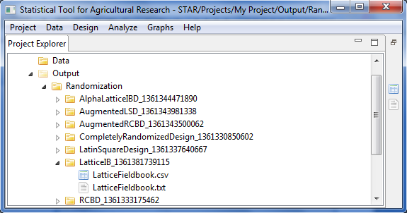

Sample *csv* data file displayed in the Data Viewer is shown below:

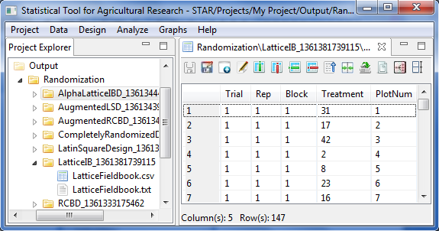

To view the text file created, double click the text file to view it in the **Result Viewer**. Sample *txt* file that was created is shown below:

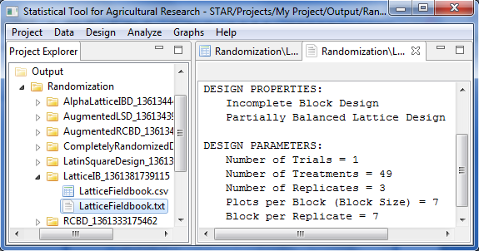

## Alpha Lattice Design

The steps to generate randomization for Alpha Lattice Design are listed below:

* Click **Design | Incomplete Block Design | Alpha Lattice Design…** from the main window. The **Randomization** dialog box will appear.

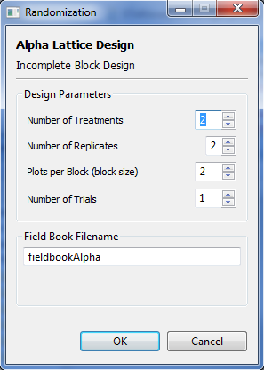

* Specify the required field and appropriate options.

**Number of Treatments**

Define the number of treatments to be included in the randomization. The default and minimum value is 2.

**Number of Replicates**

The default and minimum value is 2 while the maximum is equal to 4. If number of replicates (r) is equal to 2, the block size (k) should be less than or equal to the number of blocks (s). If r = 3, and s is an odd number, k <= s. If r = 3, and s is an even number, k <= s – 1. If r = 4, and s is an odd number but multiple of 3, k <= s. The number of blocks can be computed as the number of treatments /block size.

**Plots per Block (block size)**

Define the number of plots per block or the block size. The default and minimum value is 2

**Number of Trials**

Define the number of trials to be generated. The default value and minimum value is equal to one.

**Field Book Filename**

This field is required and it specifies the file name where the result of the randomization will be saved. The default filename is *fieldbookAlpha*.

For this example, suppose we want to generate a randomization for an experiment that will be conducted using Alpha Lattice design with 72 entries grouped into 8 with three replicates. The completed dialog box should appear as illustrated below:

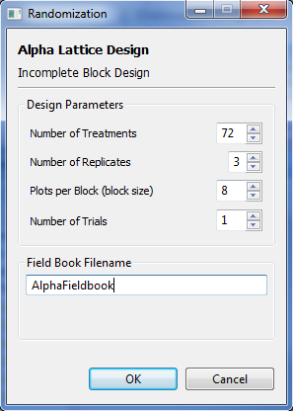

* Click the **OK** button to generate the randomization. The **Randomization** dialog box will be minimized and STAR will automatically display the *csv* data file created in the Data Viewer.

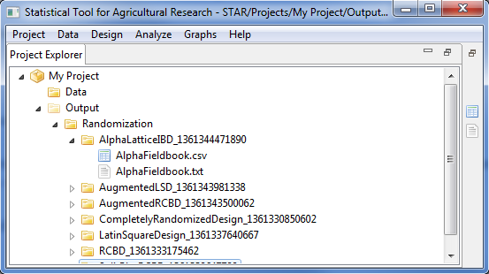

Sample *csv* data file displayed in the Data Viewer is shown below:

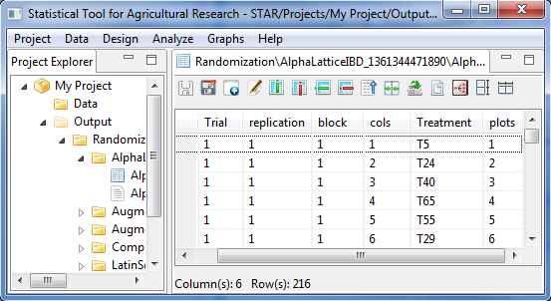

To view the text file created, double click the text file to view it in the **Result Viewer**. Sample *txt* file that was created is shown below:

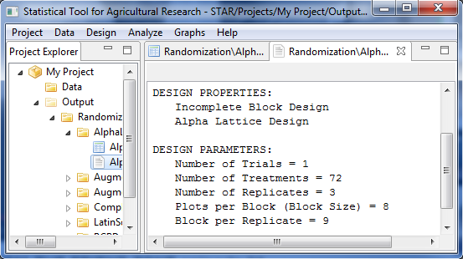

## Augmented Design in Randomized Complete Block

The steps to generate randomization for Augmented Design in Randomized Complete Block are listed below:

* Click **Design | Augmented Design | Randomized Complete Block Design…** from the main window. The **Randomization** dialog box will appear.

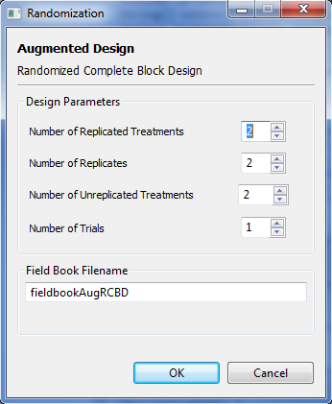

* Specify the required fields and appropriate options.

**Number of Replicated Treatments**

Define the number of replicated treatments to be included in the randomization. The default and minimum value is 2.

**Number of Replicates**

Define the number of replicates or blocks. The default and minimum value is 2.

**Number of Unreplicated Treatments**

Define the number of unreplicated treatments to be included in the randomization. The entry should be divisible by the number of replicated treatments. The default and minimum value is 2.

**Number of Trials**

Define the number of trials to be generated. The default and minimum value is 1.

**Field Book Filename**

This field is required and it specifies the file name where the result of the randomization will be saved. The default filename is *fieldbookAugRCBD*.

For this example, suppose we want to generate a randomization for an experiment which will be conducted using augmented design in randomized complete block involving four replicates. The experiment will use six replicated treatment and 60 unreplicated treatments (test entries). The completed dialog box should appear as illustrated below:

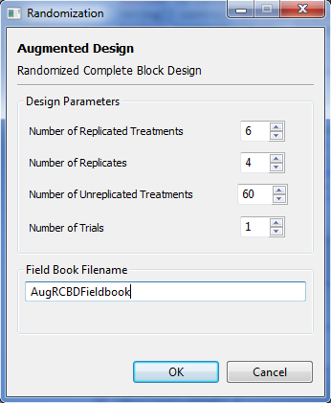

* Click the **OK** button to generate the randomization. The **Randomization** dialog box will be minimized and STAR will automatically display the *csv* data file created in the Data Viewer.

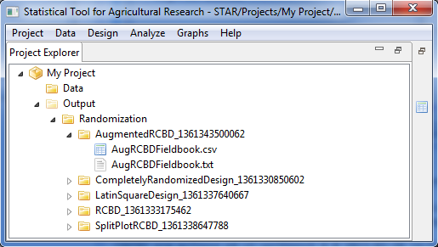

Sample *csv* data file displayed in the Data Viewer is shown below:

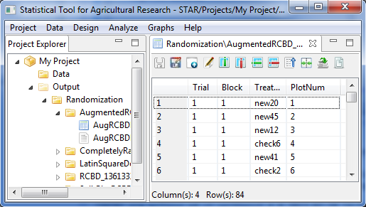

To view the text file created, double click the text file to view it in the **Result Viewer**. Sample *txt* file that was created is shown below:

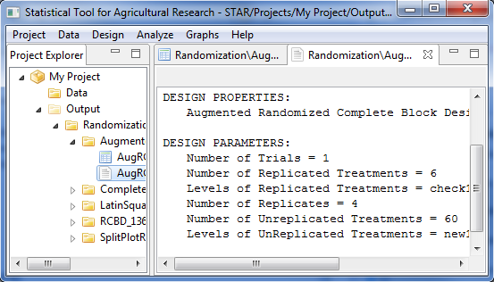

## Augmented Design in Latin Square

The steps to generate randomization for Augmented Design in Randomized Complete Block are listed below:

* Click **Design | Augmented Design | Latin Square Design…** from the main window. The **Randomization** dialog box will appear.

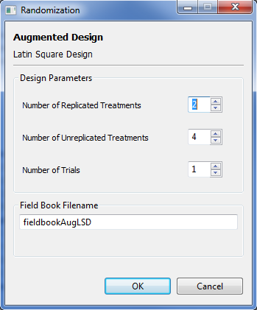

* Specify the required fields and appropriate options.

**Number of Replicated Treatments**

Define the number of replicated treatments to be included in the randomization. The default and minimum value is 2.

**Number of Unreplicated Treatments**

Define the number of unreplicated treatments to be included in the randomization. The entry should be divisible by the squared of the number of replicated treatments. The default and minimum value is 4.

**Number of Trials**

Define the number of trials to be generated. The default and minimum value is 1.

**Field Book Filename**

This field is required and it specifies the file name where the result of the randomization will be saved. The default filename is *fieldbookAugLSD*.

For this example, suppose we want to generate a randomization for an experiment which will be conducted using augmented design in randomized complete block involving four replicates. The experiment will use six replicated treatment and 60 unreplicated treatment (test entries). The completed dialog box should appear as illustrated below:

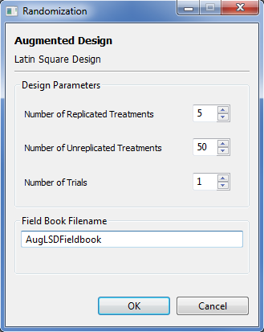

* Click the **OK** button to generate the randomization. The **Randomization** dialog box will be minimized and STAR will automatically display the *csv* data file created in the Data Viewer.

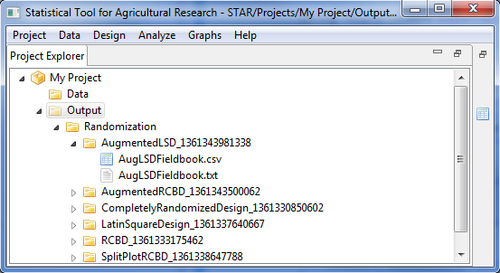

Sample *csv* data file displayed in the Data Viewer is shown below:

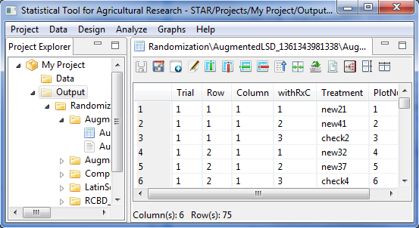

To view the text file created, double click the text file to view it in the **Result Viewer**. Sample *txt* file that was created is shown below:

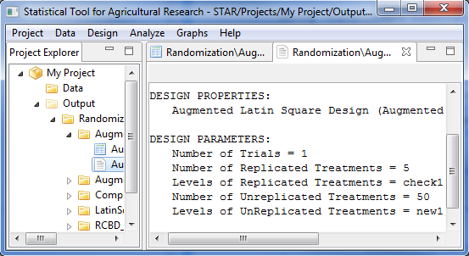

# Graphs

## Bar Graph

Bar graphs are useful for visualizing frequencies, sums, and statistics such as means and medians. The bar graphs that are created here can come from raw data or from pre-computed summary information.

The steps to create a bar graph are listed below:

* On the **Project Explorer** panel, select the data file *Year\_ReshapeToWide.csv.* Double-click the file to open it and view it in the Data Viewer. Rename the variables *GRNYLD.1995* and *GRNYLD.1996* (see **Edit Variable Information**) to *Y95* and *Y96*, respectively.

The file *Year\_ReshapeToWide.csv* was created in the **Reshaping data from long (serial) to wide (parallel)** sectionof this user manual.

* Click **Graphs | Bar Graph…**. The **Bar Graph** dialog box will appear.

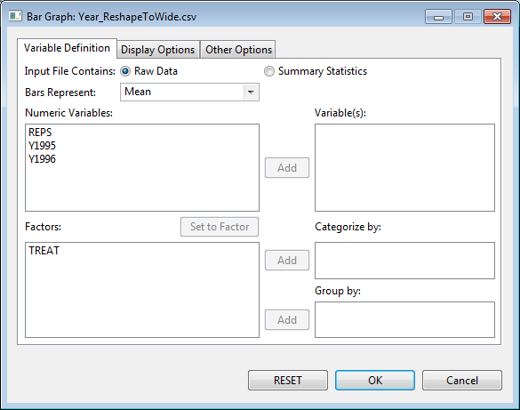

* Specify the inputs for the required fields and desired options.

**Variable Definition Tab**

**Input File Contains**

There are two options available, ***Raw Data***(default option) and ***Summary******Statistics***.

**Bars Represent**

This item is enabled if the **Input File Contains *Raw******Data***option is selected. Four options are available for creating the bars: ***Frequency****,* ***Mean****,* ***Median****,* and***Sum****.*

**Variable(s)**

At least one entry should be specified for the graph to be created. Entries should come from the **Numeric Variables** dialog box.

**Categorize by**

This field is required. The factor specified will define the labels for the bars and, if input file contains raw data, the categories for which values are computed.

**Group by**

This field is optional. If a factor is specified, a bar graph is going to be generated per category of the factor. Entries should come from the **Factors** list box.

**Display Options** **Tab**

**Main Title**

This field will contain the title for the graph.

**Category Axis Label**

This field will contain the label for the factor. If two or more numeric variables are specified in the graph, checking the **Display variable names** box will add the names of the numeric variables onto the category axis.

**Value Axis**

The ***Label*** field will contain the label for the numeric variable(s). The ***Range***will contain the suggested minimum (***Lower******Limit***) and maximum (***Upper******Limit***) values for the axis. If not specified (*Auto*), these are determined from the data.

**Draw box around plot**

If checked, the graph will be enclosed in a box.

**Show legend**

If checked, a legend will be added to the graph. The legend may be placed in any of nine positions within the graph: *bottom, bottom-left, bottom-right, center, left, right, top, top-left, top-right*. The legend may or may not have a title.

This option is useful if there are two or more numeric variables used in the graph and the **Display variable names** is unchecked.

**Display multiple graphs in a page**

If checked, several graphs will be displayed on a single page, based on the specified number of rows and columns and orientation. At most 5 rows and 5 columns of graphs can be fitted into a single page, arranged either from *Top-to-bottom* or *Left-to-right*.

**Other Options** **Tab**

**Orientation**

Bars can either be drawn vertically or horizontally.

**Style**

This option is useful if several numeric variables are selected. Bars can be clustered (side-by-side) or stacked.

**Color and Fill**

Different colors (solid fill pattern) have been pre-selected to distinguish bars for different numeric variables. The default settings may be changed in this section/

**Display Error Bars**

If the bars represent means to be computed from raw data, error bars may be added based on one of three options: **confidence level** (default: 95%), **standard error** (with multiplier 1, 2, or 3), and **standard deviation** (with multiplier 1, 2, or 3).

For the example, suppose we want to create a bar graph of the means of *Y1995* and *Y1996* with error bars, the completed **Variable Definition** tab should appear as illustrated:

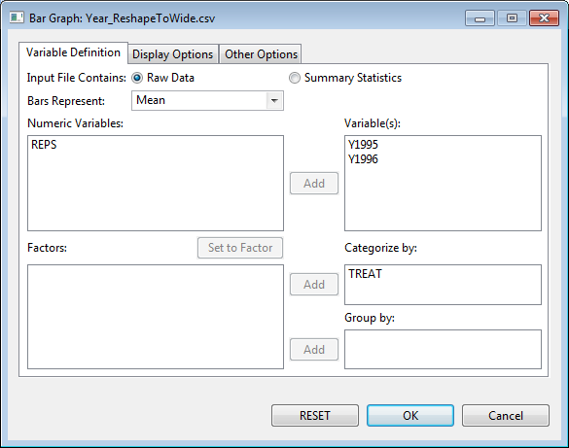

Items in the **Display Options** tab may be supplied as illustrated:

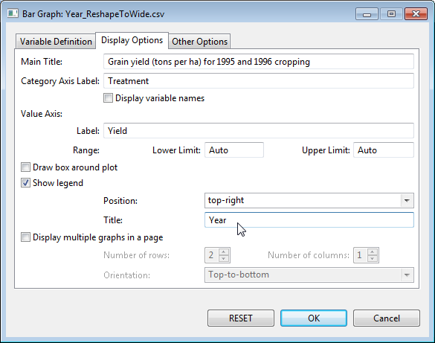

Items in the **Other Options** tab may be supplied as illustrated:

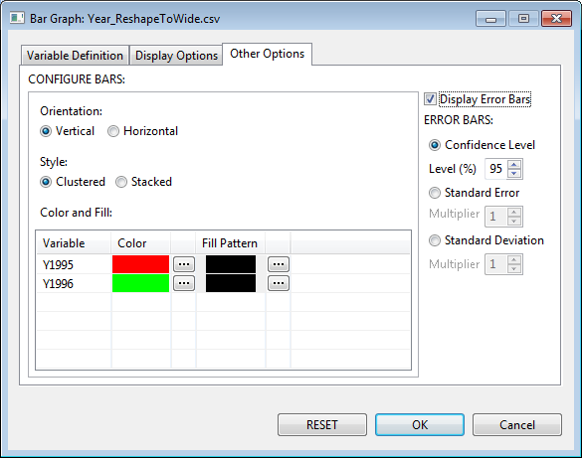

* Click the **OK** button to create the graph. The **Bar Graph** dialog box will be minimized and the Result Viewer will be activated.

Sample graph as displayed in the *Graph* page of the Result Viewer:

**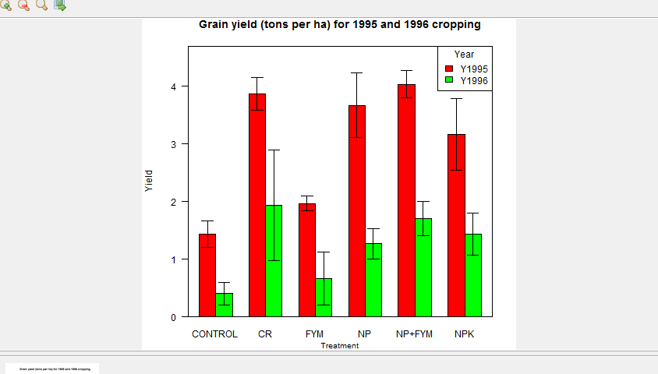**

## Box Plot

Box plots are useful for displaying distributional properties of data.

The steps to create a box plot are listed below:

* On the **Project Explorer**, using the project named *My Project*,import the data *Gerua* from STAR Package. Double-click the file to open and view it in the Data Viewer tab.
* Click **Graphs | Box Plot…**. The **Box Plot** (or Box-and-Whiskers Plot) dialog box will appear.

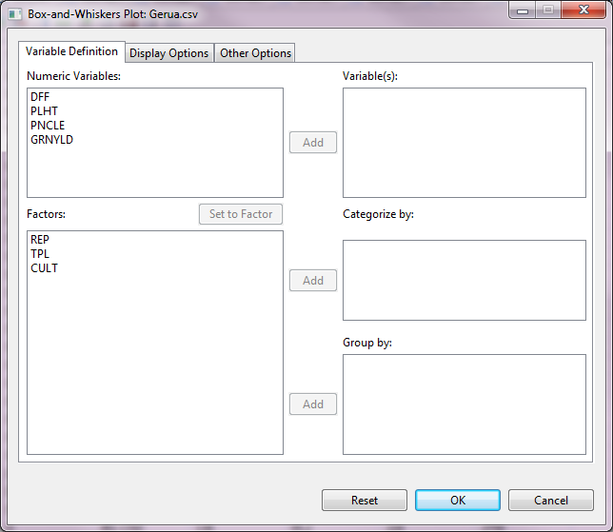

* Specify the inputs for the required fields and desired options.

**Variable Definition Tab**

**Variable(s)**

At least one entry should be specified for the graph to be created. Entries should come from the **Numeric Variables** dialog box.

**Categorize by**

This field, if specified, will define the labels and sub-grouping for the box plots.

**Group by**

This field is optional. If a factor is specified, a graph is going to be generated per category of the factor. Entries should come from the **Factors** list box.

**Display Options** **Tab**

**Main Title**

This field will contain the title for the graph.

**Category Axis Label**

This field will contain the label for the factor.

**Value Axis**

The label and limits for the numeric variable(s) can be edited here. Default axis label is the name of the numeric variable(s). Lower and upper limits, if not specified, are determined from the data.

**Orientation**

Plots can be displayed vertically (default) or horizontally.

**Draw box around plot**

If checked, the graph will be enclosed in a box.

**Display multiple graphs in a page**

If checked, several graphs will be displayed on a single page, based on the specified number of rows and columns and orientation. At most 5 rows and 5 columns of graphs can be fitted into a single page, arranged either from *Top-to-bottom* or *Left-to-right*.

**Other Options** **Tab**

**BOX**

Color for the box outline and fill, as well as the size of the line used for the box may be edited here.

**WHISKERS**

Color, type and width for the line representing the whiskers may be edited here.

**MEDIAN**

Color, type and width for the line representing the median may be edited here.

**OUTLIERS**

Color, symbol and size for the representing the outliers may be edited here.

For the example, suppose we want to create box plots for the plant height (*PLHT*) and grain yield (*GRNYLD*) variables. The completed **Variable Definition** tab should appear as illustrated:

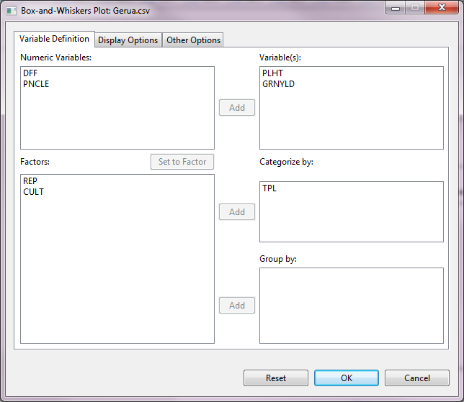

Items in the **Display Options** tab may be supplied as illustrated:

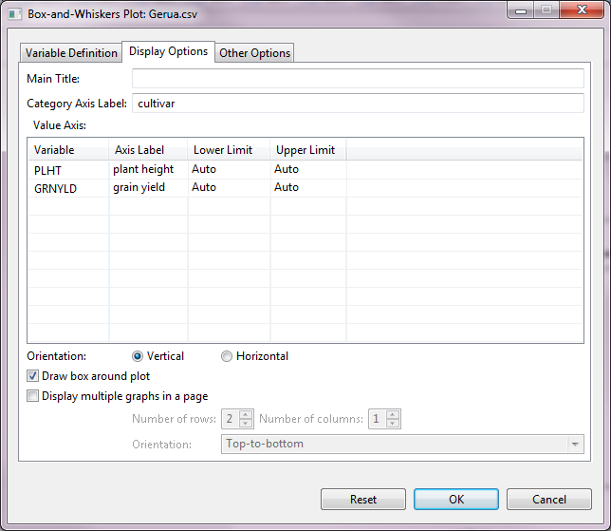

Items in the **Other Options** tab may be supplied as illustrated:

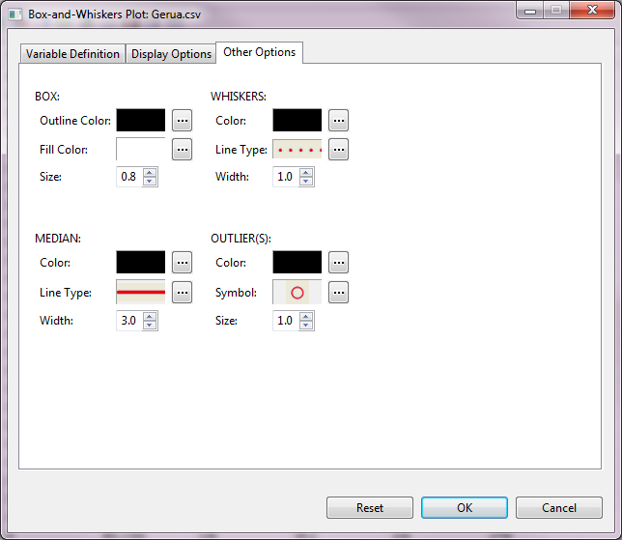

* Click the **OK** button to create the graph. The **Box Plot** dialog box will be minimized and the Result Viewer will be activated.

Sample graph as displayed in the *Graph* page of the Result Viewer:

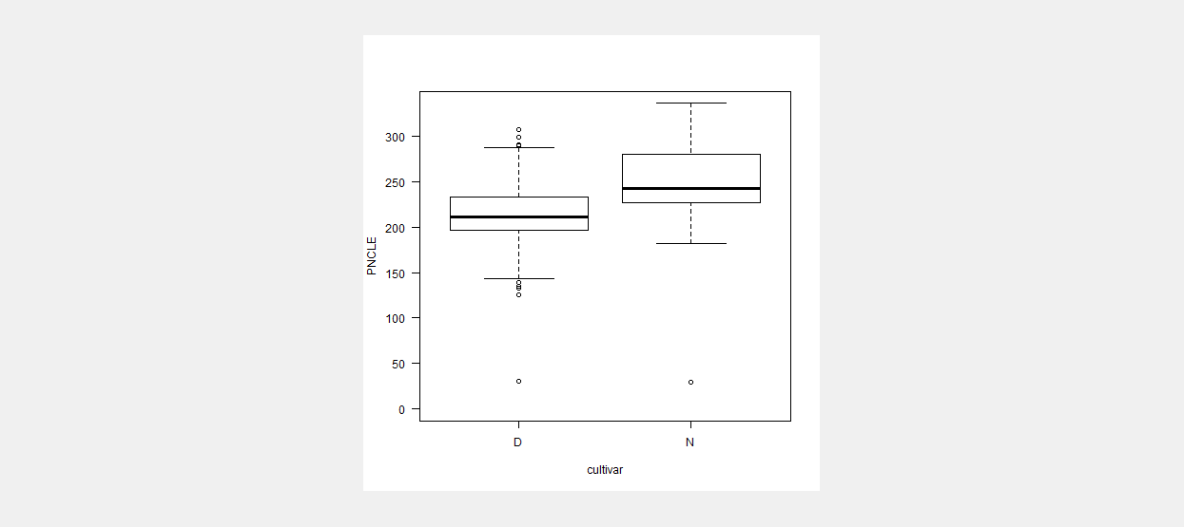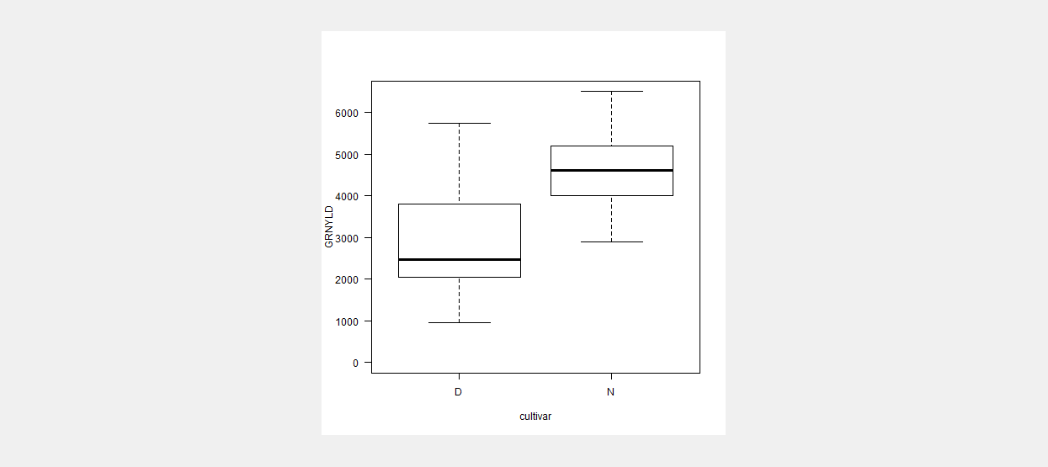

## Histogram

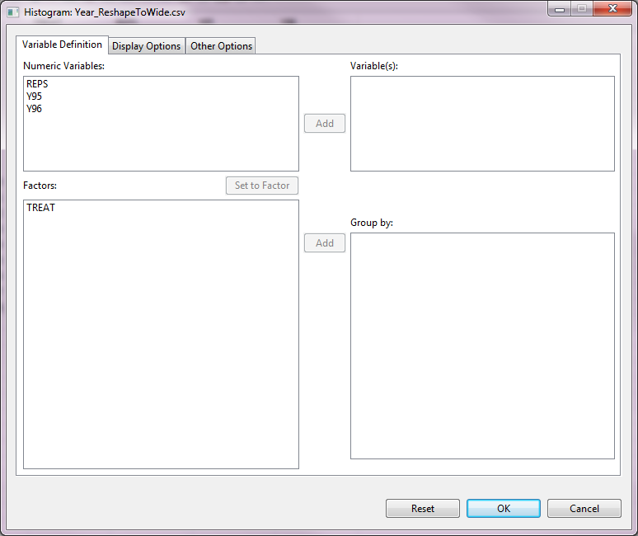

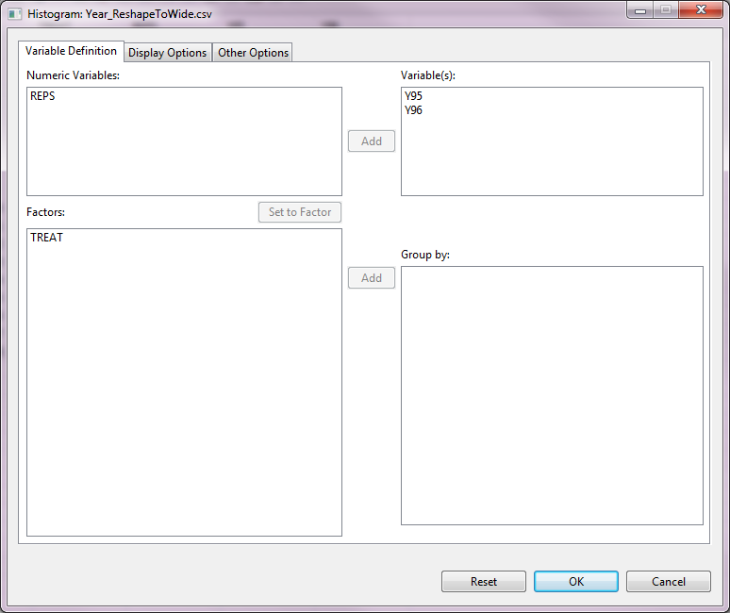

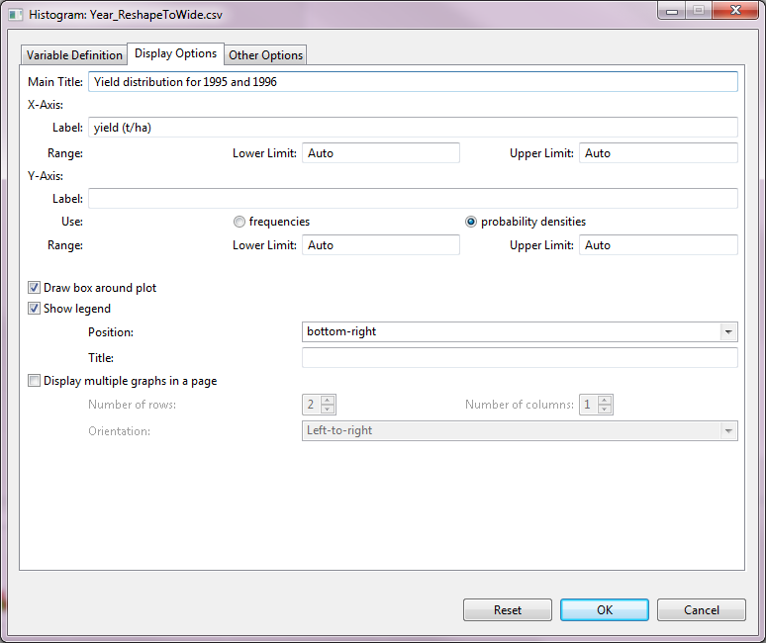

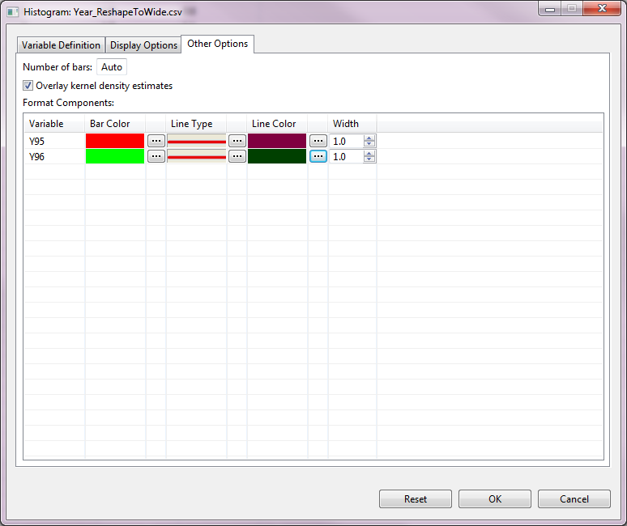

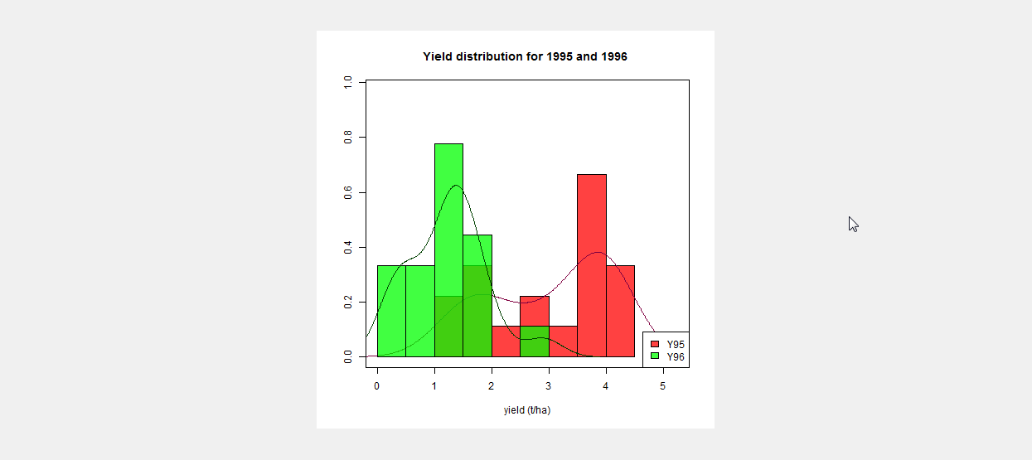

## Line Graph

Line graphs are useful for displaying trends using either raw data or statistics.

The steps to create a line graph are listed below:

* On the **Project Explorer**, using the project named *My Project*,import the data *soil\_redox* from STAR Package. Double-click the file to open and view it in the Data Viewer tab.

The file contains the data of number of days after seeding (DAS) and soil redox potential (EH). Based on this data, a line graph can be created to examine the behavior of soil redox potential assess over time (days) after seeding, on the average.

* Click **Graphs | Line Graph…**. The **Line Graph** dialog box will appear.

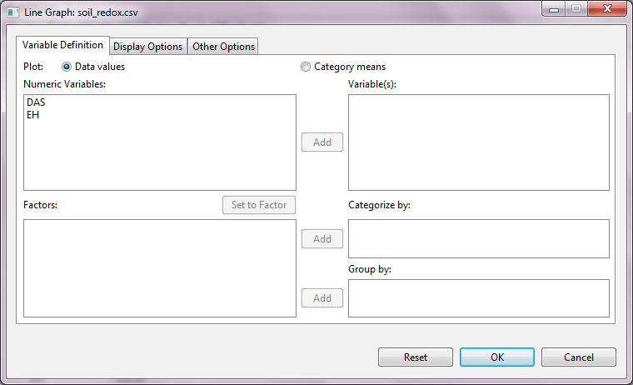

* Specify the inputs for the required fields and desired options.

**Variable Definition Tab**

**Plot**

There are two options available, ***Data******values***(default option) and ***Category means***. If the default option is used, the values from the raw data are plotted directly.

**Variable(s)**

At least one entry should be specified for the graph to be created. Entries should come from the **Numeric Variables** dialog box.

**Categorize by**

If specified, will determine the categories for which means are computed, if category means are to be plotted. If data values are to be plotted, this will just define the grids in the category axis. If not specified, only data values are plotted.

**Group by**

This field is optional. If a factor is specified, a line graph is going to be generated per category of the factor. Entries should come from the **Factors** list box.

**Display Options** **Tab**

**Main Title**

This field will contain the title for the graph.

**Horizontal Axis Label**

This field will contain the label for the factor.

**Vertical Axis**

The ***Label*** field will contain the label for the numeric variable(s). The ***Range***will contain the suggested minimum (***Lower******Limit***) and maximum (***Upper******Limit***) values for the axis. If not specified (*Auto*), these are determined from the data.

**Draw box around plot**

If checked, the graph will be enclosed in a box.

**Display line labels**

If checked, the name(s) of the numeric variable(s) are displayed on the right side of the corresponding line(s).

This option is useful if there are two or more numeric variables used in the graph and the **Display variable names** is unchecked.

**Show legend**

If checked, a legend will be added to the graph. The legend may be placed in any of nine positions within the graph: *bottom, bottom-left, bottom-right, center, left, right, top, top-left, top-right*. The legend may or may not have a title.

This option is useful if there are two or more numeric variables used in the graph and the **Display variable names** is unchecked.

**Display multiple graphs in a page**

If checked, several graphs will be displayed on a single page, based on the specified number of rows and columns and orientation. At most 5 rows and 5 columns of graphs can be fitted into a single page, arranged either from *Top-to-bottom* or *Left-to-right*.

**Other Options** **Tab**

**Format Components (lines and points)**

Formats of lines and points (if any) can be edited here. Under *Type*, available options are *lines only*, *overplot* (overlapping lines and points), or *both* (non-overlapping lines and points)*.* Default color, width and type for lines, as well as symbol and size for points can be changed.

**Display Error Bars**

If category means are plotted, error bars may be added based on one of two options: **confidence level** (default: 95%) and **standard error** (with multiplier 1, 2, or 3).

For the example, the **Variable Definition** tab should appear as illustrated:

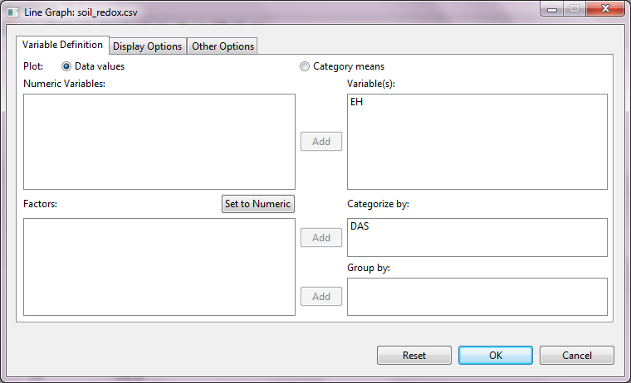

Items in the **Display Options** tab may be supplied as illustrated:

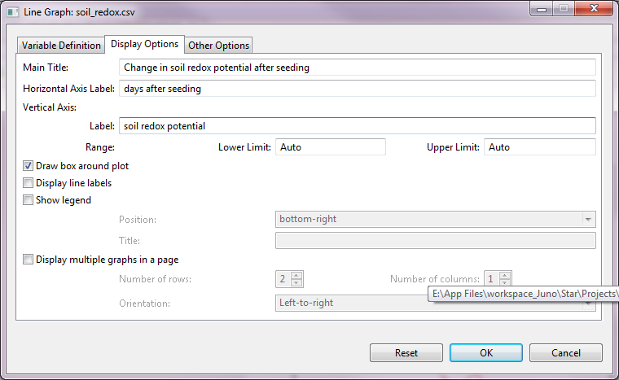

Components in the **Other Options** tab may be edited:

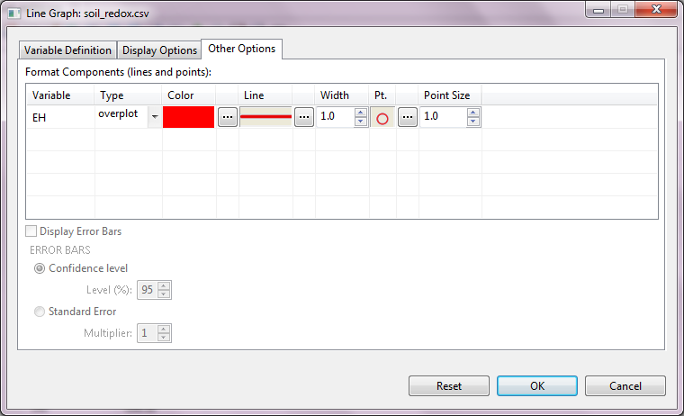

Sample graph as displayed in the *Graph* page of the Result Viewer:

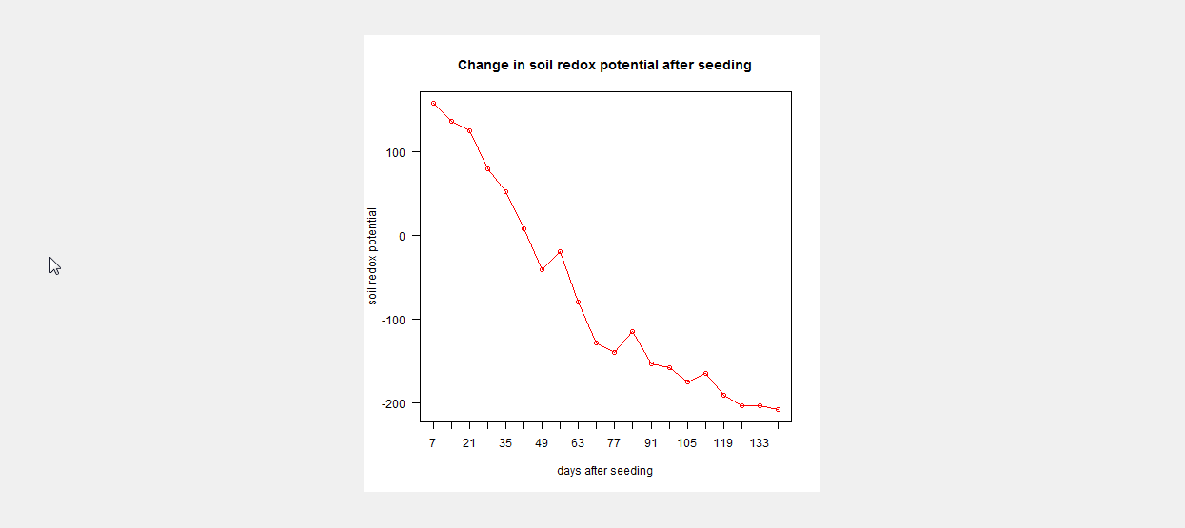

## Pie Chart

Pie charts are useful for presenting how a data set is divided into different sections or groups. In STAR, pie charts can be created from raw data or summaries (containing frequencies).

The steps to create a pie chart are listed below:

* On the **Project Explorer**, using the project named *My Project*,import the data *GomezMaizeCross* from STAR Package. Double-click the file to open and view it in the Data Viewer tab.
* Click **Graphs | Pie Chart…**. The **Pie Chart** dialog box will appear.

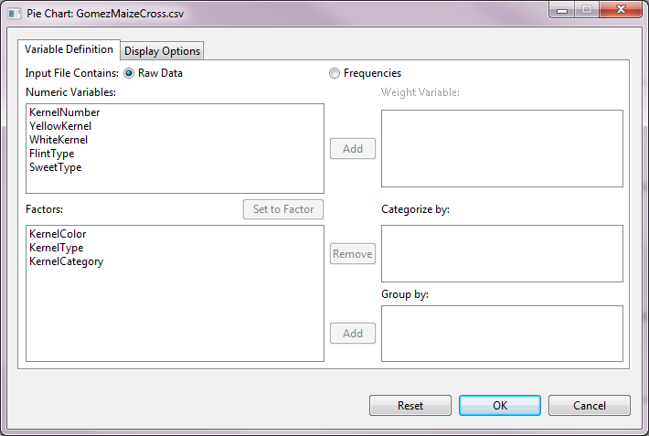

* Specify the inputs for the required fields and desired options.

**Variable Definition Tab**

**Input file contains**

There are two options available, ***Raw Data***(default option) and ***Frequencies***. If the default option is used, the percentages (or frequencies) are determined for the category variable, otherwise, values from the frequencies are plotted directly.

**Weight Variable**

This item is enabled if ***Input file contains Frequencies***is selected. This will contain the frequencies variable.

**Categorize by**

This will determine the sections for partitioning the pie. This field is required.

**Group by**

This field is optional. If a factor is specified, a pie chart is going to be generated per category of the factor. Entries should come from the **Factors** list box.

**Display Options** **Tab**

**Main Title**

This field will contain the title for the graph.

**Format slices**

In this section, changes to the formats of the slices may be made.

Under ***Labels***, available options are: none, counts, percentages, levels, both counts and levels and both levels and percentages.

**Draw box around plot**

If checked, the graph will be enclosed in a box.

**Show legend**

If checked, a legend will be added to the graph. The legend may be placed in any of nine positions within the graph: *bottom, bottom-left, bottom-right, center, left, right, top, top-left, top-right*. The legend may or may not have a title.

**Display multiple graphs in a page**

If checked, several graphs will be displayed on a single page, based on the specified number of rows and columns and orientation. At most 5 rows and 5 columns of graphs can be fitted into a single page, arranged either from *Top-to-bottom* or *Left-to-right*.

For the example, the **Variable Definition** tab should appear as illustrated:

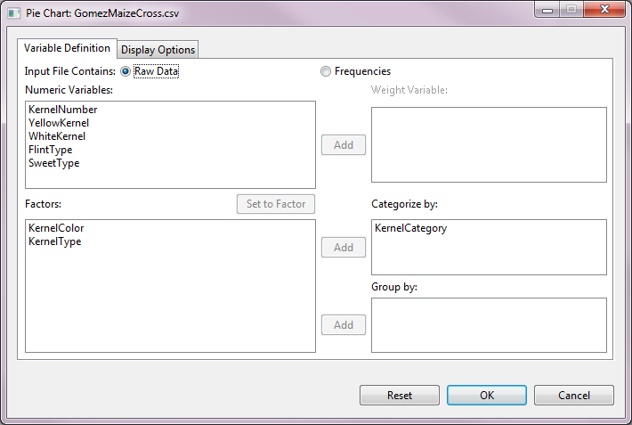

The **Display Options** Tabmay be edited:

**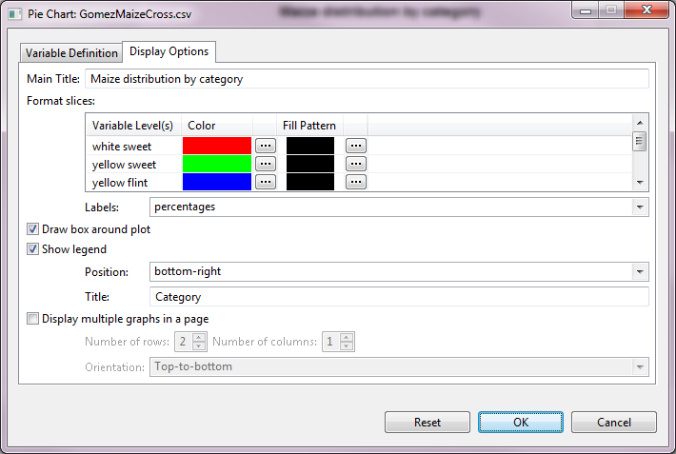**

Sample graph as displayed in the *Graph* page of the Result Viewer:

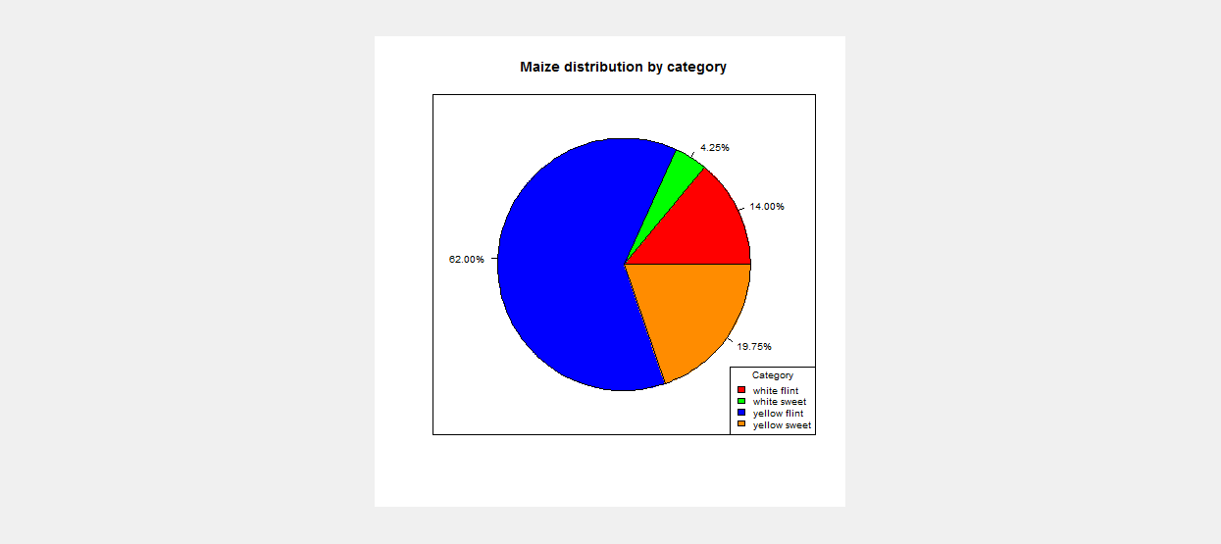

## Scatter Plot

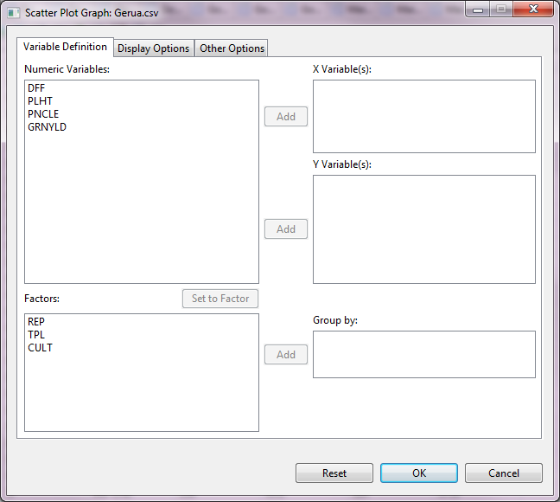

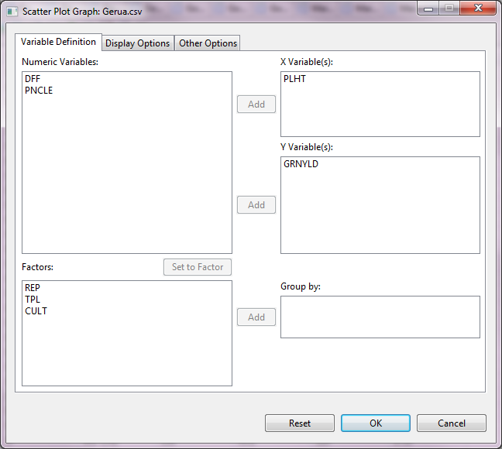

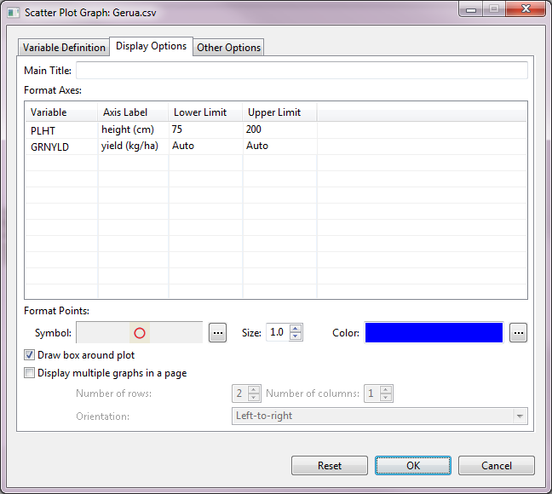

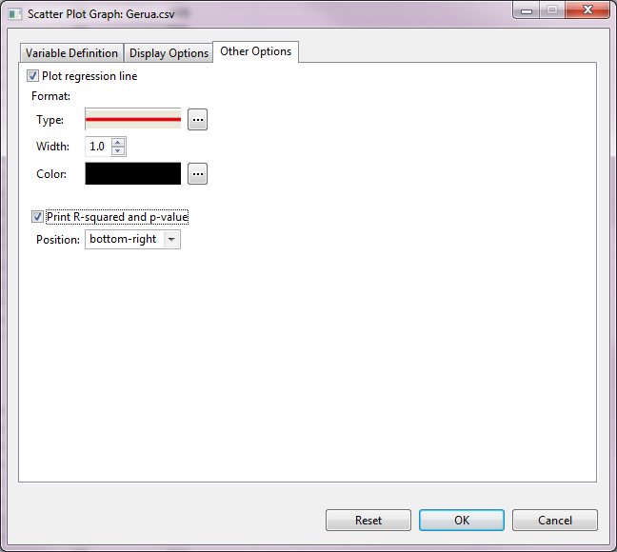

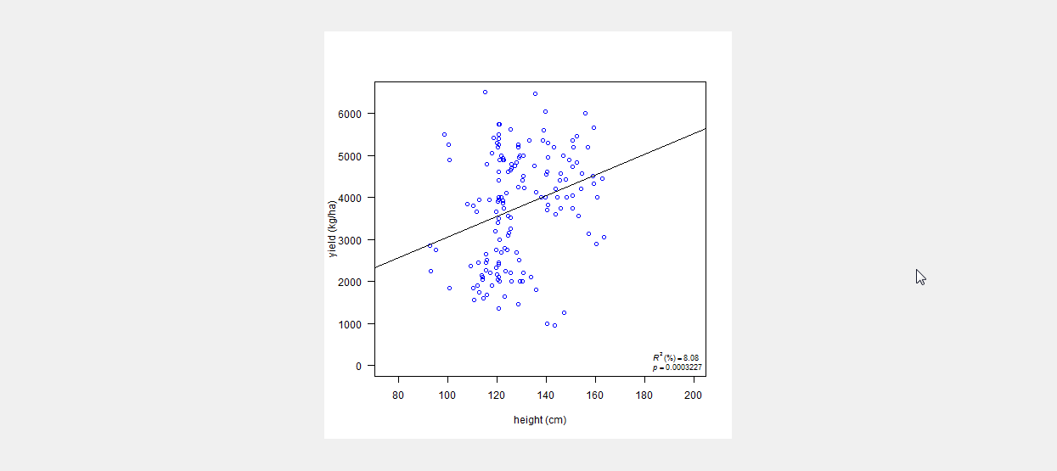

# Descriptive Statistics

The **Descriptive** procedureperforms univariate summary statistics for several variables and/or per levels of grouping variable(s).

The steps to obtain numerical descriptive measures are listed below:

* On the **Project Explorer** panel, double-click the file to be used for the analysis to open it and view it in the Data Viewer tab.

For the example, using the project named *My Project*, import the data *MasterData.csv* from the *Data* folder of the project named *SampleProject*. To import data from the *SampleProject*, see *Importing Data from Other Project* sectionof this user manual.

Opening the data for the first time, *REP* field is regarded by STAR as numerical variable. To change its type, choose the variable *REP* and click on the **Set to Factor** button.

* Click **Analyze | Descriptive Statistics | Descriptive…**. The **Descriptive Statistics** dialog box will appear.

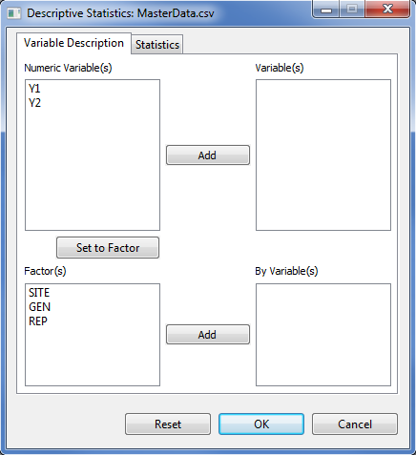

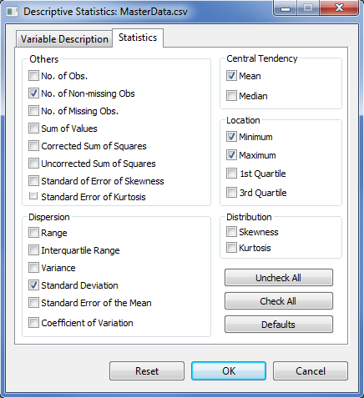

* Specify the required field and appropriate options for the analysis.

**Variable Description** **Tab**

This tab lets the user identify the variables and grouping variable(s) where descriptive statistics will be computed.

**Variable(s)**

At least one entry is needed for the analysis to proceed. Entries should come from the **Numeric Variable(s)** list box.

**By Variable(s)**

This field is optional. If a **By Variable(s)** is specified, it will generate descriptive statistic per category of the **By Variable**. Entries should come from the **Factor(s)** list box.

**Statistics Tab**

This tab lets the user identify the numerical descriptive measures to be displayed. By default, the procedure will display five statistics, namely: number of non-missing observations (NNMissObs), minimum (min), maximum (max), mean, and standard deviation (stdDev). To request for all statistics, click the **Check All** button of the **Statistics** tab. User may click on the **Uncheck All** button to remove previously selected items and start with a new selection.At least one statistics should be check to the analysis to proceed.

For the example, suppose we want to compute the descriptive statistics of variables *Y1* and *Y2*. The completed **Variable Description** tab and **Statistics** tab should appear as illustrated:

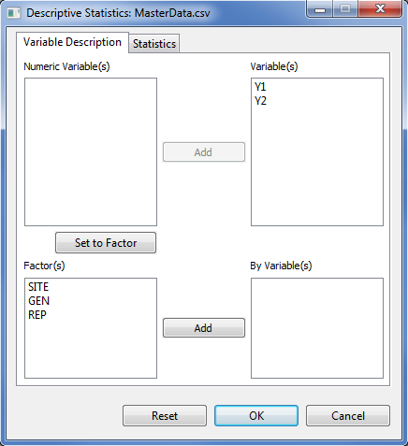



* Click the **OK** button to generate the summary statistics. The **Descriptive Statistics** dialog box will be minimize and STAR activates the **Output** page of the **Result Viewer** tab. Sample output of the descriptive statistics is shown below:

Descriptive Statistics

------------------------------------------------------

Variable N\_NonMissObs Min Max Mean StdDev

------------------------------------------------------

Y1 96 14.00 151.00 130.43 16.05

Y2 96 92.60 163.50 124.50 15.05

------------------------------------------------------

Suppose we want to compute the descriptive statistics for variables *Y1* and *Y2* per level of *GEN*. The completed **Variable Description** tab should appear as illustrated:

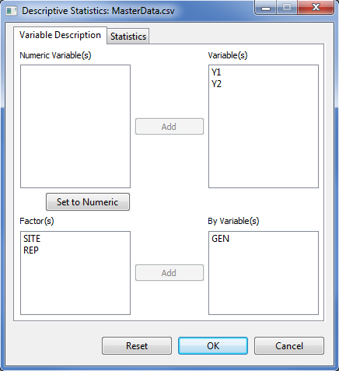

* Click the **OK** button to generate the summary statistics. Sample output of the descriptive statistics is shown below:

Descriptive Statistics

-------------------------------------------------------------

Variable GEN N\_NonMissObs Min Max Mean StdDev

-------------------------------------------------------------

Y1 Gen1 12 113.00 144.00 132.33 10.50

Y1 Gen2 12 106.00 150.00 134.17 11.07

Y1 Gen3 12 116.00 148.00 132.42 9.46

Y1 Gen4 12 14.00 151.00 122.92 36.36

Y1 Gen5 12 106.00 145.00 129.42 11.84

Y1 Gen6 12 121.00 143.00 133.25 6.84

Y1 Gen7 12 109.00 149.00 130.00 12.05

Y1 Gen8 12 106.00 144.00 128.92 12.26

Y2 Gen1 12 92.60 163.50 128.87 20.06

Y2 Gen2 12 95.20 149.30 119.24 14.21

Y2 Gen3 12 93.10 148.40 120.09 15.03

Y2 Gen4 12 100.50 150.70 124.54 16.45

Y2 Gen5 12 98.60 160.70 125.22 16.83

Y2 Gen6 12 110.20 130.60 119.24 5.54

Y2 Gen7 12 117.90 159.30 130.05 13.78

Y2 Gen8 12 111.70 150.90 128.72 13.98

-------------------------------------------------------------

# Cross Tabulation

The cross tabulation forms two-way tables. By default, the observed frequency is displayed.

The steps to perform Cross Tabulation are listed below:

* On the **Project Explorer** panel, double-click the file to be used for analysis to open it and view it in the Data Viewer tab.

For the example, using the project named *My Project*, import the data *GomezMaizeCross.csv* from the package. To import data from the package, see *Importing Data from Package* sectionof this user manual.

* To generate cross table, from the main window click **Analyze | Descriptive Statistics | Cross Tabulation…**. The **Cross Tabulation** dialog box will appear.

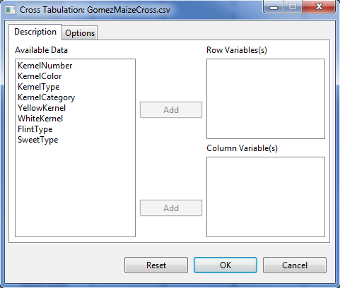

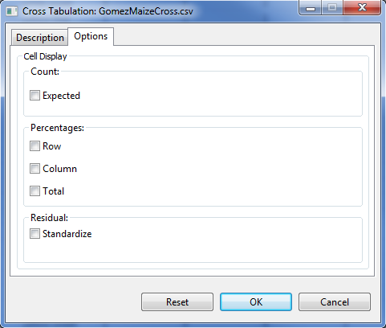

* Specify the required field and the appropriate options for the analysis.

**Description** **Tab**

This tab lets the user identify the variables where cross tabulation will be performed.

**Row Variable(s)**

At least one entry is need for the analysis to proceed.

**Column Variable(s)**

At least one entry is need for the analysis to proceed.

**Options Tab**

This tab lets the user identify the additional output that will be displayed.

**Expected Count**

If this option is selected, the expected frequency will be displayed.

**Row Percentages**

If this option is selected, the row percentage will be displayed.

**Column Percentages**

If this option is selected, the column percentage will be displayed.

**Total Percentages**

If this option is selected, the total percentage will be displayed.

**Standardize Residual**

If this option is selected, the standardize residual will be displayed.

For the example, the completed **Variable Description** tab and **Options** tab should appear as illustrated below:

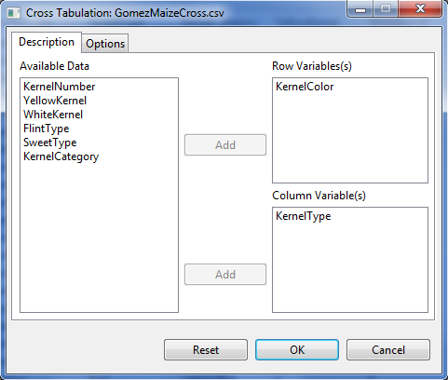

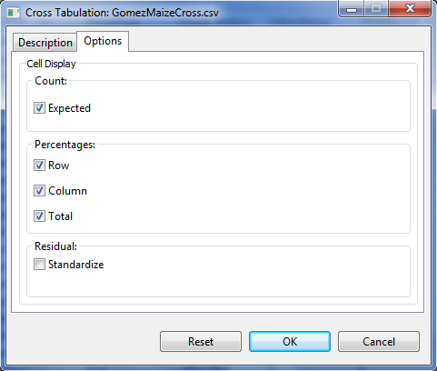

* Click the **OK** button. The **Cross Tabulation** dialog box will be minimized and STAR actives the **Output** page of the **Result Viewer** tab. Sample output of the analysis is shown below:

CROSS TABULATION

Table of KernelColor by KernelType

|KernelType

-----------------------------------+-----------+-----------+-----------+

KernelColor |flint |sweet |Total |

-----------------------------------+-----------+-----------+-----------+

white |Obs Freq | 112| 34| 146|

|Expected Freq | 110.9600| 35.0400| 146.0000|

|% within KernelColor | 76.7123| 23.2877| 100.0000|

|% within KernelType | 18.4211| 17.7083| |

|% of Total | 14.0000| 4.2500| 18.2500|

-----------------------------------+-----------+-----------+-----------+

yellow |Obs Freq | 496| 158| 654|

|Expected Freq | 497.0400| 156.9600| 654.0000|

|% within KernelColor | 75.8410| 24.1590| 100.0000|

|% within KernelType | 81.5789| 82.2917| |

|% of Total | 62.0000| 19.7500| 81.7500|

-----------------------------------+-----------+-----------+-----------+

Total |Obs Freq | 608| 192| 800|

|Expected Freq | 608.0000| 192.0000| 800.0000|

|% within KernelType | 100.0000| 100.0000| |

|% of Total | 76.0000| 24.0000| 100.0000|

-----------------------------------+-----------+-----------+-----------+

# Normality Test

The Test for Normality menu display normality test for at least one numeric variable. There are five procedures available in this menu, namely: Shapiro-Wilk, Shapiro-Francia, Lilliefors (Kolmogorov-Smirnov), Cramer-Von Mises and the Anderson-Darling test for normality.

The Shapiro-Wilk test for normality can be used if the number of non-missing observations is between 3 and 5000. While the Shapiro-Francia test for normality can be used if the number of non-missing observations is between 5 and 5000. The Lilliefors test for normality can be used if the number of non-missing observations is greater than 4. The Cramer-Von Mises and the Anderson-Darling test for normality can both be used if the number of non-missing observations is greater than 7.

The steps to perform Normality Test are listed below:

* On the **Project Explorer** panel, double-click the file to be used for the analysis to open it and view it in the Data Viewer tab.

For the example, using the project named *My Project*, import the data *MasterData.csv* from the *Data* folder of the project named *SampleProject*. To import data from the *SampleProject*, see *Importing Data from Other Project* sectionof this user manual.

Opening the data for the first time, *REP* field is regarded by STAR as numerical variable. To change its type, choose the variable *REP* and click on the **Set to Factor** button.

* Click **Analyze | Descriptive Statistics | Normality Test…**. The **Normality Test** dialog box will appear.

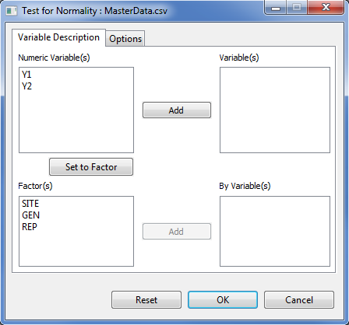

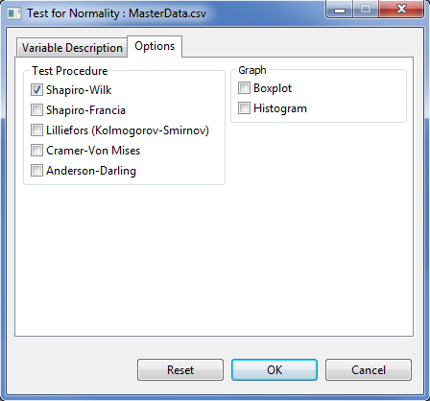

* Specify the required field and appropriate options for the analysis.

**Variable Description Tab**

This tab lets the user identify the variables and grouping variable(s) where test for normality will be performed.

**Variables**

At least one entry should be specified for the analysis to proceed. Entries for this list box should come from the **Numeric Variable(s)** list box.

**By Variables**

This field is optional. If a by variable(s) is specified, it will perform test for normality per level of the **By Variable(s)**. Entries for this list box should come from the **Factor(s)** list box.

**Options Tab**

**Test Procedure**

This option is required. At least one test procedure should be selected for the analysis to proceed. By default, the Shapiro-Wilk test is selected.

**Graph**

The user has the option to display the box plot and the histogram.

For the example, suppose we want to perform normality test using Shapiro-Wilk test for variables *Y1* and *Y2* per level of *GEN*. The completed **Variable Description** tab and **Option** tab should appear as:

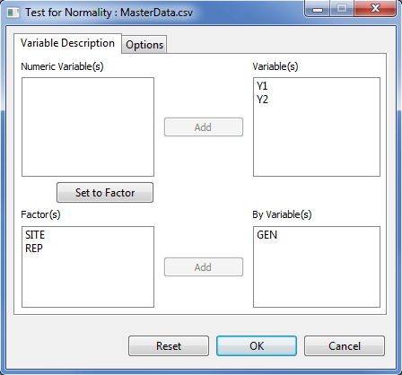



* Click the **OK** button to perform the test. The **Normality Test** dialog box will be minimized and STAR activates the **Output** page of the **Result Viewer** tab.

Sample text output displayed in the **Output** page.

Test for Normality

-------------------------------------------------------

Grp Level Variable Method Statistics Prob

-------------------------------------------------------

GEN Gen1 Y1 Shapiro-Wilk 0.8914 0.1228

GEN Gen2 Y1 Shapiro-Wilk 0.8947 0.1353

GEN Gen3 Y1 Shapiro-Wilk 0.9560 0.7259

GEN Gen4 Y1 Shapiro-Wilk 0.6460 0.0003

GEN Gen5 Y1 Shapiro-Wilk 0.9268 0.3474

GEN Gen6 Y1 Shapiro-Wilk 0.9645 0.8454

GEN Gen7 Y1 Shapiro-Wilk 0.9618 0.8097

GEN Gen8 Y1 Shapiro-Wilk 0.9020 0.1681

GEN Gen1 Y2 Shapiro-Wilk 0.9700 0.9107

GEN Gen2 Y2 Shapiro-Wilk 0.9341 0.4251

GEN Gen3 Y2 Shapiro-Wilk 0.9811 0.9876

GEN Gen4 Y2 Shapiro-Wilk 0.9200 0.2860

GEN Gen5 Y2 Shapiro-Wilk 0.9314 0.3956

GEN Gen6 Y2 Shapiro-Wilk 0.9450 0.5658

GEN Gen7 Y2 Shapiro-Wilk 0.8047 0.0106

GEN Gen8 Y2 Shapiro-Wilk 0.8613 0.0508

-------------------------------------------------------

Sample graphical output displayed in the **Graph** page.

|  |  |
| --- | --- |
| E:\Applications\STAR\Projects\My Project\Output\NormalityStatistic_1361383487648\Boxplot__Y1.png | E:\Applications\STAR\Projects\My Project\Output\NormalityStatistic_1361383487648\Boxplot__Y2.png |
| E:\Applications\STAR\Projects\My Project\Output\NormalityStatistic_1361383487648\Histogram__Y1.png | E:\Applications\STAR\Projects\My Project\Output\NormalityStatistic_1361383487648\Histogram__Y2.png |

# Homogeneity of Variance

The Homogeneity of Variances menu perform test for equally of variances across groups. There are two procedures available in this menu, namely: Bartlett’s test and the Levene’s test.

The steps to perform the test are listed below:

* On the **Project Explorer** panel, double-click the file to be used for the analysis to open it and view it in the Data Viewer tab.

For the example, using the project named *My Project*, import the data *MasterData.csv* from the *Data* folder of the project named *SampleProject*. To import data from the *SampleProject*, see *Importing Data from Other Project* sectionof this user manual.

Opening the data for the first time, *REP* field is regarded by STAR as numerical variable. To change its type, choose the variable *REP* and click on the **Set to Factor** button.

* Click **Analyze | Descriptive Statistics | Homogeneity of Variance…**. The **Homogeneity of Variance** dialog box will appear.

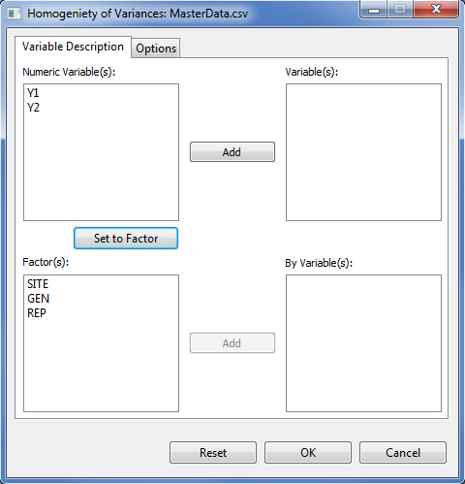

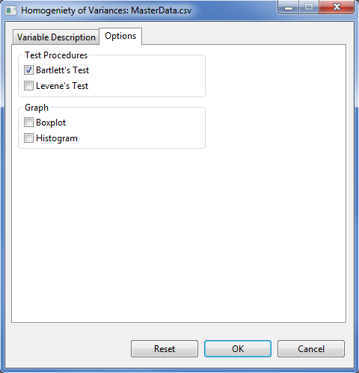

* Specify the required field and appropriate options for the analysis.

**Variable Description Tab**

This tab lets the user identify the variables and grouping variable(s) where test for homogeneity of variances will be performed.

**Variables**

At least one entry should be specified for the analysis to proceed. Entries must come from the **Numeric Variable(s)** list box.

**By Variables**

At least one entry should be specified for the analysis to proceed. Entries specified here should contain two or more levels and must come from the **Factor(s)** list box.

**Options Tab**

**Test Procedure**

At least one test procedure should be selected for the analysis to proceed. By default, the Bartlett’s test for homogeneity of variances is selected.

**Graph**

The user has the option to display the box plot and the histogram.

For the example, suppose we want to determine whether the variances are equal among the levels of *GEN* for variables *Y1* and *Y2*. For the *example*, the completed **Variable Description** tab and completed **Option** tab should appear as illustrated below:

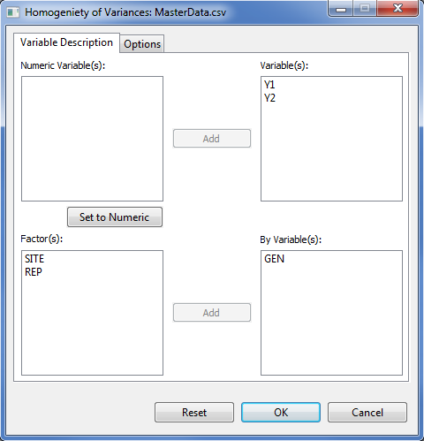

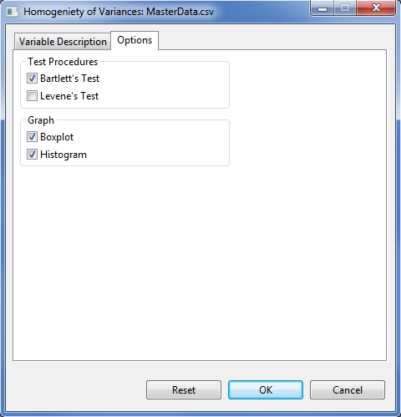

* Click the **OK** button to perform the test. The **Homogeneity of Variances** dialog box will be minimized and STAR activates the **Output** page of the **Result Viewer** tab.

Sample text output as displayed in the **Output** page:

Test for Homogeneity of Variances

------------------------------------------------

Grp Variable Method DF Statistics Prob

------------------------------------------------

GEN Y1 bartlett 7 49.91 0.0000

GEN Y2 bartlett 7 15.00 0.0359

------------------------------------------------

Sample graphicaloutput as displayed in the **Graph** page.

|  |  |
| --- | --- |
| E:\Applications\STAR\Projects\My Project\Output\NormalityStatistic_1361383487648\Boxplot__Y1.png | E:\Applications\STAR\Projects\My Project\Output\NormalityStatistic_1361383487648\Boxplot__Y2.png |
| E:\Applications\STAR\Projects\My Project\Output\NormalityStatistic_1361383487648\Histogram__Y1.png | E:\Applications\STAR\Projects\My Project\Output\NormalityStatistic_1361383487648\Histogram__Y2.png |

# Fitting Distributions

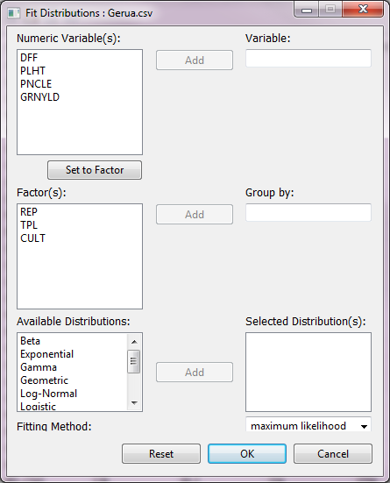

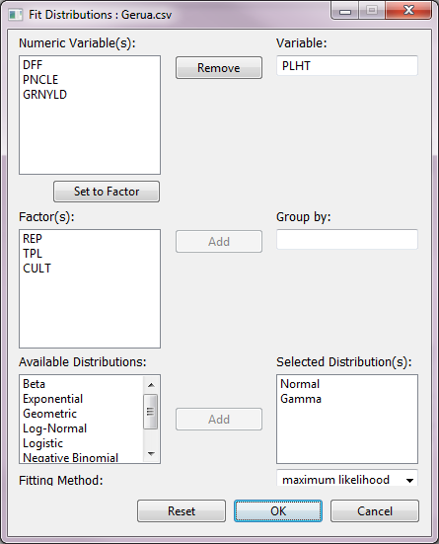

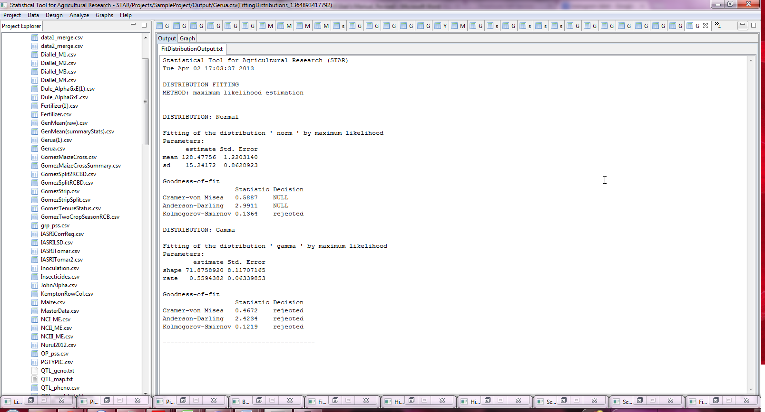

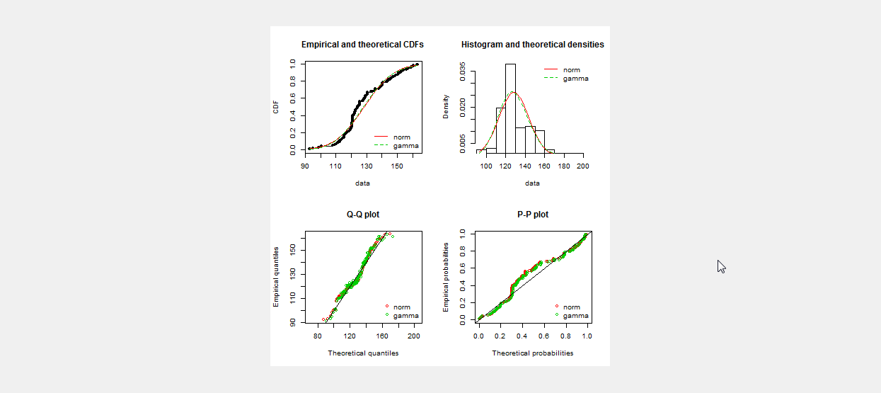

# t-Test

## One Sample *t*-test

The One Sample *t*-test procedure determine whether the mean of one variable differ from the hypothesized value. It assumes that the samples are randomly taken from the population of interest and that the observations are obtained from a normal distribution.

The steps to perform the one sample t-test are listed below:

* On the **Project Explorer** panel, double-click the file to be used for the analysis to open it and view it in the Data Viewer tab.

For the example, using the project named *My Project*, import the data *MasterData.csv* from the *Data* folder of the project named *SampleProject*. To import data from the *SampleProject*, see *Importing Data from Other Project* sectionof this user manual.

Opening the data for the first time, *REP* field is regarded by STAR as numerical variable. To change its type, choose the variable *REP* and click on the **Set to Factor** button.

* Click **Analyze | t-Test | One Sample…**. The **One Sample** dialog box will appear.

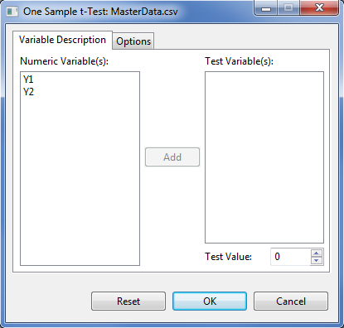

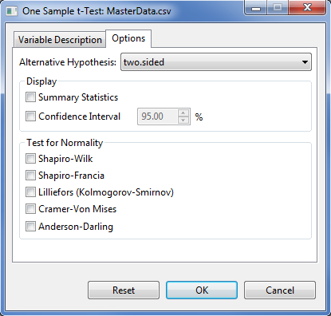

* Specify the required field and appropriate options for the analysis.

**Variable Description Tab**

**Test Variable(s)**

At least one entry should be specified for the analysis to proceed. Entries should come from the **Numeric Variable(s)** dialog box.

**Test Value**

This field is required and will only accept one entry at a time. The default value is 0. User can change the value by typing a value inside the spin box or by pressing the up-arrow key to increment the value, down-arrow key, otherwise.

**Options** **Tab**

**Alternative Hypothesis**

User can select a one-tailed or two-tailed test. The default alternative hypothesis used is that for the two-sided test.

**Summary Statistics**

If this option is selected, a summary table with number of observations, minimum, maximum, mean and standard deviation will be displayed.

**Confidence Interval**

If this option is selected, a confidence interval of the mean will be displayed. If this is selected, by default, a 95% confidence interval is displayed.

**Test for Normality**

If at least one option is selected, if display the test for normality test for each level of the **Grouping Variable**. There are five available tests for normality procedure.

For the example, suppose we want to determine whether the mean of *Y1* is significantly different from 125. The completed **Variable Description** tab and **Option** tab should appear as illustrated:

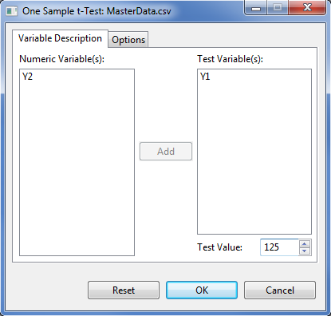

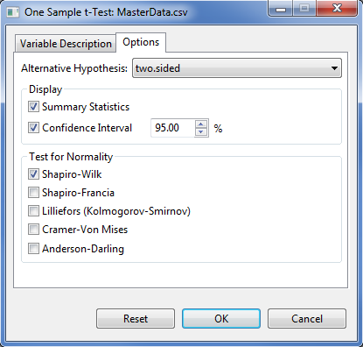

* Click the **OK** button to perform the test. The **One Sample t-Test** dialog box will be minimized and STAR activates the **Output** page of the **Result Viewer** tab.

Sample output as displayed in the **Output**page.

Test for Normality

-------------------------------------------

Variable Method Statistics Prob

-------------------------------------------

Y1 Shapiro-Wilk 0.6908 0.0000

-------------------------------------------

Descriptive Statistics

-------------------------------------------------------------

Variable N Lower CI\* Mean Upper CI\* StdDev SE\_Mean

-------------------------------------------------------------

Y1 96 127.18 130.43 133.68 16.05 1.64

-------------------------------------------------------------

\* At 95% Confidence Level.

One Sample t-Test, h0: mean = 125

---------------------------------

Variable DF t Value Pr > |t|

---------------------------------

Y1 95 3.31 0.0013

---------------------------------

## Paired Sample *t*-tests

The paired sample *t*-test is used to compares the means of paired or related samples. It assumes that the samples are randomly taken from the population of interest and the population of differences is normally distributed.

The steps to perform paired t-test are listed below:

* On the **Project Explorer** panel, double-click the file to be used for the analysis to open it and view it in the Data Viewer tab.

For the example, using the project named *My Project*, import the data *Sensors* from the package. To import data from thepackage, see *Importing Data from the Package* sectionof this user manual.

* Click **Analyze | t-Tests | Paired Samples…** from the main window. The **Paired Samples t-Test** dialog box will appear.

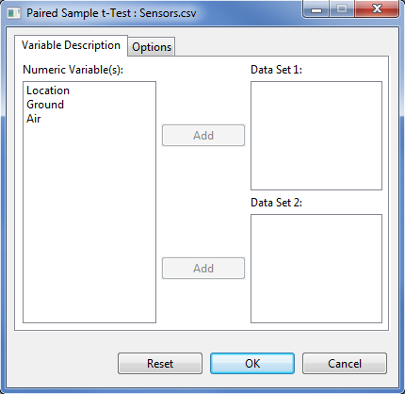

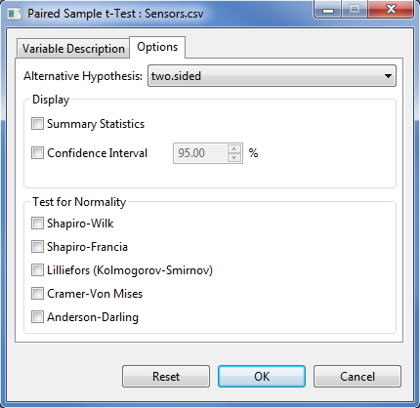

* Specify the required field and appropriate options for the analysis.

**Variable Description Tab**

**Data Set 1**

This field needs at least one entry for the analysis to proceed and must have the same number of entry as **Data Set 2**.

**Data Set 2**

This field needs at least one entry for the analysis to proceed and must have the same number of entry as **Data Set 1**.

**Options** **Tab**

**Alternative Hypothesis**

User can select a one-tailed or two-tailed test. The default alternative hypothesis used is that for the two-sided test.

**Summary Statistics**

If this option is selected, a summary table with number of observations, minimum, maximum, mean and standard deviation will be displayed.

**Confidence Interval**

If this option is selected, a confidence interval of the mean will be displayed. If this is selected, by default, a 95% confidence interval is displayed.

**Test for Normality**

If at least one option is selected, if display the test for normality test for the difference between each pair of variables. There are five available tests for normality procedure.

For the example, the completed **Variable Description** tab and **Options** tab should appear as illustrated below:

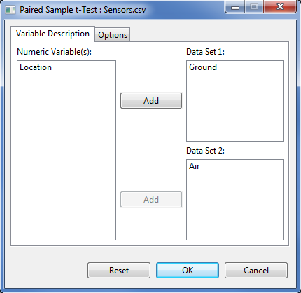

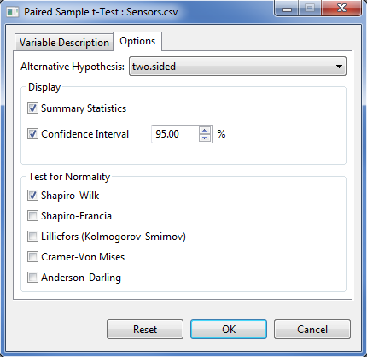

* Click the **OK** button to perform the analysis. The **Paired Sample t-Test** dialog box will be minimized and STAR activates the **Output** page of the **Result Viewer** tab.

Sample output of the analysis as shown in the Output page is displayed below:

Test for Normality

-----------------------------------------------

Difference Method Statistics Prob

-----------------------------------------------

Ground - Air Shapiro-Wilk 0.9403 0.5562

-----------------------------------------------

Descriptive Statistics

---------------------------------------------------------------

Difference N Lower CI\* Mean Upper CI\* StdDev SE\_Mean

---------------------------------------------------------------

Ground - Air 10 -2.10 -1.55 -0.9987 0.7706 0.2437

---------------------------------------------------------------

\* At 95% Confidence Level.

Paired Sample t-Test, h0: mean = 0

------------------------------------

Difference DF t Value Pr > |t|

------------------------------------

Ground - Air 9 -6.36 0.0001

------------------------------------

## Independent Sample *t*-tests

The independent sample *t*-test is used to determine whether the means between two groups or populations are equal. It assumes that (i) the samples are drawn independently from each population; (ii) the samples from each population are randomly taken; and (iii) the observations from each population are obtained from a normal distribution.

Default output of the t-test for two independent samples in STAR includes the test for equality of variances. Depending on the result of the equality of variances, pooled t-test or a t-test with satterwaite adjustment is computed.

The steps to perform *t*-Test for two independent samples are listed below:

* On the **Project Explorer**, double-click the file to be used for the analysis to open and view it in the Data Viewer tab.

For the example, using the project named *My Project*,import the data *Fertilizer* from package. To import that data from package*, s*ee *Importing from Package* section of this user manual.

* Click **Analyze | t-test | Independent Sample…** from the main window. The **Two Independent Sample t-Test** dialog box will appear.

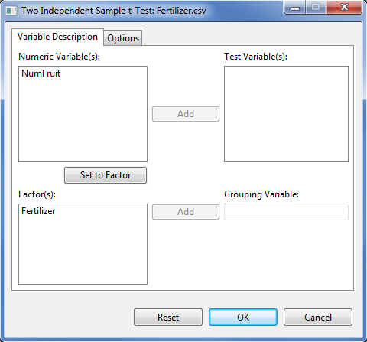

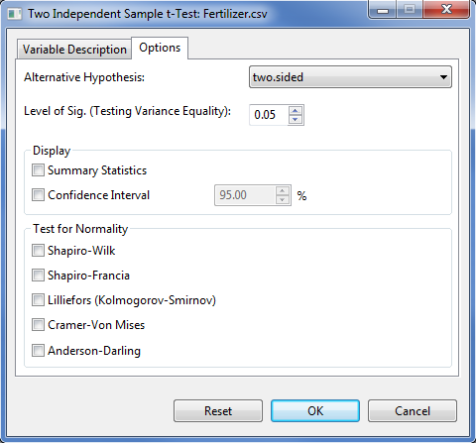

* Specify the required field and appropriate options for the analysis.

**Variable Description Tab**

**Test Variable(s)**

This field need at least one entry for the analysis to proceed and should come from the **Numeric Variable(s)** list box.

**Grouping Variable**

This field accepts one entry at a time and needs an entry for the analysis to proceed. The entry must come from the **Factor(s)** list box. The entry should have only two levels.

**Options** **Tab**

**Alternative Hypothesis**

User can select a one-tailed or two-tailed test. The default alternative hypothesis used is that for the two-sided test.

**Level of Significance**

This will be used to determine if the two groups have equal variance. Its default value is 0.05. The user can change this value by specifying a numeric value from zero to 1.

**Summary Statistics**

If this option is selected, a summary table with number of observations, minimum, maximum, mean and standard deviation will be displayed.

**Confidence Interval**

If this option is selected, a confidence interval of the mean will be displayed. If this is selected, by default, a 95% confidence interval is displayed.

**Test for Normality**

If at least one option is selected, if display the test for normality test for each level of the **Grouping Variable**. There are five available tests for normality procedure.

For the example, suppose we want to test the hypothesis that the mean numbers of fruits from trees sprayed by the two fertilizers are the same. The completed **Variable Description** tab and **Option** tab should appear as illustrated below:

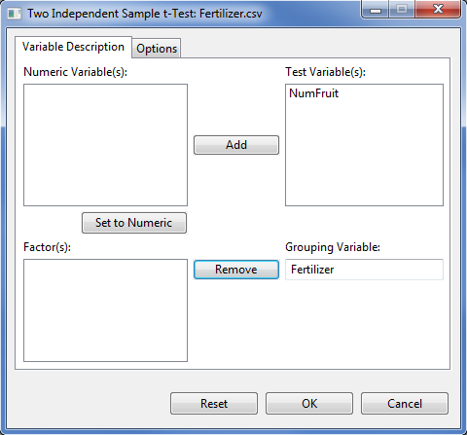

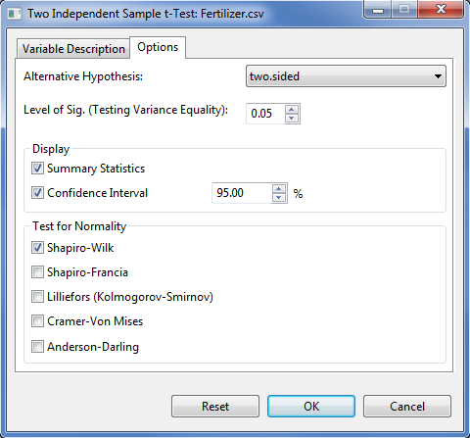

* Click the **OK** button to perform the analysis. The **Two** **Independent Sample** **t-test** dialog box will be minimized and STAR actives the **Output** page of the **Result Viewer** tab.

Sample output of the analysis as shown in the Output page is displayed below.

Test for Normality

--------------------------------------------------------------

Grp Level Variable Method Statistics Prob

--------------------------------------------------------------

Fertilizer A NumFruit Shapiro-Wilk 0.9726 0.8950

Fertilizer B NumFruit Shapiro-Wilk 0.9198 0.1916

--------------------------------------------------------------

Descriptive Statistics

------------------------------------------------------------------------

Variable Fertilizer N Lower CI\* Mean Upper CI\* StdDev SE\_Mean

------------------------------------------------------------------------

NumFruit A 15 21.51 23.13 24.75 2.92 0.76

NumFruit B 15 19.25 20.87 22.49 3.54 0.91

NumFruit Diff(A-B) -0.16 2.27 4.70 3.25 1.19

------------------------------------------------------------------------

\* At 95% Confidence Level.

Homogeneity of Variances

----------------------------------------------------

Variable Method Num DF Den DF F Value Pr > F

----------------------------------------------------

NumFruit Folded F 14 14 1.47 0.4820

----------------------------------------------------

Two Independent Sample t-Test, h0: mean diff = 0

-----------------------------------------------------

Variable Method\* Variances DF t Value Pr > |t|

-----------------------------------------------------

NumFruit Pooled Equal 28 1.91 0.0663

-----------------------------------------------------

\* At 0.05 level of significance.

# Chi-Square Test

The Chi-Square test

## Goodness of fit Test

The steps to perform chi-square goodness of fit test are listed below:

* On the **Project Explorer**, double-click the file to be used for the analysis to open and view it in the Data Viewer tab.

For the example, using the project named *My Project*,import the data *GomezMaizeCross* from the package. To import the data from the package*, s*ee *Importing from Package* section of this user manual.

* Click **Analyze | Chi-Square | Goodness of Fit…** from the main window. The **Goodness of Fit Test** dialog box will appear as illustrated:

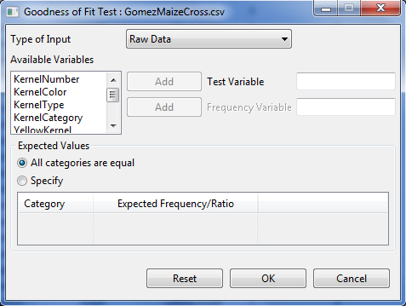

* Specify the required field and appropriate options for the analysis.

**Type of Input**

There are two options available, *Raw Data* (default option) and *Summary Data*.

**Test Variable**

This variable is required.

**Frequency Variable**

If the *Summary Data* is chosen as type of input, this variable is required.

**Expected Values**

There are two options available, *All categories are equal* (default option) and *specify*. If *specify* option is selected, table will be enable wherein user need to indicate the expected frequency/ratio for each of the unique categories of the test variable. The default and minimum expected frequency/ratio for each category is 1.

For the example, the completed dialog box should appear as illustrated below:

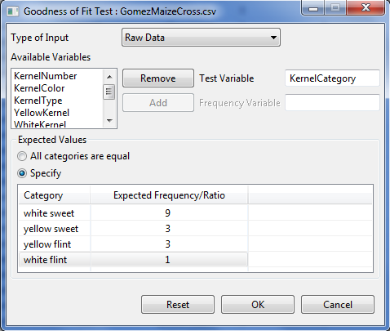

* Click **OK** button to perform the analysis. The **Goodness of Fit Test** dialog box will be minimized and STAR activates the **Output** page of the **Result Viewer** tab.

Sample text output is shown below.

Frequency Table:

-----------------------------------

KernelCategory Obs Freq Exp Freq

-----------------------------------

white flint 112 50

white sweet 34 150

yellow flint 496 450

yellow sweet 158 150

-----------------------------------

Chi-Square Goodness of Fit Test

------------------------------

Chi-Square 171.7156

DF 3

Pr > Chi-Square 0.0000

------------------------------

## Test of Independence

The steps to perform Chi-Square test of independence are listed below:

* On the **Project Explorer**, double-click the file to be used for the analysis to open and view it in the Data Viewer tab.

For the example, using the project named *My Project*,import the data *GomezMaizeCross* from the package. To import the data the package*, s*ee *Importing from Package* section of this user manual.

* Click **Analyze | Chi-Square | Test of Independence…** from the main window. The **Test of Independence** dialog box will appear as illustrated:

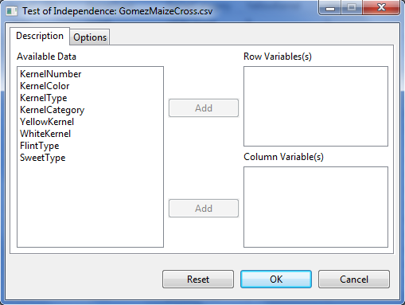

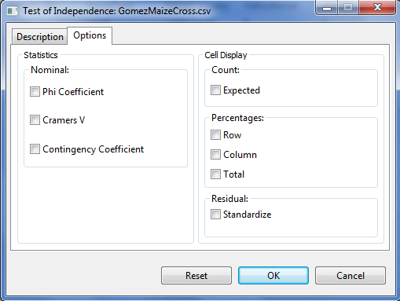

* Specify the required field and appropriate options for the analysis.

**Description** **Tab**

**Row Variable(s)**

At least one entry is need for the analysis to proceed.

**Column Variable(s)**

At least one entry is need for the analysis to proceed.

**Options Tab**

**Phi Coefficient**

If this option is selected, the phi coefficient will be displayed.

**Cramer’s V**

If this option is selected, the cramer’s v coefficient will be displayed.

**Contingency Coefficient**

If this option is selected, the contingency coefficient will be displayed.

**Expected Count**

If this option is selected, the expected frequency will be displayed.

**Row Percentages**

If this option is selected, the row percentage will be displayed.

**Column Percentages**

If this option is selected, the column percentage will be displayed.

**Total Percentages**

If this option is selected, the total percentage will be displayed.

**Standardize Residual**

If this option is selected, the standardize residual will be displayed.

For the example, the completed dialog box is illustrated below:

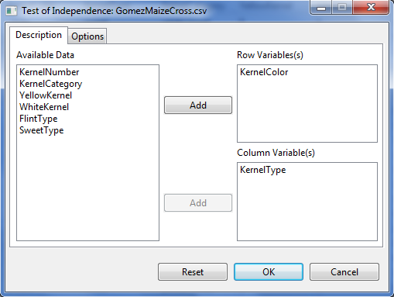

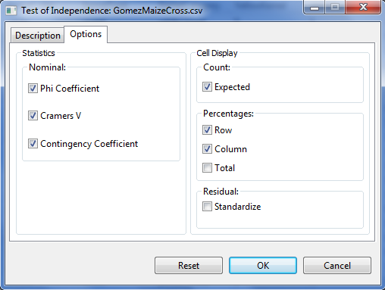

* Click the **OK** button to perform the analysis. The **Test of Independent** dialog box will be minimized and STAR actives the **Output** page of the **Result Viewer** tab.

Sample output of the analysis as displayed in the Output page is shown below.

Table of KernelColor by KernelType

|KernelType

-----------------------------------+-----------+-----------+-----------+

KernelColor |flint |sweet |Total |

-----------------------------------+-----------+-----------+-----------+

white |Obs Freq | 112| 34| 146|

|Expected Freq | 110.9600| 35.0400| 146.0000|

|% within KernelColor | 76.7123| 23.2877| 100.0000|

|% within KernelType | 18.4211| 17.7083| |

|% of Total | 14.0000| 4.2500| 18.2500|

-----------------------------------+-----------+-----------+-----------+

yellow |Obs Freq | 496| 158| 654|

|Expected Freq | 497.0400| 156.9600| 654.0000|

|% within KernelColor | 75.8410| 24.1590| 100.0000|

|% within KernelType | 81.5789| 82.2917| |

|% of Total | 62.0000| 19.7500| 81.7500|

-----------------------------------+-----------+-----------+-----------+

Total |Obs Freq | 608| 192| 800|

|Expected Freq | 608.0000| 192.0000| 800.0000|

|% within KernelType | 100.0000| 100.0000| |

|% of Total | 76.0000| 24.0000| 100.0000|

-----------------------------------+-----------+-----------+-----------+

Statistics for Table KernelColor by KernelType

Statistics DF Value Prob

--------------------------------------------------

Pearson Chi-Square 1 0.0134 0.9079

Likelihood Ratio Chi-Square 1 0.0499 0.8232

Phi Coefficient 0.0482

Contingency Coefficient 0.0482

Cramer's V 0.0482

Fisher's Exact Test 0.9147

--------------------------------------------------

# Test on Proportion

The steps to perform test on proportion are listed below:

* On the **Project Explorer**, using the project named *My Project*,import the data *GomezMaizeCross* from the package. Double-click the file to open and view it in the Data Viewer.

To import the data*, s*ee *Importing from Package* section of this user manual.

* Click **Analyze | Test on Proportion …** from the main window. The **Test on Proportion** dialog box will appear as illustrated:

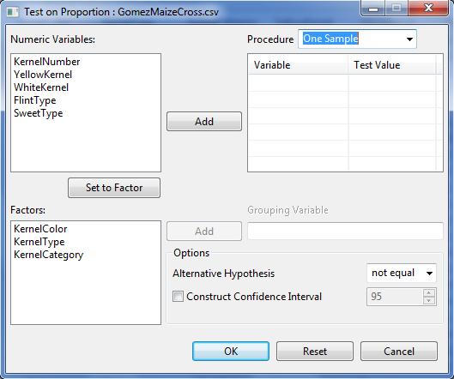

* Specify the required field and appropriate options for the analysis.

**Procedure**

There are three available procedures available: *One Sample*, *Two Related Samples* and *Independent Sample*.

**Grouping Variable**

At least one entry is need for the analysis to proceed.

**Grouping Variable**

At least one entry is need for the analysis to proceed.

**Grouping Variable**

This field is required and visible if the procedure is *Independent Samples* is chosen.

**Alternative hypothesis**

There are three available options: *less*, *greater* and *not equal*.

**Construct Confidence Interval**

This option is available only if the procedure chosen is either *One Sample* or *Independent Sample*. If this option is selected, a confidence interval will be constructed.

For the example, the completed dialog box is illustrated below:

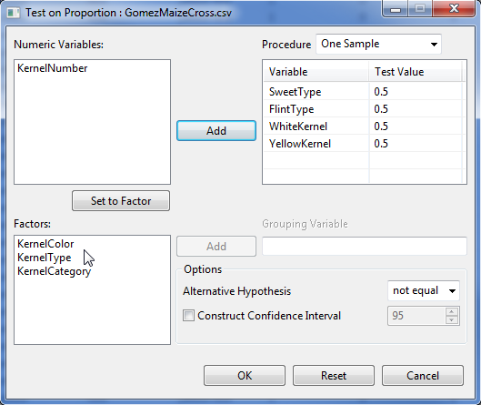

* Click the **OK** button to perform the analysis. The **Test on Proportion** dialog box will be minimized and STAR actives the **Output** page of the **Result Viewer** tab.

Sample output of the analysis as displayed in the Output page is shown below.

Summary

-------------------------------------------------

Variable Num Success Num Trial Proportion

-------------------------------------------------

SweetType 192 800 0.2400

FlintType 608 800 0.7600

WhiteKernel 146 800 0.1825

YellowKernel 654 800 0.8175

-------------------------------------------------

Test on One Proportion

------------------------------------------------------------

Variable Procedure TestValue Statistics Prob

------------------------------------------------------------

SweetType Chi-Square 0.5000 216.32 0.0000

SweetType Exact Binomial 0.5000 192.00 0.0000

SweetType Approx Z 0.5000 -14.71 0.0000

FlintType Chi-Square 0.5000 216.32 0.0000

FlintType Exact Binomial 0.5000 608.00 0.0000

FlintType Approx Z 0.5000 14.71 0.0000

WhiteKernel Chi-Square 0.5000 322.58 0.0000

WhiteKernel Exact Binomial 0.5000 146.00 0.0000

WhiteKernel Approx Z 0.5000 -17.96 0.0000

YellowKernel Chi-Square 0.5000 322.58 0.0000

YellowKernel Exact Binomial 0.5000 654.00 0.0000

YellowKernel Approx Z 0.5000 17.96 0.0000

------------------------------------------------------------

\* alternative hypothesis = 'two.sided'

# Analysis of Variance

The Analysis of Variance is a statistical technique which partitions the total variation into explained variation and unexplained variation.

The **Analysis of Variance submenu** can be use to perform analysis of variance for data from experimental designs with single error (e.g., RCB) and with 2 or more errors (e.g., Split Plot).

The Analysis of Variance in STAR uses fixed model and can be used for balanced data set. For data set with less than 10% missing observations, STAR can still perform the analysis of variance by first estimating the missing observations.

Treatment means or means of the treatment combination will be displayed depending on the result of the analysis of variance. If the analysis is performed on single factor and the treatment effect is not significant, the table of means is displayed. If the analysis is performed on multi-factor experiment and the highest interaction is not significant, the mean of the treatment combination are displayed.

Depending on the results of the analysis of variance, pairwise comparison means will be automatically generated for all effects that are significant using one applicable pairwise comparison procedure. If the factor being compared has at most 5 levels, the default pairwise comparison procedure used in STAR is the Least Significant Difference (LSD) test; otherwise the Honestly Significant Difference (HSD) or Tukey’s test is used. Aside from LSD and HSD, Duncan’s Multiple Range test, Student Newmann-Keul’s test and Scheffe’s test maybe also be requested.

Boxplot of the response variable and two diagnostic plots are automatically displayed in the *Graph* page of the **Result Viewer** tab. The *Residuals vs. Fitted* is for assessing the distribution of the residuals. An ideal plot should reveal that the points are distributed around 0. The residuals should not be affected by the size of the fitted values. Problematic data may result to a plot wherein the points increase as the fitted values increase, thus forming a “funnel-shaped” distribution. This will indicate a violation of the homogeneity of variances requirement for analysis of variance. The *Normal Q-Q* plot is used for assessing normality. The points should lie about the line.

Contrast analysis maybe requested in this menu. There are three available contrast analyses that maybe request for each factor, namely: compare with control, orthogonal polynomial contrast and user specified contrast.

## Completely Randomized Design

This submenu can be used to perform analysis of variance for single and multi factor experiment.

The steps to perform the analysis are listed below:

* On the **Project Explorer**, double-click the file to be used for the analysis to open and view it in the Data Viewer tab.

For the example, using the project named *My Project*,import the data *Insecticides* from package. To import the data from the package*, s*ee *Importing from Package* section of this user manual.

* Click **Analyze | Analysis of Variance | Completely Randomized Design…** from the main window. The **Completely Randomized Design** dialog box will appear as illustrated:

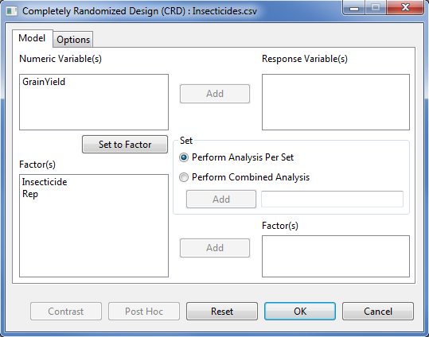

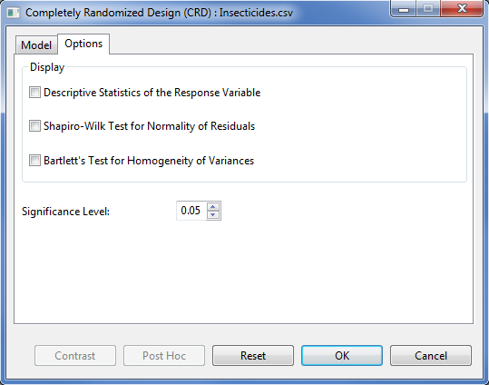

* Specify the required field and appropriate options for the analysis.

**Model Tab**

**Response Variable(s)**

For the analysis to proceed, at least one item should be entered in the list box. Only Items from the **Numeric Variable(s)** can be added in this dialog box.

**Set**

There are two options available, *perform analysis per set* (default) and *perform combined analysis*. If default option is selected and a **Set** variable is specified, STAR will perform analysis for each level of the **Set** variable. If the default option is selected and no **Set** variable is specified, STAR will perform the analysis as if the entire data came from only one set variable. If *perform combined analysis* is selected, a **Set** variable with at least two levels must be specified. The item should come from the **Factor(s)** list box.

**Factor(s)**

At least one item should be added in this list box and should come from the **Factor(s)** list box.

**Options Tab**

**Descriptive Statistics of the Response Variable**

If this option is selected, a summary table with number of non-missing observations, minimum, maximum, mean and standard deviation of the response variable will be displayed.

**Shapiro-Wilk Test for Normality of Residuals**

If this option is selected, test for normality of residuals using Shapiro-Wilk will be displayed, if the number of observation is between 3 and 5000.

**Bartlett’s Test for Homogeneity of Variances**

This option is visible if *perform analysis per set* is selected. If this option is selected, test for homogeneity of variances using Bartlett’s Test will be displayed.

**Significance Level**

This will be used to determine if the treatment effects and interaction effects are significant in the Analysis of Variance. This is also the level of significance to be used when pairwise mean comparison is performed. Its default value is 0.05. The user can change this value by specifying a numeric value from zero to 1.

For the example, the completed **Model** tab and **Option** tab should appear as illustrated:

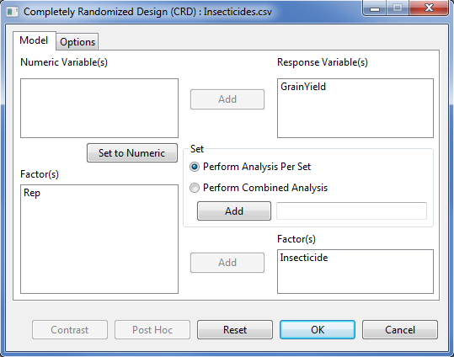

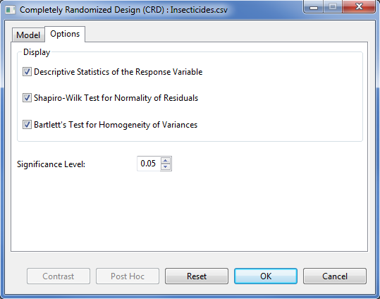

* Click **OK** button to perform the analysis. The **Completely Randomized Design** dialog box will be minimized and STAR activates the **Output** page of the **Result Viewer** tab.

Sample text output is shown below.

Analysis of Variance

Completely Randomized Design

===============================================

ANALYSIS FOR RESPONSE VARIABLE: GrainYield

===============================================

Summary Information

----------------------------------------------------------------

FACTOR NO. OF LEVELS LEVELS

----------------------------------------------------------------

Insecticide 7 Azodin, Control, ..., Dol-Mix (2kg)

----------------------------------------------------------------

Number of Observations Read and Used: 28

Descriptive Statistics

-----------------------------------------------

Variable N\_Obs Min Max Mean StdDev

-----------------------------------------------

GrainYield 28 1077 3366 2039.64 529.76

-----------------------------------------------

Bartlett's Test for Homogeneity of Variances

----------------------------------

Method DF Statistics Prob

----------------------------------

bartlett 6 5.56 0.4744

----------------------------------

Test for Normality

---------------------------------------------------

Variable Method Statistics Prob

---------------------------------------------------

GrainYield\_resid Shapiro-Wilk 0.9857 0.9587

---------------------------------------------------

ANOVA TABLE

Response Variable: GrainYield

--------------------------------------------------------------

Source DF Sum of Square Mean Square F Value Pr > F

--------------------------------------------------------------

Insecticide 6 5587174.9286 931195.8214 9.83 0.0000

Error 21 1990237.5000 94773.2143

Total 27 7577412.4286

--------------------------------------------------------------

Summary Statistics

--------------------------

Coef Var GrainYield Mean

--------------------------

15.09 2039.64

--------------------------

Standard Errors

--------------------

Effects StdErr

--------------------

Insecticide 217.68

--------------------

Pairwise Mean Comparison of Insecticide

Tukeys's Honest Significant Difference (HSD) Test

Alpha 0.05

Error Degrees of Freedom 21

Error Mean Square 94773.2143

Critical Value 4.5973

Test Statistics 707.6456

Summary of the Result:

-----------------------------------

Insecticide means N group

-----------------------------------

Azodin 2128.00 4 ab

Control 1316.00 4 c

DDT + phi-BHC 2551.75 4 a

Dimercon-Boom 1796.00 4 bc

Dimercon-Knap 1681.00 4 bc

Dol-Mix (1kg) 2126.75 4 ab

Dol-Mix (2kg) 2678.00 4 a

-----------------------------------

\* Means with the same letter are not significantly different.

Sample graphical output displayed in the **Graph** page.

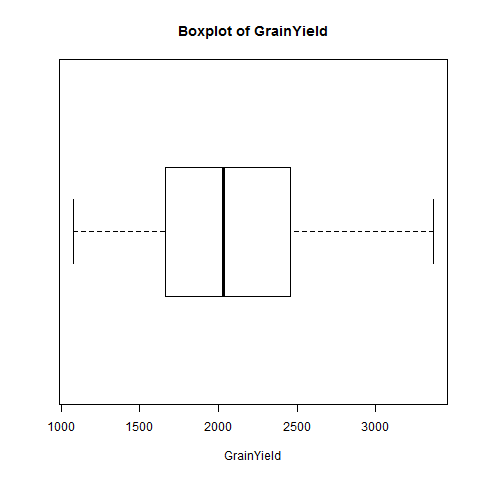

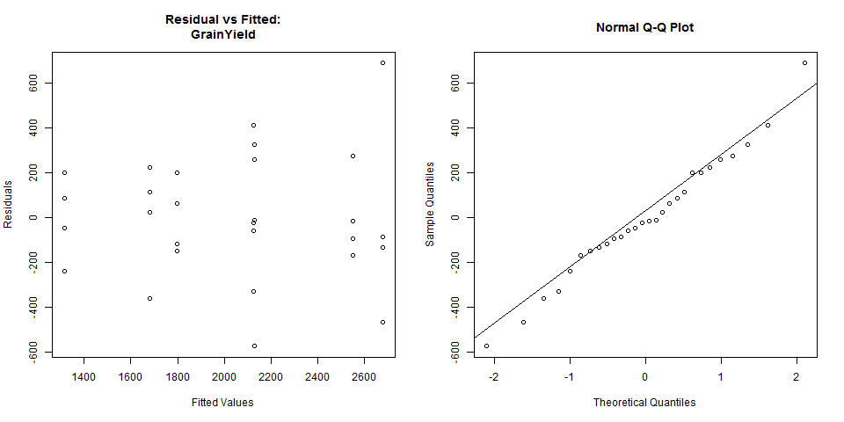

**Additional Options**

If there are still modifications to be made, the following option buttons may be used:

* **Post Hoc**

Use this option if other pairwise comparison procedures, other than what was presented in the **Output** page, are desired. There are five pairwise mean comparison procedure available, namely: Least Significant Difference Test, Duncan Multiple Range Test, Tukey’s Honest Significant Test, Student Newmann-Keul’s Test and the Scheffe’s Test. This button will be disabled if *F*-tests conducted using ANOVA yielded results that are not significant. Use of this button will be discussed in Pairwise Comparison section on this module.

* **Contrast**

This button will be enabled if there is at least one factor that has more than two levels. Use of this button will be discussed in Partitioning Sum of Squares section of this module.

## Randomized Complete Block Design

This submenu can be used to perform analysis of variance for single and multi factor experiment.

The steps to perform the analysis are listed below:

* On the **Project Explorer**, using the project named *My Project*,import the data *SeedingRate* from package. Double-click the file to open and view it in the Data Viewer.

To import that data*, s*ee *Importing from Project* section of this user manual.

* From the main window of STAR click **Analyze | Analysis of Variance | Randomized Complete Block Design…**. The **Randomized Complete Block Design** dialog box will appear.

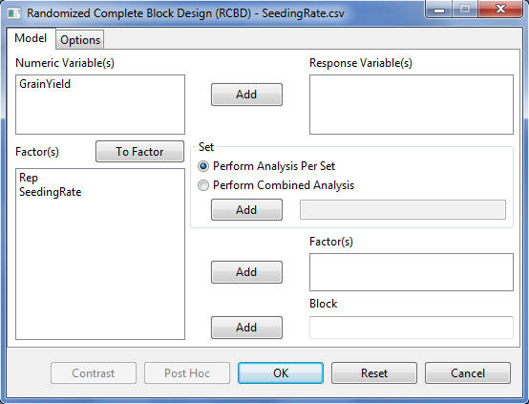

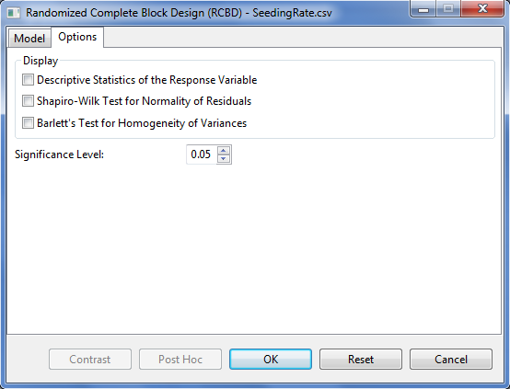

* Specify the required field and appropriate options for the analysis.

**Model Tab**

**Response Variable(s)**

For the analysis to proceed, at least one item should be entered in the list box. Only Items from the **Numeric Variable(s)** can be added in this dialog box.

**Set**

There are two options available, *perform analysis per set* (default option) and *perform combined analysis*. If default option is selected and a **Set** variable is specified, STAR will perform analysis for each level of the **Set** variable. If the default option is selected and the **Set** variable is not specified, STAR will perform the analysis as if the entire data came from only one site. If **perform combined analysis is selected**, a Set variable must be specified.

**Factor(s)**

At least one item should be added in this list box and should come from the **Factor(s)** list box.

**Block**

Only one item can be added in this field and should come from the Factor(s) list box.

**Options Tab**

**Descriptive Statistics of the Response Variable**

If this option is selected, a summary table with number of non-missing observations, minimum, maximum, mean and standard deviation of the response variable will be displayed.

**Shapiro-Wilk Test for Normality of Residuals**

If this option is selected, test for normality of residuals using Shapiro-Wilk will be displayed, if the number of observation is between 3 and 5000.

**Bartlett’s Test for Homogeneity of Variances**

If this option is selected, test for homogeneity of variances using Bartlett’s Test will be displayed.

**Significance Level**

This will be used to determine if the treatment effects and interaction effects are significant in Analysis of Variance. This is also the level of significance to be used when pairwise mean comparison is performed. Its default value is 0.05. The user can change this value by specifying a numeric value from zero to 1.

For the example, the completed **Model** tab should appear as illustrated below:

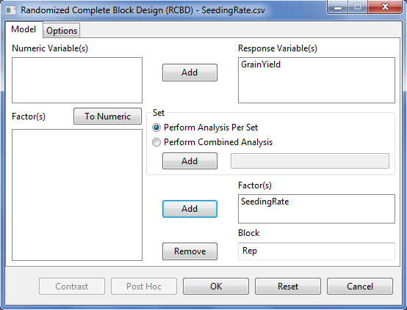

The completed Options tab should appear as illustrated below:

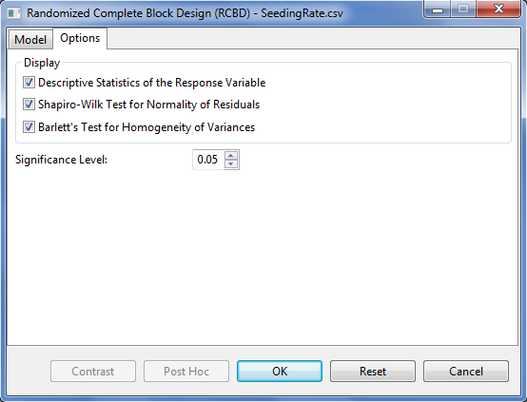

* Click **OK** button to perform the analysis. The **Randomized Complete Block Design (RCBD)** dialog box will be minimized and STAR activates the **Output Viewer** tab and the **Graph Viewer** tab.
* Sample text output of the analysis displayed in the Output Viewer tab is shown below:

Analysis of Variance

Randomized Complete Block Design (RCBD)

===============================================

ANALYSIS FOR RESPONSE VARIABLE: GrainYield

===============================================

Summary Information

---------------------------------------------

FACTOR NO. OF LEVELS LEVELS

---------------------------------------------

SeedingRate 6 25, 50, ..., 150

Rep 4 1, 2, 3, 4

---------------------------------------------

Number of Observations Read and Used: 24

DESCRIPTIVE STATISTICS

-------------------------------------------

Variable N\_Obs Min Max Mean StdDev

-------------------------------------------

GrainYield 24 2.80 6 4.65 0.7735

-------------------------------------------

Bartlett's Test for Homogeneity of Variances

---------------------------------

Method DF Statistics Prob

---------------------------------

bartlett 5 4.76 0.4462

---------------------------------

TEST FOR NORMALITY

---------------------------------------------------

Variable Method Statistics Prob

---------------------------------------------------

GrainYield\_resid Shapiro-Wilk 0.9346 0.1235

---------------------------------------------------

ANOVA TABLE

Response Variable: GrainYield

--------------------------------------------------------------

Source DF Sum of Square Mean Square F Value Pr > F

--------------------------------------------------------------

Rep 3 1.7667 0.5889 4.87 0.0147

SeedingRate 5 10.1800 2.0360 16.84 0.0000

Error 15 1.8133 0.1209

Total 23 13.7600

--------------------------------------------------------------

Summary Statistics

--------------------------

Coef Var GrainYield Mean

--------------------------

7.48 4.65

--------------------------

Standard Errors

--------------------

Effects StdErr

--------------------

Rep 0.2007

SeedingRate 0.2459

--------------------

Pairwise Mean Comparison of SeedingRate

Tukeys's Honest Significant Difference (HSD) Test

Alpha 0.05

Error Degrees of Freedom 15

Error Mean Square 0.1209

Critical Value 4.5947

Test Statistics 0.7988

Summary of the Result:

-----------------------------

SeedingRate means N group

-----------------------------

100 4.35 4 b

125 4.67 4 ab

150 3.38 4 c

25 5.12 4 ab

50 5.08 4 ab

75 5.30 4 a

-----------------------------

\* Means with the same letter are not significantly different.

* Sample graphical output of the analysis displayed in the Graph Viewer tab is shown below:

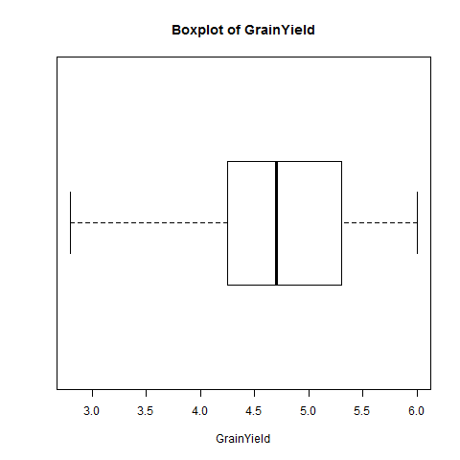

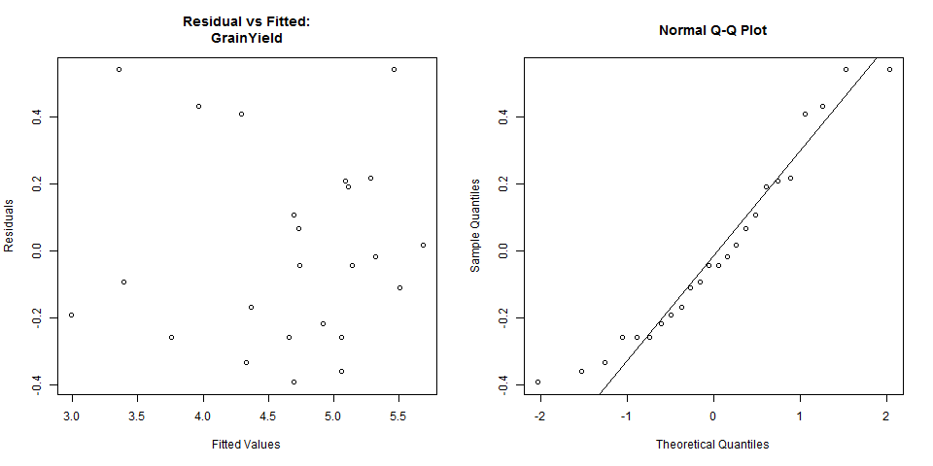

**Additional Options**

If there are still modifications to be made, the following option buttons may be used:

* **Post Hoc**

Use this option if other pairwise comparison procedures, other than what was presented in the **Output** page, are desired. There are five pairwise mean comparison procedure available, namely: Least Significant Difference Test, Duncan Multiple Range Test, Tukey’s Honest Significant Test, Student Newmann-Keul’s Test and the Scheffe’s Test. This button will be disabled if *F*-tests conducted using ANOVA yielded results that are not significant. Use of this button will be discussed in Pairwise Comparison section on this module.

* **Contrast**

This button will be enabled if there is at least one factor that has more than two levels. Use of this button will be discussed in Partitioning Sum of Squares section of this module.

## Latin Square Design

This submenu can be used to perform analysis of variance for single and multi factor experiment.

The steps to perform the analysis are listed below:

* On the **Project Explorer**, using the project named *My Project*,import the data *Maize* from STAR Package. Double-click the file to open and view it in the Data Viewer.

To import that data*, s*ee Importing from Package section of this user manual.

* From the main window of STAR click **Analyze | Analysis of Variance | Latin Square Design…**. The **Latin Square Design** dialog box will appear.

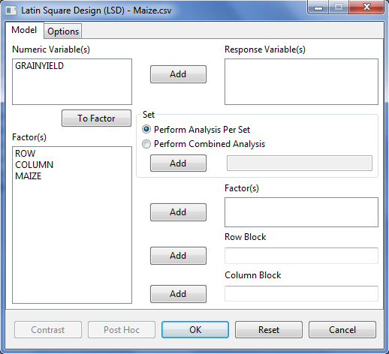

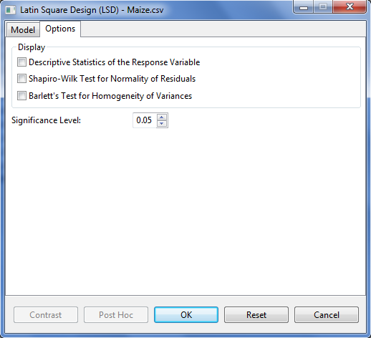

* Specify the required field and appropriate options for the analysis.

**Model Tab**

**Response Variable(s)**

For the analysis to proceed, at least one item should be entered in the list box. Only Items from the **Numeric Variable(s)** can be added in this dialog box.

**Set**

There are two options available, *perform analysis per set* (default option) and *perform combined analysis*. If default option is selected and a **Set** variable is specified, STAR will perform analysis for each level of the **Set** variable. If the default option is selected and the **Set** variable is not specified, STAR will perform the analysis as if the entire data came from only one site. If **perform combined analysis is selected**, a Set variable must be specified.

**Factor(s)**

At least one item should be added in this list box and should come from the **Factor(s)** list box.

**Row Block**

Only one item can be added in this field and should come from the Factor(s) list box.

**Column Block**

Only one item can be added in this field and should come from the Factor(s) list box.

**Options Tab**

**Descriptive Statistics of the Response Variable**

If this option is selected, a summary table with number of non-missing observations, minimum, maximum, mean and standard deviation of the response variable will be displayed.

**Shapiro-Wilk Test for Normality of Residuals**

If this option is selected, test for normality of residuals using Shapiro-Wilk will be displayed, if the number of observation is between 3 and 5000.

**Bartlett’s Test for Homogeneity of Variances**

If this option is selected, test for homogeneity of variances using Bartlett’s Test will be displayed.

**Significance Level**

This will be used to determine if the treatment effects and interaction effects are significant in Analysis of Variance. This is also the level of significance to be used when pairwise mean comparison is performed. Its default value is 0.05. The user can change this value by specifying a numeric value from zero to 1.

For the example, the completed **Model** tab should appear as illustrated below:

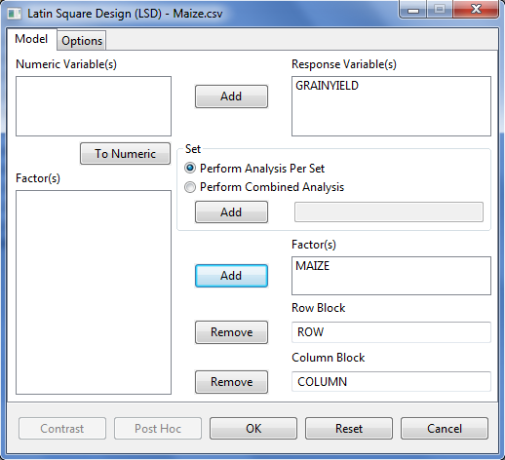

The completed Options tab should appear as illustrated below:

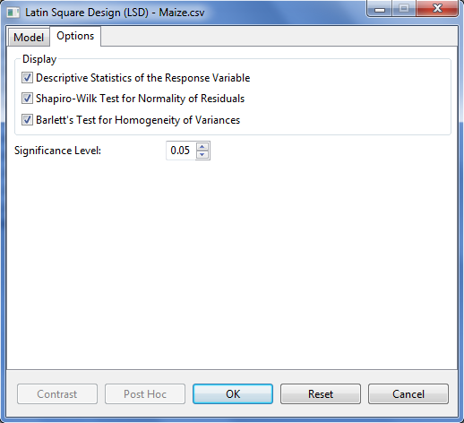

* Click **OK** button to perform the analysis. The **Latin Square Design** dialog box will be minimized and STAR activates the **Output Viewer** tab and the **Graph Viewer** tab.
* Sample text output of the analysis displayed in the Output Viewer tab is shown below:

Analysis of Variance

Latin Square Design (LSD)

===============================================

ANALYSIS FOR RESPONSE VARIABLE: GRAINYIELD

===============================================

Summary Information

----------------------------------

FACTOR NO. OF LEVELS LEVELS

----------------------------------

MAIZE 4 A, B, C, D

ROW 4 1, 2, 3, 4

COLUMN 4 1, 2, 3, 4

----------------------------------

Number of Observations Read and Used: 16

DESCRIPTIVE STATISTICS

----------------------------------------------

Variable N\_Obs Min Max Mean StdDev

----------------------------------------------

GRAINYIELD 16 0.6600 1.67 1.34 0.3070

----------------------------------------------

Bartlett's Test for Homogeneity of Variances

---------------------------------

Method DF Statistics Prob

---------------------------------

bartlett 3 3.81 0.2825

---------------------------------

TEST FOR NORMALITY

---------------------------------------------------

Variable Method Statistics Prob

---------------------------------------------------

GRAINYIELD\_resid Shapiro-Wilk 0.9250 0.2026

---------------------------------------------------

ANOVA TABLE

Response Variable: GRAINYIELD

---------------------------------------------------------

Source DF Sum of Square Mean Square F Value Pr > F

---------------------------------------------------------

ROW 3 0.0302 0.0101 0.47 0.7170

COLUMN 3 0.8273 0.2758 12.77 0.0051

MAIZE 3 0.4268 0.1423 6.59 0.0251

Error 6 0.1296 0.0216

Total 15 1.4139

---------------------------------------------------------

Summary Statistics

--------------------------

Coef Var GRAINYIELD Mean

--------------------------

11.01 1.34

--------------------------

Pairwise Mean Comparison of MAIZE

Least Significant Difference (LSD) Test

Alpha 0.05

Error Degrees of Freedom 6

Error Mean Square 0.0216

Critical Value 2.4469

Test Statistics 0.2543

Summary of the Result:

-----------------------

MAIZE means N group

-----------------------

A 1.46 4 a

B 1.47 4 a

C 1.07 4 b

D 1.34 4 a

-----------------------

\* Means with the same letter are not significantly different.

* Sample graphical output of the analysis displayed in the Graph Viewer tab is shown below:

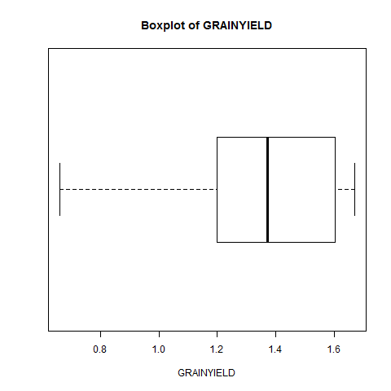

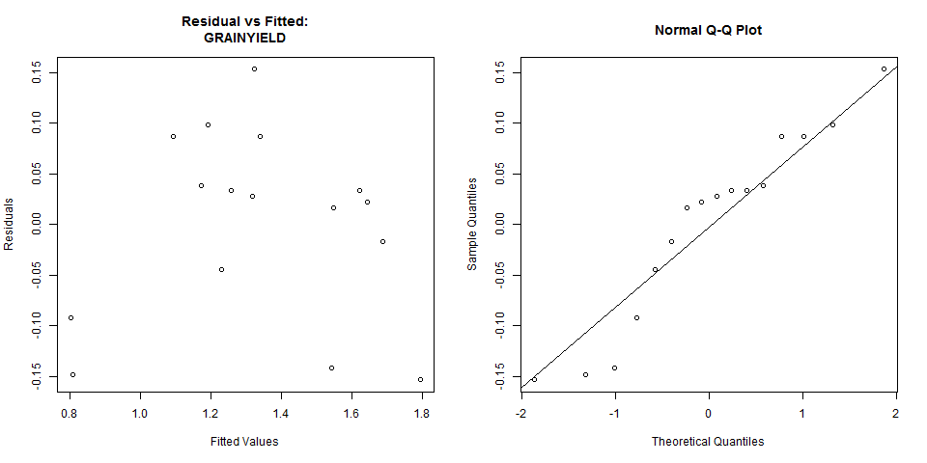

**Additional Options**

If there are still modifications to be made, the following option buttons may be used:

* **Post Hoc**

Use this option if other pairwise comparison procedures, other than what was presented in the **Output** page, are desired. There are five pairwise mean comparison procedure available, namely: Least Significant Difference Test, Duncan Multiple Range Test, Tukey’s Honest Significant Test, Student Newmann-Keul’s Test and the Scheffe’s Test. This button will be disabled if *F*-tests conducted using ANOVA yielded results that are not significant. Use of this button will be discussed in Pairwise Comparison section on this module.

* **Contrast**

This button will be enabled if there is at least one factor that has more than two levels. Use of this button will be discussed in Partitioning Sum of Squares section of this module.

## Split Plot Design

This analysis can be performed for Completely Randomized Design, Randomized Complete Block Design and Latin Square Design.

The steps to perform the Analysis of Variance using Split Plot Design are listed below:

* On the **Project Explorer**, double-click the file to be used for the analysis to open and view it in the Data Viewer.

For the example, using the project named *My Project*,import the data *Nurul2012* from the package. To import the data from the package, see *Importing from Package* section of this user manual.

* From the main window of STAR click **Analyze | Analysis of Variance | Split Plot Design**. Choose the appropriate design structure that will be used. The **Split Plot Design** dialog box will appear.

For the example, click **Analyze | Analysis of Variance | Split Plot Design | Randomized Complete Block Design …** from the main window.

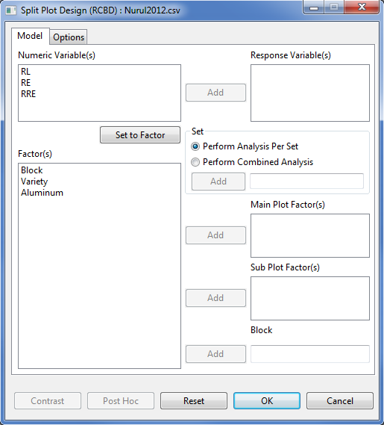

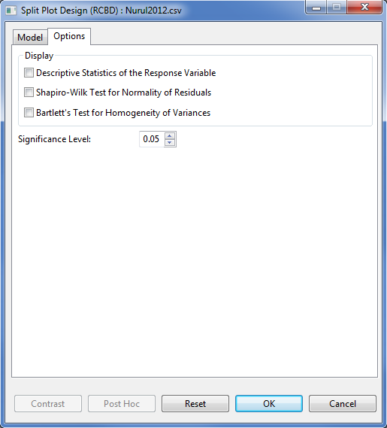

* Specify the required field and appropriate options for the analysis.

**Model Tab**

**Response Variable(s)**

For the analysis to proceed, at least one item should be entered in the list box. Only Items from the **Numeric Variable(s)** can be added in this dialog box.

**Set**

There are two options available, *perform analysis per set* (default) and *perform combined analysis*. If default option is selected and a **Set** variable is specified, STAR will perform analysis for each level of the **Set** variable. If the default option is selected and no **Set** variable is specified, STAR will perform the analysis as if the entire data came from only one set variable. If *perform combined analysis* is selected, a **Set** variable with at least two levels must be specified. The item should come from the **Factor(s)** list box.

**Main Plot Factor(s)**

At least one item should be added in this list box and should come from the **Factor(s)** list box.

**SubPlot Factor(s)**

At least one item should be added in this list box and should come from the **Factor(s)** list box.

**Replicate**

Applicable only if Completely Randomized Design is chosen. Only one item can be added in this field and should come from the Factor(s) list box.

**Block**

Applicable only if Randomized Complete Block Design is chosen. Only one item can be added in this field and should come from the Factor(s) list box.

**Row Block**

Applicable only if Latin Square Design is chosen. Only one item can be added in this field and should come from the Factor(s) list box.

**Column Block**

Applicable only if Latin Square Design is chosen. Only one item can be added in this field and should come from the Factor(s) list box.

**Options Tab**

**Descriptive Statistics of the Response Variable**

If this option is selected, a summary table with number of non-missing observations, minimum, maximum, mean and standard deviation of the response variable will be displayed.

**Shapiro-Wilk Test for Normality of Residuals**

If this option is selected, test for normality of residuals using Shapiro-Wilk will be displayed, if the number of observation is between 3 and 5000.

**Bartlett’s Test for Homogeneity of Variances**

This option is visible if *perform analysis per set* is selected. If selected, test for homogeneity of variances using Bartlett’s Test will be displayed.

**Significance Level**

This will be used to determine if the treatment effects and interaction effects are significant in Analysis of Variance. This is also the level of significance to be used when pairwise mean comparison is performed. Its default value is 0.05. The user can change this value by specifying a numeric value from zero to 1.

For the example, the completed **Model** tab and **Options** tab should appear as illustrated:

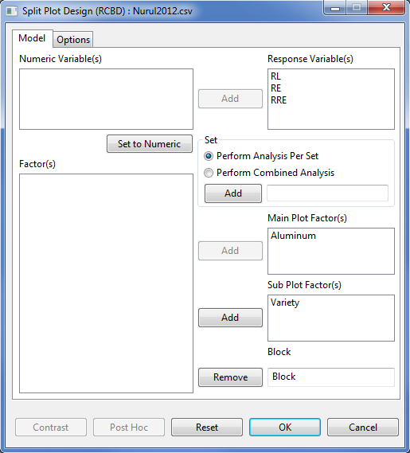

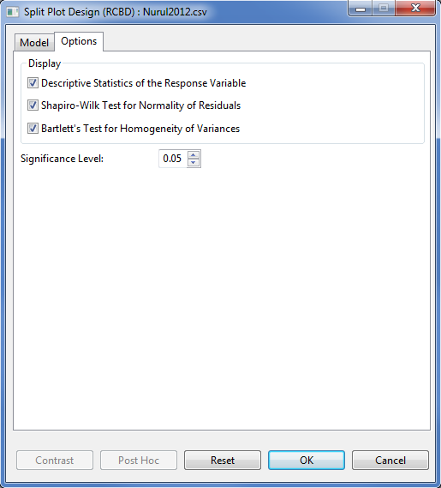

* Click OK button to perform the analysis. The Split Plot Design (RCBD) dialog box will be minimized and STAR activates the Output Viewer tab and the Graph Viewer tab.

Sample text output of the analysis (only results from response variable = GRNYLD) displayed in the Output Viewer tab is shown below:

Analysis of Variance

Split Plot in Randomized Complete Block Design

=======================================

ANALYSIS FOR RESPONSE VARIABLE: RE

=======================================

Summary Information

-------------------------------------------------------------------

FACTOR NO. OF LEVELS LEVELS

-------------------------------------------------------------------

Aluminum 4 0, 540, 750, 1300

Variety 8 Azucena112854, Azucena47125, ..., Pokalli

Block 2 I, II

-------------------------------------------------------------------

Number of Observations Read and Used: 64

ANOVA TABLE

Response Variable: RE

-------------------------------------------------------------------

Source DF Sum of Square Mean Square F Value Pr > F

-------------------------------------------------------------------

Block 1 647.2572 647.2572 177.11 0.0009

Aluminum 3 11826.5606 3942.1869 1078.68 0.0000

Error(a) 3 10.9639 3.6546

Variety 7 17768.2497 2538.3214 64.04 0.0000

Aluminum:Variety 21 3085.8037 146.9430 3.71 0.0007

Error(b) 28 1109.9079 39.6396

Total 63 34448.7430

-------------------------------------------------------------------

Summary Statistics

----------------------------------

Coef Var(a) Coef Var(b) RE Mean

----------------------------------

3.42 11.26 55.93

----------------------------------

Comparison of Aluminum at each level of Variety

Least Significant Difference (LSD) Test

Alpha 0.05

Error Degrees of Freedom 28

Error Mean Square 35.1415

Critical Value 2.0462

Test Statistic 12.1297

Summary:

--------------------------------------------------------------------

Aluminum N Variety = Azucena112854 group ...

--------------------------------------------------------------------

0 2 65.14 a ...

1300 2 23.07 c ...

540 2 54.95 ab ...

750 2 44.60 b ...

--------------------------------------------------------------------

\* Means with the same letter are not significantly different

Comparison of Variety at each level of Aluminum

Tukeys's Honest Significant Difference (HSD) Test

Alpha 0.05

Error Degrees of Freedom 28

Error Mean Square 39.6396

Critical Value 4.6248

Test Statistic 20.5893

Summary:

--------------------------------------------------------------------Variety N Aluminum = 0 group Aluminum = 540 group ...

--------------------------------------------------------------------

Azucena112854 2 65.14 bc 54.95 bc ...

Azucena47125 2 79.63 ab 82.34 a ...

Azucena52992 2 99.31 a 86.05 a ...

Chadungda 2 54.86 c 36.94 c ...

IR20 2 32.05 d 40.03 c ...

IR64 2 56.96 c 70.94 ab ...

IR74 2 67.40 bc 83.85 a ...

Pokalli 2 91.10 a 79.60 a ...

--------------------------------------------------------------------

\* Means with the same letter are not significantly different

Sample graphical output of the analysis displayed in the Graph Viewer tab is shown below:

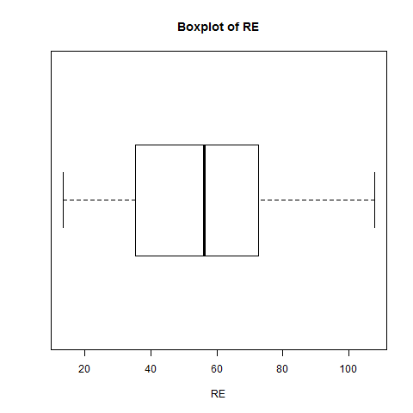

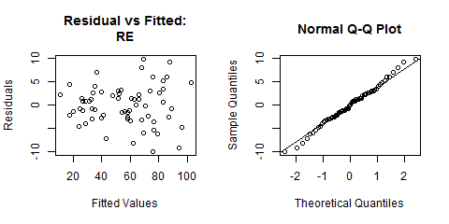

**Additional Options**

If there are still modifications to be made, the following option buttons may be used:

* **Post Hoc**

Use this option if other pairwise comparison procedures, other than what was presented in the **Output** page, are desired. There are five pairwise mean comparison procedure available, namely: Least Significant Difference Test, Duncan Multiple Range Test, Tukey’s Honest Significant Test, Student Newmann-Keul’s Test and the Scheffe’s Test. This button will be disabled if *F*-tests conducted using ANOVA yielded results that are not significant. Use of this button will be discussed in Pairwise Comparison section on this module.

* **Contrast**

This button will be enabled if there is at least one factor that has more than two levels. Use of this button will be discussed in Partitioning Sum of Squares section of this module.

## Strip Plot Design

The steps to perform the Analysis of Variance in Strip Plot Design are listed below:

* On the **Project Explorer**, using the project named *My Project*,import the data *GomezStrip* from STAR Package. Double-click the file to open and view it in the Data Viewer.

The example file contains data from an experiment conducted to compare the effects of six rice variety (*Variety*, with levels *V1, V2, V3, V4, V5* and *V6*) and three rates of nitrogen (*NITROGEN,* in kg/ha with levels *0, 60* and *120*) on grain yield (*GRNYLD*, in kg/ha). A strip plot design with three blocks (*REP* with levels *1*, *2*, and *3*) was used with rice variety as the horizontal factor and nitrogen rates as the vertical factor.

* From the main window of STAR click **Analyze | Analysis of Variance | Strip Plot Design**. The **Strip Plot** dialog box will appear.

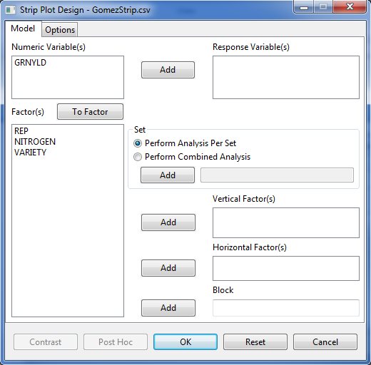

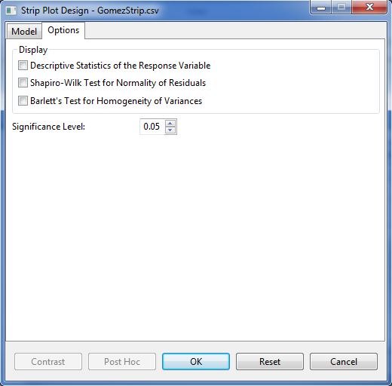

* Specify the required field and appropriate options for the analysis.

**Model Tab**

**Response Variable(s)**

For the analysis to proceed, at least one item should be entered in the list box. Only Items from the **Numeric Variable(s)** can be added in this dialog box.

**Set**

There are two options available, *perform analysis per set* (default option) and *perform combined analysis*. If default option is selected and a **Set** variable is specified, STAR will perform analysis for each level of the **Set** variable. If the default option is selected and the **Set** variable is not specified, STAR will perform the analysis as if the entire data came from only one site. If **perform combined analysis is selected**, a Set variable must be specified.

**Vertical Factor(s)**

At least one item should be added in this list box and should come from the **Factor(s)** list box.

**Horizontal Factor(s)**

At least one item should be added in this list box and should come from the **Factor(s)** list box.

**Block**

Only one item can be added in this field and should come from the Factor(s) list box.

**Options Tab**

**Descriptive Statistics of the Response Variable**

If this option is selected, a summary table with number of non-missing observations, minimum, maximum, mean and standard deviation of the response variable will be displayed.

**Shapiro-Wilk Test for Normality of Residuals**

If this option is selected, test for normality of residuals using Shapiro-Wilk will be displayed, if the number of observation is between 3 and 5000.

**Bartlett’s Test for Homogeneity of Variances**

If this option is selected, test for homogeneity of variances using Bartlett’s Test will be displayed.

**Significance Level**

This will be used to determine if the treatment effects and interaction effects are significant in Analysis of Variance. This is also the level of significance to be used when pairwise mean comparison is performed. Its default value is 0.05. The user can change this value by specifying a numeric value from zero to 1.

For the example, the completed **Model** Specification tab should appear as illustrated below:

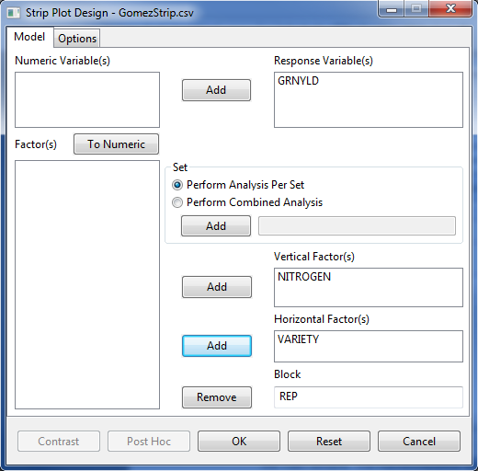

The completed **Options** tab should appear as illustrated below:

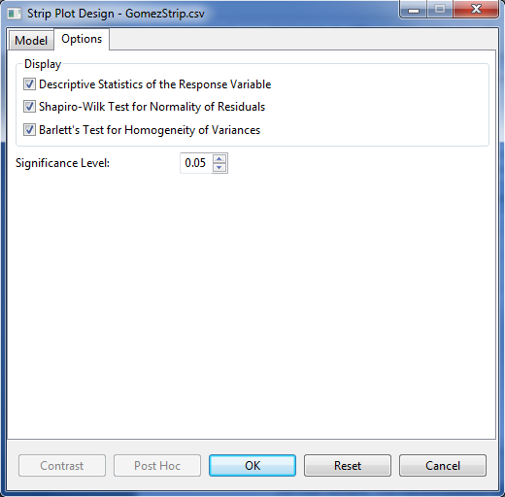

* Click OK button to perform the analysis. The Strip Plot Design dialog box will be minimized and STAR activates the Output Viewer tab and the Graph Viewer tab.

Sample text output of the analysis displayed in the Output Viewer tab is shown below:

Analysis of Variance

Strip Plot Design

===========================================

ANALYSIS FOR RESPONSE VARIABLE: GRNYLD

===========================================

Summary Information

-----------------------------------------

FACTOR NO. OF LEVELS LEVELS

-----------------------------------------

NITROGEN 3 0, 60, 120

VARIETY 6 V1, V2, ..., V6

REP 3 1, 2, 3

-----------------------------------------

Number of Observations Read and Used: 54

DESCRIPTIVE STATISTICS

----------------------------------------------

Variable N\_Obs Min Max Mean StdDev

----------------------------------------------

GRNYLD 54 1556 8611 5289.94 1775.12

----------------------------------------------

Test for Homogeneity of Variances

---------------------------------

Method DF Statistics Prob

---------------------------------

bartlett 17 21.30 0.2130

---------------------------------

TEST FOR NORMALITY

-----------------------------------------------

Variable Method Statistics Prob

-----------------------------------------------

GRNYLD\_resid Shapiro-Wilk 0.9732 0.2665

-----------------------------------------------

ANOVA TABLE

Response Variable: GRNYLD

--------------------------------------------------------------------

Source DF Sum of Square Mean Square F Value Pr > F

--------------------------------------------------------------------

REP 2 9220962.3333 4610481.1667 6.20 0.0595

NITROGEN 2 50676061.4444 25338030.7222 34.07 0.0031

Error(a) 4 2974907.8889 743726.9722

VARIETY 5 57100201.2778 11420040.2556 7.65 0.0034

Error(b) 10 14922619.2222 1492261.9222

NITROGEN:VARIETY 10 23877979.4444 2387797.9444 5.80 0.0004

Error(c) 20 8232917.2222 411645.8611

Total 53 167005648.8333

--------------------------------------------------------------------

Summary Statistics

---------------------------------------------------

Coef Var(a) Coef Var(b) Coef Var(c) GRNYLD Mean

---------------------------------------------------

16.30 23.09 12.13 5289.94

---------------------------------------------------

Comparison of NITROGEN at each level of VARIETY

Least Significant Difference (LSD) Test

Alpha 0.05

Error Degrees of Freedom 22

Error Mean Square 466992.7130

Critical Value 2.0716

Test Statistic 1155.8848

Summary:

--------------------------------------------------------------------

NITROGEN N VARIETY = V1 group VARIETY = V2 group ...

--------------------------------------------------------------------

0 3 3571.67 c 4934.33 b ...

120 3 7548.00 a 7211.33 a ...

60 3 5132.00 b 6713.67 a ...

--------------------------------------------------------------------

\* Means with the same letter are not significantly different

Comparison of VARIETY at each level of NITROGEN

Tukeys's Honest Significant Difference (HSD) Test

Alpha 0.05

Error Degrees of Freedom 10

Error Mean Square 1492261.9222

Critical Value 4.9120

Test Statistic 3464.3491

Summary:

--------------------------------------------------------------------

VARIETY N NITROGEN = 0 group NITROGEN = 60 group ...

--------------------------------------------------------------------

V1 3 3571.67 a 5132.00 a ...

V2 3 4934.33 a 6713.67 a ...

V3 3 4249.67 a 6122.33 a ...

V4 3 4059.00 a 5553.67 a ...

V5 3 4101.67 a 5633.33 a ...

V6 3 3207.33 a 3714.33 a ...

--------------------------------------------------------------------

\* Means with the same letter are not significantly different

Sample graphical output of the analysis displayed in the Graph Viewer tab is shown below:

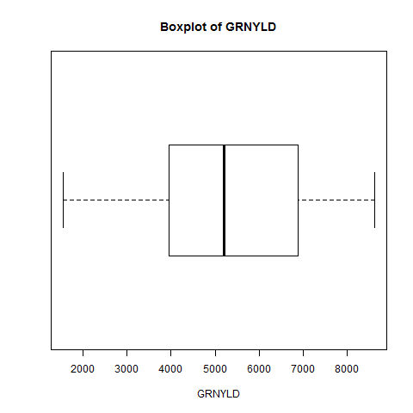

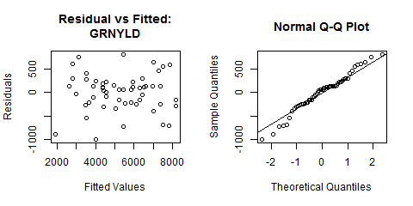

**Additional Options**

If there are still modifications to be made, the following option buttons may be used:

* **Post Hoc**

Use this option if other pairwise comparison procedures, other than what was presented in the **Output** page, are desired. There are five pairwise mean comparison procedure available, namely: Least Significant Difference Test, Duncan Multiple Range Test, Tukey’s Honest Significant Test, Student Newmann-Keul’s Test and the Scheffe’s Test. This button will be disabled if *F*-tests conducted using ANOVA yielded results that are not significant. Use of this button will be discussed in Pairwise Comparison section on this module.

* **Contrast**

This button will be enabled if there is at least one factor that has more than two levels. Use of this button will be discussed in Partitioning Sum of Squares section of this module.

## Split-Split Plot Design

This analysis can be performed for Completely Randomized Design, Randomized Complete Block Design and Latin Square Design.

The steps to perform the Analysis of Variance using Split-Split Plot Design are listed below:

* On the **Project Explorer**, double-click the file to be used for the analysis to open and view it in the Data Viewer.

For the example, using the project named *My Project*, import the data *GomezSplit2RCBD* from the package. To import the data from the package, see *Importing from Package* section of this user manual.

* From the main window of STAR click **Analyze | Analysis of Variance | Split-Split Plot Design**. Choose the appropriate design structure that will be used. The **Split-Split Plot Design** dialog box will appear.

For the example, choose **Analyze | Analysis of Variance | Split-Split Plot Design | Randomized Complete Block Design …** from the main window.

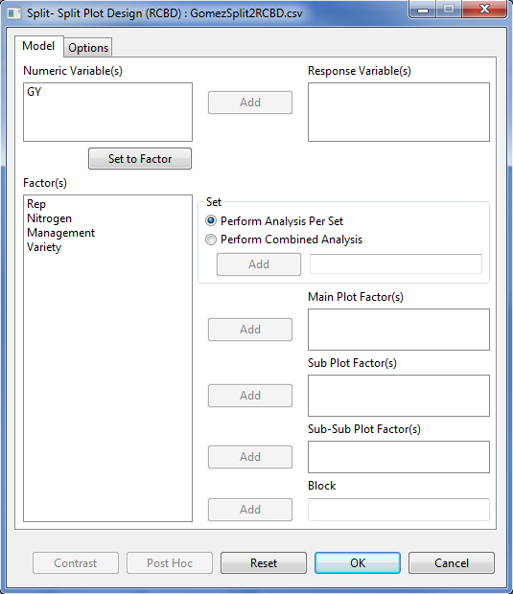

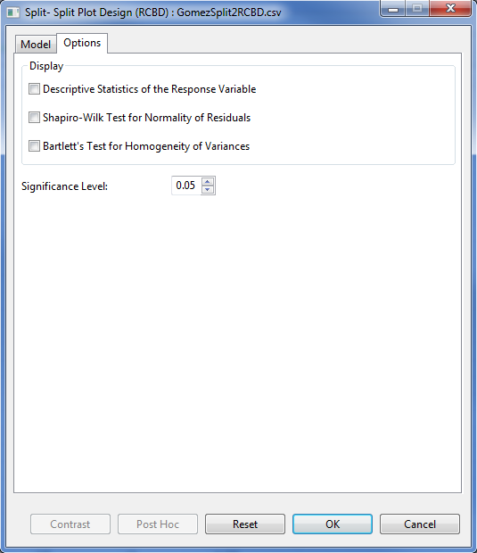

* Specify the required field and appropriate options for the analysis.

**Model Tab**

**Response Variable(s)**

For the analysis to proceed, at least one item should be entered in the list box. Only Items from the **Numeric Variable(s)** can be added in this dialog box.

**Set**

There are two options available, *perform analysis per set* (default) and *perform combined analysis*. If default option is selected and a **Set** variable is specified, STAR will perform analysis for each level of the **Set** variable. If the default option is selected and no **Set** variable is specified, STAR will perform the analysis as if the entire data came from only one set variable. If *perform combined analysis* is selected, a **Set** variable with at least two levels must be specified. The item should come from the **Factor(s)** list box.

**Main Plot Factor(s)**

At least one item should be added in this list box and should come from the **Factor(s)** list box.

**SubPlot Factor(s)**

At least one item should be added in this list box and should come from the **Factor(s)** list box.

**Sub-SubPlot Factor(s)**

At least one item should be added in this list box and should come from the **Factor(s)** list box.

**Replicate**

Applicable only if Completely Randomized Design is chosen. Only one item can be added in this field and should come from the **Factor(s)** list box.

**Block**

Applicable only if Randomized Complete Block Design is chosen. Only one item can be added in this field and should come from the Factor(s) list box.

**Row Block**

Applicable only if Latin Square Design is chosen. Only one item can be added in this field and should come from the Factor(s) list box.

**Column Block**

Applicable only if Latin Square Design is chosen. Only one item can be added in this field and should come from the Factor(s) list box.

**Options Tab**

**Descriptive Statistics of the Response Variable**

If this option is selected, a summary table with number of non-missing observations, minimum, maximum, mean and standard deviation of the response variable will be displayed.

**Shapiro-Wilk Test for Normality of Residuals**

If this option is selected, test for normality of residuals using Shapiro-Wilk will be displayed, if the number of observation is between 3 and 5000.

**Bartlett’s Test for Homogeneity of Variances**

This option is visible if *perform analysis per set* is selected. If selected, test for homogeneity of variances using Bartlett’s Test will be displayed.

**Significance Level**

This will be used to determine if the treatment effects and interaction effects are significant in Analysis of Variance. This is also the level of significance to be used when pairwise mean comparison is performed. Its default value is 0.05. The user can change this value by specifying a numeric value from zero to 1.

For the example, the completed **Model** tab and **Option** tab should appear as illustrated:

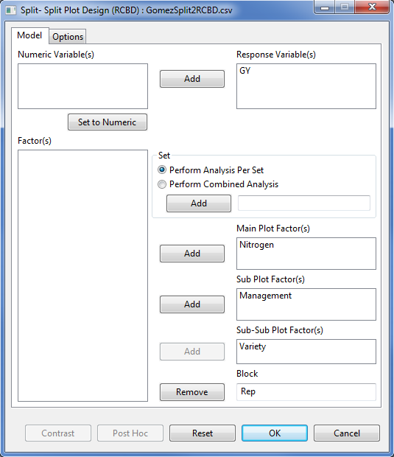

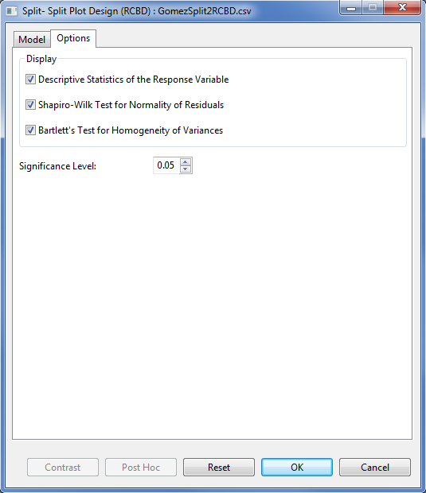

* Click **OK** button to perform the analysis. The **Split-Split Plot Design** dialog box will be minimized and STAR activates the Output page of the Result Viewer tab.

Sample text output displayed in the Output page is shown below:

Analysis of Variance

Split-Split Plot in Randomized Complete Block Design

=======================================

ANALYSIS FOR RESPONSE VARIABLE: GY

=======================================

Summary Information

----------------------------------------------

FACTOR NO. OF LEVELS LEVELS

----------------------------------------------

Nitrogen 5 N1, N2, N3, N4, N5

Management 3 M1, M2, M3

Variety 3 V1, V2, V3

Rep 3 1, 2, 3

----------------------------------------------

Number of Observations Read and Used: 135

Descriptive Statistics

-------------------------------------------

Variable N\_Obs Min Max Mean StdDev

-------------------------------------------

GY 135 3.13 10.36 6.55 1.67

-------------------------------------------

Test for Homogeneity of Variances

----------------------------------

Method DF Statistics Prob

----------------------------------

bartlett 44 44.66 0.4440

----------------------------------

Test for Normality

-------------------------------------------

Variable Method Statistics Prob

-------------------------------------------

GY\_resid Shapiro-Wilk 0.9951 0.9279

-------------------------------------------

ANOVA TABLE

Response Variable: GY

-------------------------------------------------------------------------------

Source DF Sum of Square Mean Square F Value Pr > F

-------------------------------------------------------------------------------

Rep 2 0.7320 0.3660 0.66 0.5439

Nitrogen 4 61.6408 15.4102 27.70 0.0001

Error(a) 8 4.4514 0.5564

Management 2 42.9361 21.4681 82.00 0.0000

Nitrogen:Management 8 1.1030 0.1379 0.53 0.8226

Error(b) 20 5.2363 0.2618

Variety 2 206.0132 103.0066 207.87 0.0000

Nitrogen:Variety 8 14.1445 1.7681 3.57 0.0019

Management:Variety 4 3.8518 0.9629 1.94 0.1149

Nitrogen:Management:Variety 16 3.6992 0.2312 0.47 0.9538

Error(c) 60 29.7325 0.4955

Total 134 373.5407

-------------------------------------------------------------------------------

Summary Statistics

-----------------------------------------------

Coef Var(a) Coef Var(b) Coef Var(c) GY Mean

-----------------------------------------------

11.38 7.81 10.74 6.55

-----------------------------------------------

Table of Means

Nitrogen N1 N2 N3 N4 N5

Management Variety

M1 V1 3.897000 4.232000 5.226000 4.650333 4.061667

V2 5.346000 5.921667 5.979667 6.252000 6.775667

V3 5.378333 6.781333 7.933333 7.452667 8.618000

M2 V1 4.317333 4.576333 5.732333 5.447333 5.200000

V2 4.711667 5.815000 6.500000 7.004000 7.084333

V3 6.496000 7.816667 8.567333 8.624667 9.399333

M3 V1 5.325000 5.482667 6.546333 6.236333 5.971667

V2 5.431000 6.312000 7.286000 7.517667 8.005333

V3 7.560000 9.045333 9.190667 9.251333 9.989333

Comparison of Nitrogen at each level of Variety

Least Significant Difference (LSD) Test

Alpha 0.05

Error Degrees of Freedom 43

Error Mean Square 0.5158

Critical Value 2.0160

Test Statistic 0.6826

Summary:

-----------------------------------------------------------------------------

Nitrogen N Variety = V1 group Variety = V2 group Variety = V3 group

-----------------------------------------------------------------------------

N1 9 4.5131 c 5.1629 d 6.4781 d

N2 9 4.7637 bc 6.0162 c 7.8811 c

N3 9 5.8349 a 6.5886 bc 8.5638 b

N4 9 5.4447 ab 6.9246 ab 8.4429 bc

N5 9 5.0778 bc 7.2884 a 9.3356 a

-----------------------------------------------------------------------------

\* Means with the same letter are not significantly different

Comparison of Variety at each level of Nitrogen

Least Significant Difference (LSD) Test

Alpha 0.05

Error Degrees of Freedom 60

Error Mean Square 0.4955

Critical Value 2.0003

Test Statistic 0.6638

Summary:

--------------------------------------------------------------------------------------

Variety N Nitrogen = N1 group Nitrogen = N2 group … Nitrogen = N5 group

--------------------------------------------------------------------------------------

V1 9 4.5131 b 4.7637 c … 5.0778 c

V2 9 5.1629 b 6.0162 b … 7.2884 b

V3 9 6.4781 a 7.8811 a … 9.3356 a

--------------------------------------------------------------------------------------

\* Means with the same letter are not significantly different

Pairwise Mean Comparison of Management

Least Significant Difference (LSD) Test

Alpha 0.05

Error Degrees of Freedom 20

Error Mean Square 0.2618

Critical Value 2.0860

Test Statistics 0.2250

Summary of the Result:

------------------------------

Management means N group

------------------------------

M1 5.90 45 c

M2 6.49 45 b

M3 7.28 45 a

------------------------------

\* Means with the same letter are not significantly different.

**Additional Options**

If there are still modifications to be made, the following option buttons may be used:

* **Post Hoc**

Use this option if other pairwise comparison procedures, other than what was presented in the **Output** page, are desired. There are five pairwise mean comparison procedure available, namely: Least Significant Difference Test, Duncan Multiple Range Test, Tukey’s Honest Significant Test, Student Newmann-Keul’s Test and the Scheffe’s Test. This button will be disabled if *F*-tests conducted using ANOVA yielded results that are not significant. Use of this button will be discussed in Pairwise Comparison section on this module.

* **Contrast**

This button will be enabled if there is at least one factor that has more than two levels. Use of this button will be discussed in Partitioning Sum of Squares section of this module.

## Strip-Split Plot Design

The steps to perform the Analysis of Variance in Strip-Split Plot Design are listed below:

* On the **Project Explorer**, double-click the file to be used for the analysis to open and view it in the Data Viewer.
* From the main window of STAR click **Analyze | Analysis of Variance | Strip-Split Plot Design**. The **Strip-Split Plot** dialog box will appear.
* Specify the required field and appropriate options for the analysis.

**Model Tab**

**Response Variable(s)**

For the analysis to proceed, at least one item should be entered in the list box. Only Items from the **Numeric Variable(s)** can be added in this dialog box.

**Set**

There are two options available, *perform analysis per set* (default option) and *perform combined analysis*. If default option is selected and a **Set** variable is specified, STAR will perform analysis for each level of the **Set** variable. If the default option is selected and the **Set** variable is not specified, STAR will perform the analysis as if the entire data came from only one site. If **perform combined analysis is selected**, a Set variable must be specified.

**Vertical Factor(s)**

At least one item should be added in this list box and should come from the **Factor(s)** list box.

**Horizontal Factor(s)**

At least one item should be added in this list box and should come from the **Factor(s)** list box.

**SubPlot Factor(s)**

At least one item should be added in this list box and should come from the **Factor(s)** list box.

**Block**

Only one item can be added in this field and should come from the Factor(s) list box.

**Options Tab**

**Descriptive Statistics of the Response Variable**

If this option is selected, a summary table with number of non-missing observations, minimum, maximum, mean and standard deviation of the response variable will be displayed.

**Shapiro-Wilk Test for Normality of Residuals**

If this option is selected, test for normality of residuals using Shapiro-Wilk will be displayed, if the number of observation is between 3 and 5000.

**Bartlett’s Test for Homogeneity of Variances**

If this option is selected, test for homogeneity of variances using Bartlett’s Test will be displayed.

**Significance Level**

This will be used to determine if the treatment effects and interaction effects are significant in Analysis of Variance. This is also the level of significance to be used when pairwise mean comparison is performed. Its default value is 0.05. The user can change this value by specifying a numeric value from zero to 1.

* Click OK button to perform the analysis. The Strip Plot Design dialog box will be minimized and STAR activates the Output Viewer tab and the Graph Viewer tab.

**Additional Options**

If there are still modifications to be made, the following option buttons may be used:

* **Post Hoc**

Use this option if other pairwise comparison procedures, other than what was presented in the **Output** page, are desired. There are five pairwise mean comparison procedure available, namely: Least Significant Difference Test, Duncan Multiple Range Test, Tukey’s Honest Significant Test, Student Newmann-Keul’s Test and the Scheffe’s Test. This button will be disabled if *F*-tests conducted using ANOVA yielded results that are not significant. Use of this button will be discussed in Pairwise Comparison section on this module.

* **Contrast**

This button will be enabled if there is at least one factor that has more than two levels. Use of this button will be discussed in Partitioning Sum of Squares section of this module.

## Split-Split-Split Plot Design

This analysis can be performed for Completely Randomized Design, Randomized Complete Block Design and Latin Square Design.

The steps to perform the Analysis of Variance using Split-Split-Split Plot Design are listed below:

* On the **Project Explorer**, double-click the file to be used for the analysis to open and view it in the Data Viewer.
* From the main window of STAR click **Analyze | Analysis of Variance | Split- Split- Split Plot Design**. Choose the appropriate design structure that will be used. The **Split -Split -Split Plot Design** dialog box will appear.
* Specify the required field and appropriate options for the analysis.

**Model Tab**

**Response Variable(s)**

For the analysis to proceed, at least one item should be entered in the list box. Only Items from the **Numeric Variable(s)** can be added in this dialog box.

**Set**

There are two options available, *perform analysis per set* (default option) and *perform combined analysis*. If default option is selected and a **Set** variable is specified, STAR will perform analysis for each level of the **Set** variable. If the default option is selected and the **Set** variable is not specified, STAR will perform the analysis as if the entire data came from only one site. If **perform combined analysis is selected**, a Set variable must be specified.

**Main Plot Factor(s)**

At least one item should be added in this list box and should come from the **Factor(s)** list box.

**SubPlot Factor(s)**

At least one item should be added in this list box and should come from the **Factor(s)** list box.

**Sub-SubPlot Factor(s)**

At least one item should be added in this list box and should come from the **Factor(s)** list box.

**Sub-Sub-SubPlot Factor(s)**

At least one item can be added in this list box and should come from the **Factor(s)** list box.

**Replicate**

Applicable only if Completely Randomized Design is chosen. Only one item can be added in this field and should come from the Factor(s) list box.

**Block**

Applicable only if Randomized Complete Block Design is chosen. Only one item can be added in this field and should come from the Factor(s) list box.

**Row Block**

Applicable only if Latin Square Design is chosen. Only one item can be added in this field and should come from the Factor(s) list box.

**Column Block**

Applicable only if Latin Square Design is chosen. Only one item can be added in this field and should come from the Factor(s) list box.

**Options Tab**

**Descriptive Statistics of the Response Variable**

If this option is selected, a summary table with number of non-missing observations, minimum, maximum, mean and standard deviation of the response variable will be displayed.

**Shapiro-Wilk Test for Normality of Residuals**

If this option is selected, test for normality of residuals using Shapiro-Wilk will be displayed, if the number of observation is between 3 and 5000.

**Bartlett’s Test for Homogeneity of Variances**

If this option is selected, test for homogeneity of variances using Bartlett’s Test will be displayed.

**Significance Level**

This will be used to determine if the treatment effects and interaction effects are significant in Analysis of Variance. This is also the level of significance to be used when pairwise mean comparison is performed. Its default value is 0.05. The user can change this value by specifying a numeric value from zero to 1.

* Click OK button to perform the analysis. The Split Plot Design (RCBD) dialog box will be minimized and STAR activates the Output Viewer tab and the Graph Viewer tab.

**Additional Options**

If there are still modifications to be made, the following option buttons may be used:

* **Post Hoc**

Use this option if other pairwise comparison procedures, other than what was presented in the **Output** page, are desired. There are five pairwise mean comparison procedure available, namely: Least Significant Difference Test, Duncan Multiple Range Test, Tukey’s Honest Significant Test, Student Newmann-Keul’s Test and the Scheffe’s Test. This button will be disabled if *F*-tests conducted using ANOVA yielded results that are not significant. Use of this button will be discussed in Pairwise Comparison section on this module.

* **Contrast**

This button will be enabled if there is at least one factor that has more than two levels. Use of this button will be discussed in Partitioning Sum of Squares section of this module.

## Strip-Split-Split Plot Design

The steps to perform the Analysis of Variance in Strip-Split-Split Plot Design are listed below:

* On the **Project Explorer**, double-click the file to be used for the analysis to open and view it in the Data Viewer.
* From the main window of STAR click **Analyze | Analysis of Variance | Strip-Split-Split Plot Design**. The **Strip-Split-Split Plot** dialog box will appear.
* Specify the required field and appropriate options for the analysis.

**Model Tab**

**Response Variable(s)**

For the analysis to proceed, at least one item should be entered in the list box. Only Items from the **Numeric Variable(s)** can be added in this dialog box.

**Set**

There are two options available, *perform analysis per set* (default option) and *perform combined analysis*. If default option is selected and a **Set** variable is specified, STAR will perform analysis for each level of the **Set** variable. If the default option is selected and the **Set** variable is not specified, STAR will perform the analysis as if the entire data came from only one site. If **perform combined analysis is selected**, a Set variable must be specified.

**Vertical Factor(s)**

At least one item should be added in this list box and should come from the **Factor(s)** list box.

**Horizontal Factor(s)**

At least one item should be added in this list box and should come from the **Factor(s)** list box.

**Sub Plot Factor(s)**

At least one item should be added in this list box and should come from the **Factor(s)** list box.

**Sub-Sub Plot Factor(s)**

At least one item should be added in this list box and should come from the **Factor(s)** list box.

**Block**

Only one item can be added in this field and should come from the Factor(s) list box.

**Options Tab**

**Descriptive Statistics of the Response Variable**

If this option is selected, a summary table with number of non-missing observations, minimum, maximum, mean and standard deviation of the response variable will be displayed.

**Shapiro-Wilk Test for Normality of Residuals**

If this option is selected, test for normality of residuals using Shapiro-Wilk will be displayed, if the number of observation is between 3 and 5000.

**Bartlett’s Test for Homogeneity of Variances**

If this option is selected, test for homogeneity of variances using Bartlett’s Test will be displayed.

**Significance Level**

This will be used to determine if the treatment effects and interaction effects are significant in Analysis of Variance. This is also the level of significance to be used when pairwise mean comparison is performed. Its default value is 0.05. The user can change this value by specifying a numeric value from zero to 1.

* Click OK button to perform the analysis. The Strip Plot Design dialog box will be minimized and STAR activates the Output Viewer tab and the Graph Viewer tab.

**Additional Options**

If there are still modifications to be made, the following option buttons may be used:

* **Post Hoc**

Use this option if other pairwise comparison procedures, other than what was presented in the **Output** page, are desired. There are five pairwise mean comparison procedure available, namely: Least Significant Difference Test, Duncan Multiple Range Test, Tukey’s Honest Significant Test, Student Newmann-Keul’s Test and the Scheffe’s Test. This button will be disabled if *F*-tests conducted using ANOVA yielded results that are not significant. Use of this button will be discussed in Pairwise Comparison section on this module.

* **Contrast**

This button will be enabled if there is at least one factor that has more than two levels. Use of this button will be discussed in Partitioning Sum of Squares section of this module.

## Pairwise Mean Comparison

The **Post Hoc** option is used to request for other pairwise comparison procedures. This button will be enabled if there is at least one effect that is significant.

The steps to request for other pairwise mean comparison are listed below:

* On the **Project Explorer**, using the project named *My Project*, import the data *SeedingRate* from STAR package. Double-click the file to open and view it in the Data Viewer.

* Perform the Analysis of Variance. Follow the discussion in **Randomized Complete Block Design** of this module with *SeedingRate* as Factor and *Rep* as Block.
* After performing the Analysis of Variance, the **Contrast** button will be enabled if there is at least one factor in the analysis with more than two levels.

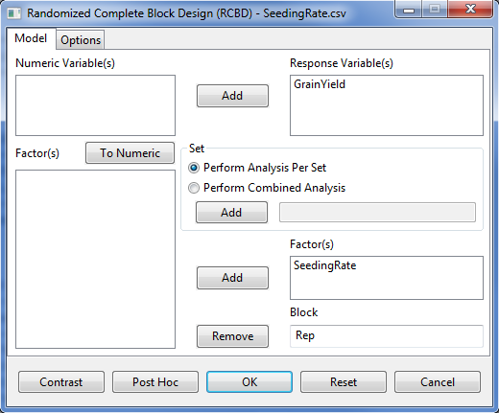

* Click the **Post Hoc** button. A dialog box will appear.

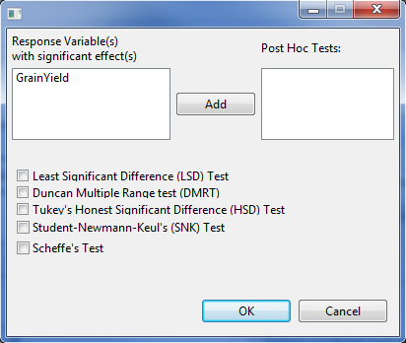

* Specify the required field and appropriate options for the analysis.

**Response Variable(s)**

This list box display all response variables with at least one significant effect. User need to select one item from this list and transfer to the **Post Hoc Test** list box to proceed with the analysis

**Post Hoc Tests**

This list box should contain at one item that will come from the Response Variable(s) list box. STAR will perform the additional pairwise comparison procedure for all effects of the response variable(s) selected.

**Pairwise Comparison Procedure**

At least one of the checkbox should be ticked for the analysis to proceed.

For the example, the completed dialog should appear as illustrated below:

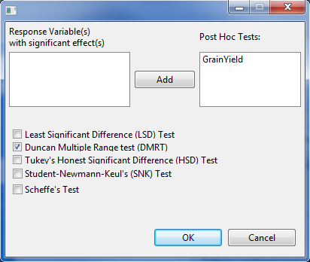

* Click the **OK** button to perform the pairwise mean comparison. The **Pairwise Comparison** dialog box will be closed. The *PairwiseOutput.txt* is created in the parent folder within the *Output* folder and STAR actives the **Result Viewer** tab.

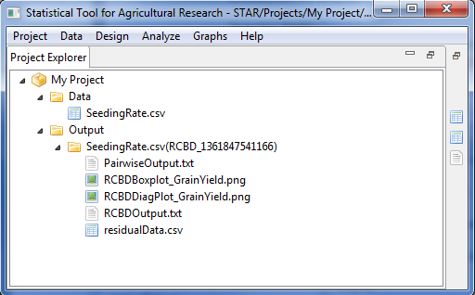

Sample content of the *PairwiseOutput.txt* displayed in the **Result Viewer** tab is shown below:

Response Variable: GrainYield

Pairwise Mean Comparison of SeedingRate

Duncan's Multiple Range Test (DMRT)

Alpha 0.05

Error Degrees of Freedom 15

Error Mean Square 0.1209

---------------------------------------------------

Number of Means 2 3 4 5 6

---------------------------------------------------

Tabular Value 3.01 3.16 3.25 3.31 3.36

Test Statistics 0.52 0.55 0.57 0.58 0.58

---------------------------------------------------

Summary of the Result:

-----------------------------

SeedingRate means N group

-----------------------------

100 4.35 4 c

125 4.67 4 bc

150 3.38 4 d

25 5.12 4 ab

50 5.08 4 ab

75 5.30 4 a

-----------------------------

\* Means with the same letter are not significantly different.

* After performing the pairwise comparison test, user can click the **OK** button to embed the requested pairwise mean comparison procedure with the Analysis of Variance output.

Sample content of the *RCBDOutput.txt* when user click the OK button after performing the pairwise comparison.

Analysis of Variance

Randomized Complete Block Design

===============================================

ANALYSIS FOR RESPONSE VARIABLE: GrainYield

===============================================

Summary Information

---------------------------------------------

FACTOR NO. OF LEVELS LEVELS

---------------------------------------------

SeedingRate 6 25, 50, ..., 150

Rep 4 1, 2, 3, 4

---------------------------------------------

Number of Observations Read and Used: 24

ANOVA TABLE

Response Variable: GrainYield

--------------------------------------------------------------

Source DF Sum of Square Mean Square F Value Pr > F

--------------------------------------------------------------

Rep 3 1.7667 0.5889 4.87 0.0147

SeedingRate 5 10.1800 2.0360 16.84 0.0000

Error 15 1.8133 0.1209

Total 23 13.7600

--------------------------------------------------------------

Summary Statistics

--------------------------

Coef Var GrainYield Mean

--------------------------

7.48 4.65

--------------------------

Standard Errors

--------------------

Effects StdErr

--------------------

Rep 0.2007

SeedingRate 0.2459

--------------------

Pairwise Mean Comparison of SeedingRate

Duncan's Multiple Range Test (DMRT)

Alpha 0.05

Error Degrees of Freedom 15

Error Mean Square 0.1209

---------------------------------------------------

Number of Means 2 3 4 5 6

---------------------------------------------------

Tabular Value 3.01 3.16 3.25 3.31 3.36

Test Statistics 0.52 0.55 0.57 0.58 0.58

---------------------------------------------------

Summary of the Result:

-----------------------------

SeedingRate means N group

-----------------------------

100 4.35 4 c

125 4.67 4 bc

150 3.38 4 d

25 5.12 4 ab

50 5.08 4 ab

75 5.30 4 a

-----------------------------

\* Means with the same letter are not significantly different.

## Partitioning Sum of Squares

The **Contrast** option isused in partitioning sum of squares that decompose the variability of the response(s) into various components to have a better view of the nature of variability. There are different selections in partitioning sum of squares such as, “Compare with Control”, “User Specified Contrast (Group Comparison)” and “Orthogonal Polynomial Contrast”.

### Group Comparison

The steps to perform the Group Comparison are listed below:

* On the **Project Explorer**, using the project named *My Project*, import the data *grp\_pss* from STAR package. Double-click the file to open and view it in the Data Viewer.

* Perform the Analysis of Variance. Follow the discussion in **Randomized Complete Block Design** of this module with *VARIETY* as Factor and *REP* as Block.
* After performing the Analysis of Variance, the **Contrast** button will be enabled if there is at least one factor in the analysis with more than two levels.

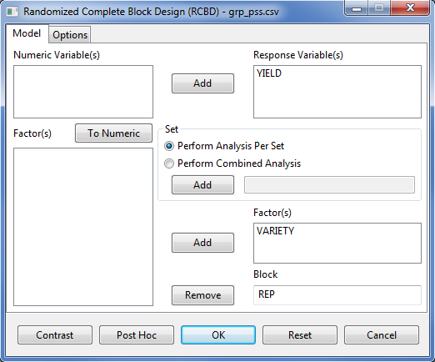

* Click the **Contrast** button. A dialog box will appear.

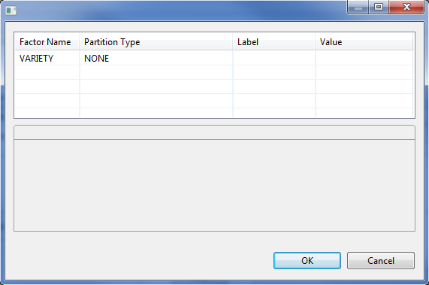

* Specify the required field and appropriate options for the analysis.

**Factor Name** column

All factors included in the analysis with more than two levels will be displayed in this column.

**Partition Type** column

Specify the type of partitioning to be performed by clicking the drop-down menu. If the levels of the factor are quantitative, the 3 choices are available, otherwise; only the choices “Compare with Control” and “User-Specified Contrast” will be available for that factor.

**Value** column

Specify the number of contrast that will be used for the analysis. The default value is 1 while the maximum number is equal to the treatment degrees of freedom.

If *User Specified Contrast* is selected, a tab will be displayed at the lower part of the Contrast Analysis dialog box to specify the coefficients for each contrast. The sum of each contrast should be equal to zero. If there are 2 or more contrasts, the sum of the cross product of each pair wise contrast should be equal to zero.

For the example, suppose we want to determine the following:

1. If the mean of the traditional variety (A) is significantly different from the new varieties (B and C).
2. If the mean of the new varieties (B and C) are significantly different.

The completed dialog box should appear as illustrated below:

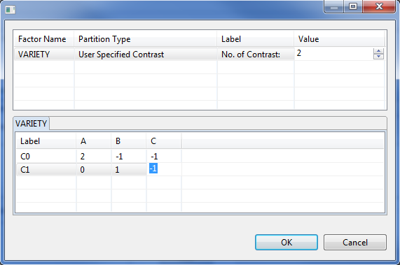

* Click the **OK** button to perform Group Comparison. The **Contrast Analysis** dialog box will be closed. The *ContrastAnalysisOutput.txt* is created in the parent folder within the *Output* folder and STAR actives the **Result Viewer** tab.

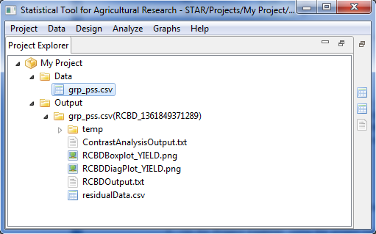

Sample content of the *ContrastAnalysisOutput.txt* displayed in the **Result Viewer** tab is shown below:

Result of Contrast Analysis

ANOVA TABLE

Response Variable: YIELD

----------------------------------------------------------------

Source DF Sum of Square Mean Square F Value Pr > F

----------------------------------------------------------------

REP 3 0.5867 0.1956 2.20 0.1889

VARIETY 2 1.0400 0.5200 5.85 0.0390

VARIETY: C0 1 0.9600 0.9600 10.80 0.0167

VARIETY: C1 1 0.0800 0.0800 0.90 0.3794

Error 6 0.5333 0.0889

Total 11 2.1600

----------------------------------------------------------------

### Trend Comparison

This procedure is applicable and available if the levels of the factor are quantitative. The steps to perform the Group Comparison are listed below:

* On the **Project Explorer**, using the project named *My Project*, import the data *OP\_pss* from STAR package. Double-click the file to open and view it in the Data Viewer.

* Perform the Analysis of Variance. Follow the discussion in **Randomized Complete Block Design** of this module with *NITROGEN* as Factor and *REP* as Block.
* After performing the Analysis of Variance, the **Contrast** button will be enabled if there is at least one factor in the analysis with more than two levels.

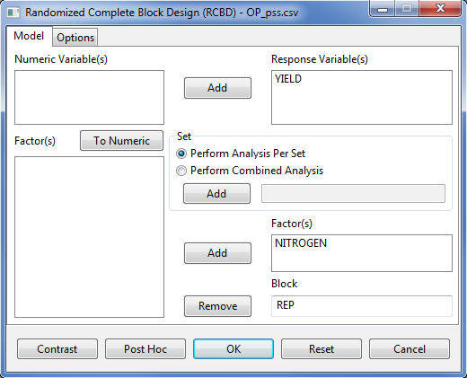

* Click the **Contrast** button. A dialog box will appear.

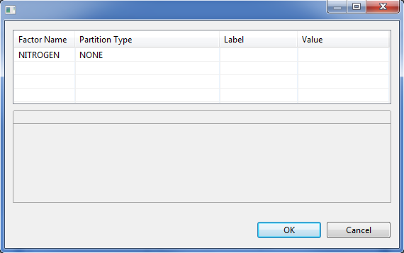

* Specify the required field and appropriate options for the analysis.

**Factor Name** column

All factors included in the analysis with more than two levels will be displayed in this column.

**Partition Type** column

Specify the type of partitioning to be performed by clicking the drop-down menu. If the levels of the factor are quantitative, the 3 choices are available, otherwise; only the choices “Compare with Control” and “User-Specified Contrast” will be available for that factor.

**Value** column

Specify the number of contrast that will be used for the analysis. The default value is 1 while the maximum number is equal to the treatment degrees of freedom.

If *User Specified Contrast* is selected, a tab will be displayed at the lower part of the Contrast Analysis dialog box to specify the coefficients for each contrast. The sum of each contrast should be equal to zero. If there are 2 or more contrasts, the sum of the cross product of each pair wise contrast should be equal to zero.

For the example, suppose we want to know the highest degree of relationship between the yield response and Nitrogen Rate. The completed dialog box should appear as illustrated below:

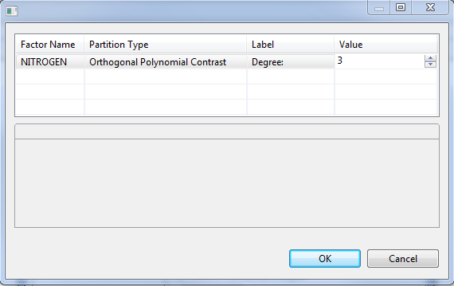

* Click the **OK** button to perform Group Comparison. The **Contrast Analysis** dialog box will be closed. The *ContrastAnalysisOutput.txt* is created in the parent folder within the *Output* folder and STAR actives the **Result Viewer** tab.

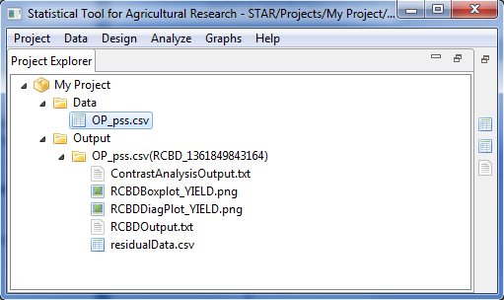

Sample text output of the analysis displayed in the Output Viewer tab is shown below:

ANOVA TABLE

Response Variable: YIELD

----------------------------------------------------------------

Source DF Sum of Square Mean Square F Value Pr > F

----------------------------------------------------------------

REP 2 0.4067 0.2033 0.65 0.5557

NITROGEN 3 11.0225 3.6742 11.73 0.0064

NITROGEN: 1 1 10.6562 10.6562 34.01 0.0011

NITROGEN: 2 1 0.1913 0.1913 0.61 0.4643

NITROGEN: 3 1 0.1750 0.1750 0.56 0.4831

Error 6 1.8800 0.3133

Total 11 13.3092

----------------------------------------------------------------

# Incomplete Block Design

The Incomplete Block submenu can be used to perform analysis for mixed model for the following design: Balanced Incomplete Block, Augmented Randomized Complete Block, Augmented Latin Square, Alpha Lattice and Row-Column design with treatment considered as fixed and the other effects as random.

## Balanced Incomplete Block Design

The steps to perform analysis for balanced incomplete block design are listed below:

* On the **Project Explorer**, double-click the file to be used for the analysis to open and view it in the Data Viewer.

For the example, using the project named *My Project*, import the data *CochranBIB* from the package. To import the data from the package, see *Importing from Package* section of this user manual.

* Choose **Analyze** | **Incomplete Block | Balanced Incomplete Block Design…** from the main window. The **Balanced Incomplete Block Design** dialog box will appear.

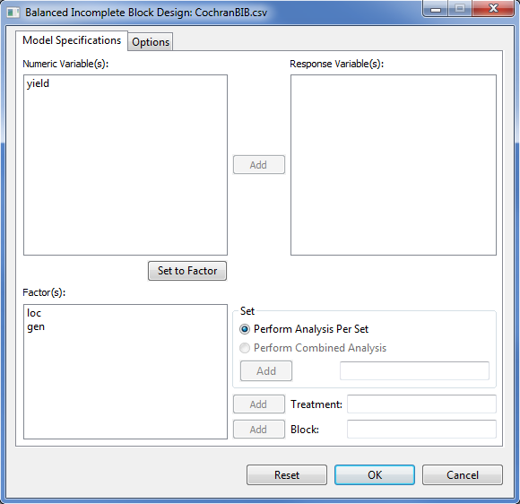

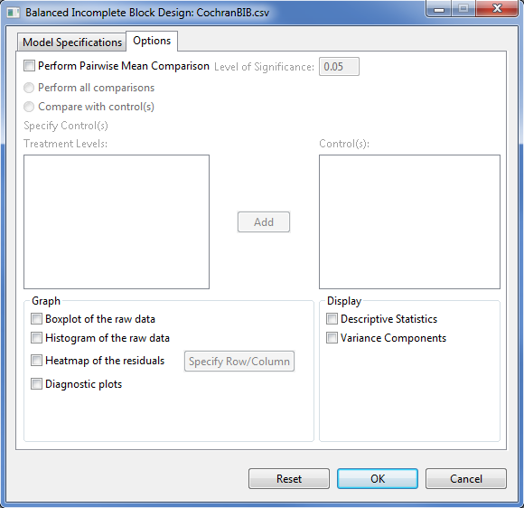

* Specify the required fields and appropriate options for the analysis.

**Model Specifications Tab**

**Response Variable(s)**

For the analysis to proceed, at least one item should be entered in the list box. The items to be entered should come from the **Numeric Variable(s)** list box.

**Set**

There are two options available, *perform analysis per set* (default) and *perform combined analysis*. If default option is selected and a **Set** variable is specified, STAR will perform analysis for each level of the **Set** variable. If the default option is selected and no **Set** variable is specified, STAR will perform the analysis as if the entire data came from only one set variable. If *perform combined analysis* is selected, a **Set** variable with at least two levels must be specified. Only one item can be added in this entry box and should come from the **Factor(s)** list box.

**Treatment**

This field is required. Only one item can be added in this entry box and should come from the **Factor(s)** list box.

**Block**

This field is required. Only one item can be added in this entry box and should come from the **Factor(s)** list box.

**Options Tab**

**Perform pairwise mean comparisons**

If this option is selected, user can either choose *Perform all comparisons* or *Compare with control(s)*. The option *Perform all comparisons* is not recommended when the number of treatment levels is very large. For now, STAR executes this option if the treatment levels is at most fifteen. If the treatment has more than 15 levels, user can only choose the option *Compare with control(s)*. If the option *Compare with control(s)* was selected, the user should specify the control levels to be compared with the rest of the treatment levels. This can be done by selecting the level(s) of the treatment that are considered as the control(s) then click the **Add** button.

**Level of Significance**

This will be enabled if *Perform pairwise mean comparison* is selected. This will be the level of significance to be used when pairwise mean comparison is performed. Its default value is 0.05.

**Display Descriptive Statistics**

If selected, a summary table with number of missing observations, mean and standard deviation will be displayed.

**Display Variance Components**

If selected, a table with the variance estimates of the some model components will be displayed.

**Graph**

Graphs like boxplot, histogram, heatmap and diagnostic plots can be generated as part of the output of the analysis. If heatmap is selected, user needs to specify a row and a column variable.

For the example, the completed **Model Specification** tab and **Options** tab should appear as illustrated:

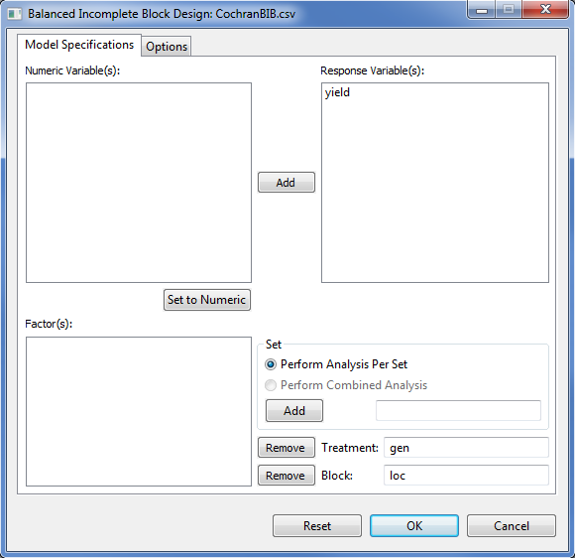

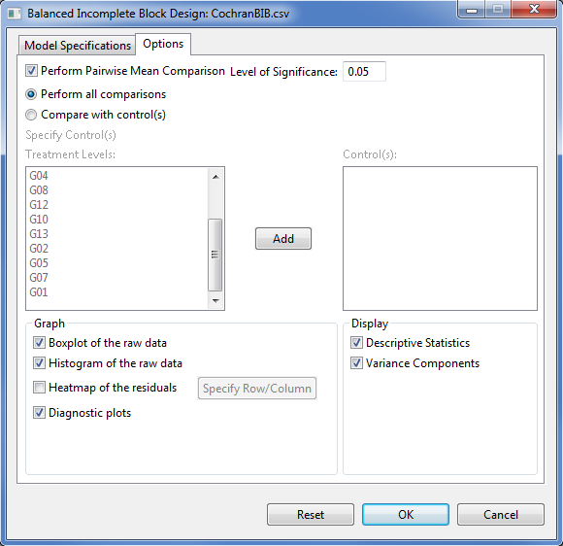

* Click **OK** button to perform the analysis. The **Augmented RCB** dialog box will be minimized and STAR activates the **Output** page of the **Result Viewer** tab.

Sample text output of the analysis is shown below:

DESIGN: Balanced Incomplete Block Design (BIBD)

==========================================

ANALYSIS FOR RESPONSE VARIABLE: yield

==========================================

Descriptive Statistics

--------------------------------------

Variable N\_NonMissObs Mean StdDev

--------------------------------------

yield 52 29.78 5.52

--------------------------------------

Summary Information

------------------------------------------

FACTOR NO. OF LEVELS LEVELS

------------------------------------------

loc 13 B01, B02, ..., B13

gen 13 G01, G02, ..., G13

------------------------------------------

Number of Observations Read and Used: 52

Estimates of Variance Components

---------------------------

Groups Variance StdDev

---------------------------

loc 6.0527 2.4602

Residual 19.9340 4.4647

---------------------------

Testing for the Significance of Genotypic Effect

Models:

model2: yield ~ 1 + (1|loc)

model1: yield ~ 1 + gen + (1|loc)

-----------------------------------------------------------------------

Source Df AIC BIC logLik Chisq Chi Df Pr(>Chisq)

-----------------------------------------------------------------------

model2 3 326.1376 331.9913 -160.0688

model1 15 328.4084 357.6770 -149.2042 21.73 12 0.0407

-----------------------------------------------------------------------

----------------------------------------------

Source Df Sum Sq Mean Sq F value Prob

----------------------------------------------

gen 12 400.63 33.39 1.67 0.0407

----------------------------------------------

gen LSMeans and Standard Error

------------------------

gen LSMean StdErrMean

------------------------

G01 34.17 2.44

G02 29.04 2.44

G03 30.11 2.44

G04 28.08 2.44

G05 30.34 2.44

G06 27.59 2.44

G07 30.76 2.44

G08 32.75 2.44

G09 28.56 2.44

G10 28.10 2.44

G11 23.47 2.44

G12 28.99 2.44

G13 35.18 2.44

------------------------

List of gen pairs that are significantly different using Tukey at alpha = 0.05

----------------------------------------

gen[i] gen[j] Estimate lwr upr

----------------------------------------

G13 G11 11.71 0.6738 22.74

----------------------------------------

Sample graphical output of the analysis is shown below:

|  |  |
| --- | --- |
| E:\AAGulles\BBI\PROGRAMS\ECLIPSE JUNO WORKSPACE\Star\Projects\Alaine Test Run\Output\CochranBIB.csv(BalancedIncompleteBlockDesign_1366939619140)\boxplotSEA_yield.png | E:\AAGulles\BBI\PROGRAMS\ECLIPSE JUNO WORKSPACE\Star\Projects\Alaine Test Run\Output\CochranBIB.csv(BalancedIncompleteBlockDesign_1366939619140)\diagPlotsSEA_yield.png |

|  |  |
| --- | --- |
| E:\AAGulles\BBI\PROGRAMS\ECLIPSE JUNO WORKSPACE\Star\Projects\Alaine Test Run\Output\CochranBIB.csv(BalancedIncompleteBlockDesign_1366939619140)\histSEA_yield.png |  |
|  |  |

## Augmented Randomized Complete Block Design

The steps to perform analysis for augmented in randomized complete block design are listed below:

* On the **Project Explorer**, double-click the file to be used for the analysis to open and view it in the Data Viewer.

For the example, using the project named *My Project*, import the data *AugRCB* from the package. To import the data from the package, see *Importing from Package* section of this user manual.

* Choose **Analyze** | **Incomplete Block | Augmented RCB…** from the main window. The **Augmented RCB** dialog box will appear.

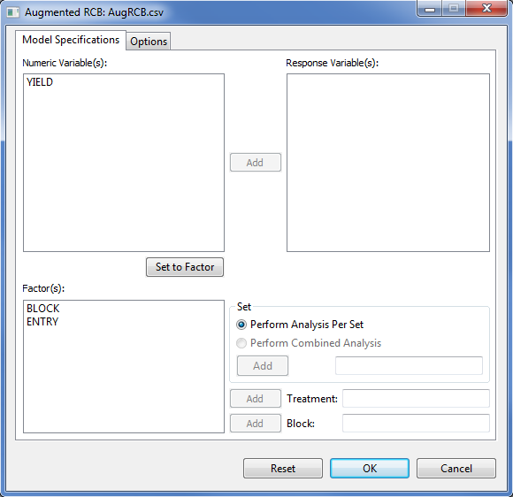

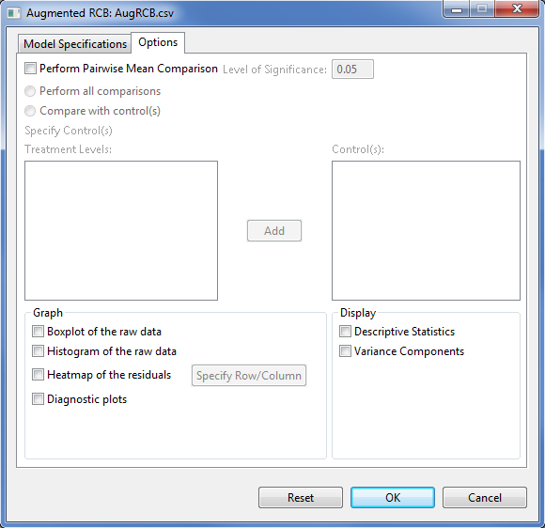

* Specify the required fields and appropriate options for the analysis.

**Model Specifications Tab**

**Response Variable(s)**

For the analysis to proceed, at least one item should be entered in the list box. The items to be entered should come from the **Numeric Variable(s)** list box.

**Set**

There are two options available, *perform analysis per set* (default) and *perform combined analysis*. If default option is selected and a **Set** variable is specified, STAR will perform analysis for each level of the **Set** variable. If the default option is selected and no **Set** variable is specified, STAR will perform the analysis as if the entire data came from only one set variable. If *perform combined analysis* is selected, a **Set** variable with at least two levels must be specified. Only one item can be added in this entry box and should come from the **Factor(s)** list box.

**Treatment**

This field is required. Only one item can be added in this entry box and should come from the **Factor(s)** list box.

**Block**

This field is required. Only one item can be added in this entry box and should come from the **Factor(s)** list box.

**Options Tab**

**Perform pairwise mean comparisons**

If this option is selected, user can either choose *Perform all comparisons* or *Compare with control(s)*. The option *Perform all comparisons* is not recommended when the number of treatment levels is very large. For now, STAR executes this option if the treatment levels is at most fifteen. If the treatment has more than 15 levels, user can only choose the option *Compare with control(s)*. If the option *Compare with control(s)* was selected, the user should specify the control levels to be compared with the rest of the treatment levels. This can be done by selecting the level(s) of the treatment that are considered as the control(s) then click the **Add** button.

**Level of Significance**

This will be enabled if *Perform pairwise mean comparison* is selected. This will be the level of significance to be used when pairwise mean comparison is performed. Its default value is 0.05.

**Display Descriptive Statistics**

If selected, a summary table with number of missing observations, mean and standard deviation will be displayed.

**Display Variance Components**

If selected, a table with the variance estimates of the some model components will be displayed.

**Graph**

Graphs like boxplot, histogram, heatmap and diagnostic plots can be generated as part of the output of the analysis. If heatmap is selected, user needs to specify a row and a column variable.

For the example, the completed **Model Specification** tab and **Options** tabshould appear as illustrated:

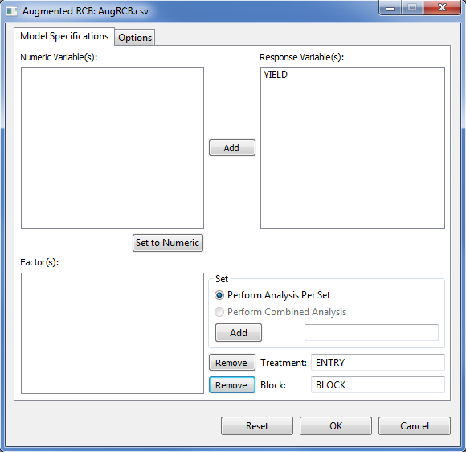

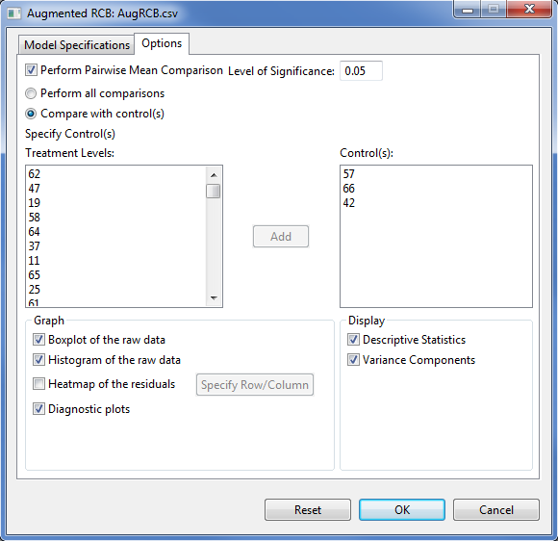

* Click **OK** button to perform the analysis. The **Augmented RCB** dialog box will be minimized and STAR activates the **Output** page of the **Result Viewer** tab.

Sample text output of the analysis is shown below:

DESIGN: Augmented Randomized Complete Block (ARCB)

==========================================

ANALYSIS FOR RESPONSE VARIABLE: YIELD

==========================================

Descriptive Statistics

-------------------------------------

Variable N\_NonMissObs Mean StdDev

-------------------------------------

YIELD 84 4.33 1.38

-------------------------------------

Summary Information

-------------------------------------

FACTOR NO. OF LEVELS LEVELS

-------------------------------------

BLOCK 4 1, 2, 3, 4

ENTRY 66 1, 2, ..., 66

-------------------------------------

Number of Observations Read and Used: 84

Estimates of Variance Components

---------------------------

Groups Variance StdDev

---------------------------

BLOCK 0.0000 0.0000

Residual 0.8766 0.9362

---------------------------

Testing for the Significance of Genotypic Effect

Models:

model2: YIELD ~ 1 + (1|BLOCK)

model1: YIELD ~ 1 + ENTRY + (1|BLOCK)

------------------------------------------------------------------------

Source Df AIC BIC logLik Chisq Chi Df Pr(>Chisq)

------------------------------------------------------------------------

model2 3 296.3952 303.6877 -145.1976

model1 68 233.7532 399.0488 -48.8766 192.64 65 0.0000

------------------------------------------------------------------------

----------------------------------------------

Source Df Sum Sq Mean Sq F value Prob

----------------------------------------------

ENTRY 65 141.50 2.18 2.48 0.0000

----------------------------------------------

ENTRY LSMeans and Standard Error

--------------------------

ENTRY LSMean StdErrMean

--------------------------

1 6.35 0.9362

2 6.50 0.9362

3 3.95 0.9362

4 5.60 0.9362

5 2.00 0.9362

6 3.50 0.9362

7 4.55 0.9362

8 3.90 0.9362

9 4.20 0.9362

10 1.05 0.9362

11 3.75 0.9362

12 3.80 0.9362

13 4.40 0.9362

14 2.60 0.9362

15 3.40 0.9362

16 8.25 0.9362

17 4.25 0.9362

18 4.35 0.9362

19 5.90 0.9362

20 4.40 0.9362

21 1.80 0.9362

22 3.45 0.9362

23 5.50 0.9362

24 5.40 0.9362

25 4.80 0.9362

26 4.70 0.9362

27 4.90 0.9362

28 3.75 0.9362

29 6.20 0.9362

30 4.50 0.9362

31 2.40 0.9362

32 4.00 0.9362

33 3.90 0.9362

34 6.60 0.9362

35 5.30 0.9362

36 3.90 0.9362

37 5.15 0.9362

38 3.70 0.9362

39 5.30 0.9362

40 7.00 0.9362

41 4.70 0.9362

42 3.40 0.9362

43 1.50 0.9362

44 4.05 0.9362

45 5.55 0.9362

46 5.60 0.9362

47 3.85 0.9362

48 3.40 0.9362

49 3.40 0.9362

50 4.90 0.9362

51 3.20 0.9362

52 2.00 0.9362

53 3.00 0.9362

54 4.05 0.9362

55 2.20 0.9362

56 3.05 0.9362

57 6.50 0.9362

58 7.00 0.9362

59 4.40 0.9362

60 7.50 0.9362

61 3.74 0.4681

62 4.34 0.4681

63 3.51 0.4681

64 4.55 0.4681

65 5.10 0.4681

66 4.17 0.4681

--------------------------

List of ENTRY pairs that are significantly different using Dunnett at alpha = 0.05

Compare with control = 57

----------------------------------------

ENTRY Control Estimate lwr upr

----------------------------------------

5 57 -4.50 -8.71 -0.29

10 57 -5.45 -9.66 -1.24

21 57 -4.70 -8.91 -0.49

43 57 -5.00 -9.21 -0.79

52 57 -4.50 -8.71 -0.29

55 57 -4.30 -8.51 -0.09

----------------------------------------

Compare with control = 66

---------------------------------------

ENTRY Control Estimate lwr upr

---------------------------------------

16 66 4.08 0.5904 7.56

---------------------------------------

Compare with control = 42

---------------------------------------

ENTRY Control Estimate lwr upr

---------------------------------------

16 42 4.85 0.6388 9.06

---------------------------------------

Sample graphical output of the analysis is shown below:

|  |  |
| --- | --- |
| E:\AAGulles\BBI\PROGRAMS\ECLIPSE JUNO WORKSPACE\Star\Projects\Alaine Test Run\Output\AugRCB.csv(BalancedIncompleteBlockDesign_1366793219547)\boxplotSEA_YIELD.png | E:\AAGulles\BBI\PROGRAMS\ECLIPSE JUNO WORKSPACE\Star\Projects\Alaine Test Run\Output\AugRCB.csv(BalancedIncompleteBlockDesign_1366793219547)\diagPlotsSEA_YIELD.png |

|  |  |
| --- | --- |
| E:\AAGulles\BBI\PROGRAMS\ECLIPSE JUNO WORKSPACE\Star\Projects\Alaine Test Run\Output\AugRCB.csv(BalancedIncompleteBlockDesign_1366793219547)\histSEA_YIELD.png |  |

## Augmented Latin Square Design

The steps to perform analysis for Incomplete Block Design are listed below:

* On the **Project Explorer**, double-click the file to be used for the analysis to open and view it in the Data Viewer.

For the example, using the project named *My Project*, import the data *AugLS* from the package. To import the data from the package, see Importing from Package section of this user manual.

* Choose **Analyze | Incomplete Block | Augmented Latin Square…** from the main window. **The Augmented Latin Square** dialog box will appear.

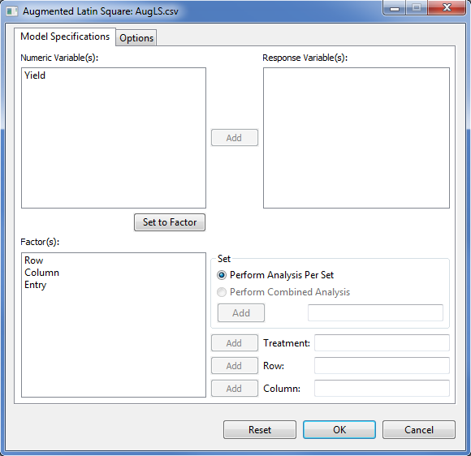

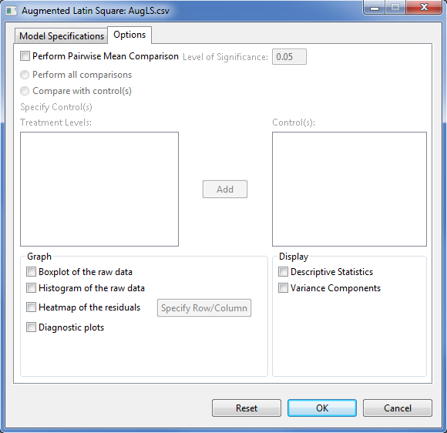

* Specify the required fields and appropriate options for the analysis.

**Model Specifications Tab**

**Response Variable(s)**

For the analysis to proceed, at least one item should be entered in the list box. The items to be entered should come from the **Numeric Variable(s)** list box.

**Set**

There are two options available, *perform analysis per set* (default) and *perform combined analysis*. If default option is selected and a **Set** variable is specified, STAR will perform analysis for each level of the **Set** variable. If the default option is selected and no **Set** variable is specified, STAR will perform the analysis as if the entire data came from only one set variable. If *perform combined analysis* is selected, a **Set** variable with at least two levels must be specified. Only one item can be added in this entry box and should come from the **Factor(s)** list box.

**Treatment**

This field is required. Only one item can be added in this entry box and should come from the **Factor(s)** list box.

**Row**

This field is required. Only one item can be added in this entry box and should come from the **Factor(s)** list box.

**Column**

This field is required. Only one item can be added in this entry box and should come from the **Factor(s)** list box.

**Options Tab**

**Perform pairwise mean comparisons**

If this option is selected, user can either choose *Perform all comparisons* or *Compare with control(s)*. The option *Perform all comparisons* is not recommended when the number of treatment levels is very large. For now, STAR executes this option if the treatment levels is at most fifteen. If the treatment has more than 15 levels, user can only choose the option *Compare with control(s)*. If the option *Compare with control(s)* was selected, the user should specify the control levels to be compared with the rest of the treatment levels. This can be done by selecting the level(s) of the treatment that are considered as the control(s) then click the **Add** button.

**Level of Significance**

This will be enabled if *Perform pairwise mean comparison* is selected. This will be the level of significance to be used when pairwise mean comparison is performed. Its default value is 0.05.

**Display Descriptive Statistics**

If selected, a summary table with number of missing observations, mean and standard deviation will be displayed.

**Display Variance Components**

If selected, a table with the variance estimates of the some model components will be displayed.

**Graph**

Graphs like boxplot, histogram, heatmap and diagnostic plots can be generated as part of the output of the analysis. If heatmap is selected, user needs to specify a row and a column variable.

For the example, the completed **Model Specification** tab and **Options** tabshould appear as illustrated:

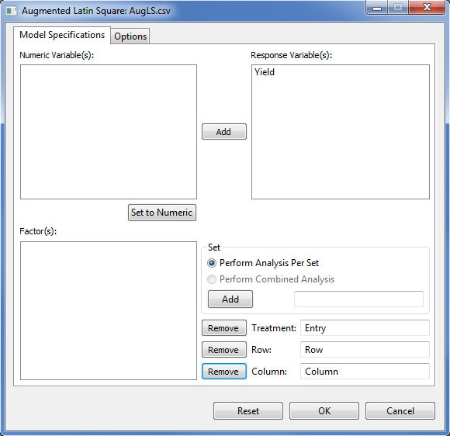

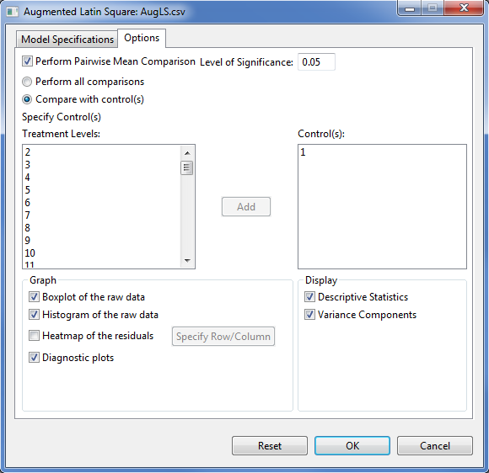

* Click **OK** button to perform the analysis. The **Augmented Latin Square** dialog box will be minimized and STAR activates the **Output** page of the **Result Viewer** tab.

Sample text output of the analysis is shown below:

DESIGN: Augmented Latin Square

==========================================

ANALYSIS FOR RESPONSE VARIABLE: Yield

==========================================

Descriptive Statistics

-------------------------------------

Variable N\_NonMissObs Mean StdDev

-------------------------------------

Yield 75 4.78 1.91

-------------------------------------

Summary Information

-------------------------------------

FACTOR NO. OF LEVELS LEVELS

-------------------------------------

Row 15 1, 10, ..., 9

Column 5 1, 2, 3, 4, 5

Entry 55 1, 2, ..., 55

-------------------------------------

Number of Observations Read and Used: 75

Estimates of Variance Components

---------------------------

Groups Variance StdDev

---------------------------

Row 0.6662 0.8162

Column 0.2305 0.4801

Residual 1.8242 1.3506

---------------------------

Testing for the Significance of Genotypic Effect

Models:

model2: Yield ~ 1 + (1|Row) + (1|Column)

model1: Yield ~ 1 + Entry + (1|Row) + (1|Column)

------------------------------------------------------------------------

Source Df AIC BIC logLik Chisq Chi Df Pr(>Chisq)

------------------------------------------------------------------------

model2 4 316.9567 326.2267 -154.4784

model1 58 291.0435 425.4578 -87.5217 133.91 54 0.0000

------------------------------------------------------------------------

----------------------------------------------

Source Df Sum Sq Mean Sq F value Prob

----------------------------------------------

Entry 54 179.50 3.32 1.82 0.0000

----------------------------------------------

Entry LSMeans and Standard Error

--------------------------

Entry LSMean StdErrMean

--------------------------

1 4.24 1.63

2 6.39 1.63

3 3.72 1.63

4 9.89 1.63

5 4.29 1.63

6 5.67 1.63

7 8.75 1.63

8 5.14 1.63

9 4.36 1.63

10 3.18 1.63

11 4.36 1.63

12 6.04 1.63

13 3.27 1.63

14 6.10 1.63

15 8.06 1.63

16 4.76 1.63

17 4.11 1.63

18 6.08 1.63

19 2.39 1.63

20 5.99 1.63

21 3.58 1.63

22 2.75 1.63

23 8.06 1.63

24 6.16 1.63

25 3.66 1.63

26 2.68 1.63

27 3.75 1.63

28 2.41 1.63

29 6.23 1.63

30 4.61 1.63

31 4.21 1.63

32 9.11 1.63

33 7.58 1.63

34 3.19 1.63

35 5.84 1.63

36 6.68 1.63

37 0.96 1.63

38 4.02 1.63

39 5.60 1.63

40 3.89 1.63

41 2.51 1.63

42 2.89 1.63

43 4.08 1.63

44 5.41 1.63

45 2.91 1.63

46 5.51 1.63

47 7.82 1.63

48 3.91 1.63

49 4.48 1.63

50 4.20 1.63

51 3.25 0.74

52 4.40 0.74

53 6.02 0.74

54 3.62 0.74

55 5.28 0.74

--------------------------

List of Entry pairs that are significantly different using Dunnett at alpha = 0.05

Compare with control = 51

----------------------------------------

Entry Control Estimate lwr upr

----------------------------------------

4 51 6.63 0.8524 12.41

32 51 5.85 0.0730 11.63

----------------------------------------

Compare with control = 54

----------------------------------------

Entry Control Estimate lwr upr

----------------------------------------

4 54 6.27 0.4892 12.05

----------------------------------------

Sample graphical output:

|  |  |
| --- | --- |
| E:\AAGulles\BBI\PROGRAMS\ECLIPSE JUNO WORKSPACE\Star\Projects\Alaine Test Run\Output\AugLS.csv(BalancedIncompleteBlockDesign_1366945211646)\boxplotSEA_Yield.png | E:\AAGulles\BBI\PROGRAMS\ECLIPSE JUNO WORKSPACE\Star\Projects\Alaine Test Run\Output\AugLS.csv(BalancedIncompleteBlockDesign_1366945211646)\diagPlotsSEA_Yield.png |
| E:\AAGulles\BBI\PROGRAMS\ECLIPSE JUNO WORKSPACE\Star\Projects\Alaine Test Run\Output\AugLS.csv(BalancedIncompleteBlockDesign_1366945211646)\histSEA_Yield.png |  |

## Alpha Lattice Design

The steps to perform analysis for Incomplete Block Design are listed below:

* On the **Project Explorer**, double-click the file to be used for the analysis to open and view it in the Data Viewer.

For the example, using the project named *My Project*, import the data *JohnAlpha* from the package. To import the data from the package, see *Importing from Package* section of this user manual.

* Choose **Analyze | Incomplete Block | Augmented Latin Square…** from the main window. **The Alpha-Lattice** dialog box will appear.

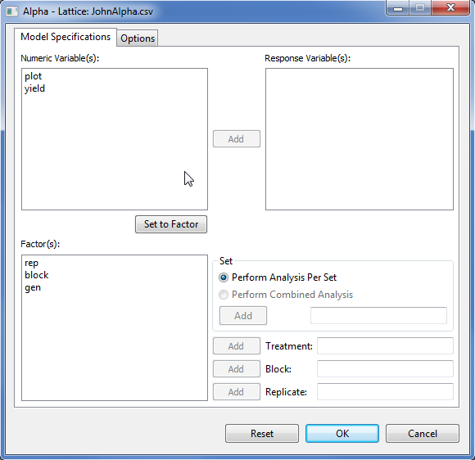

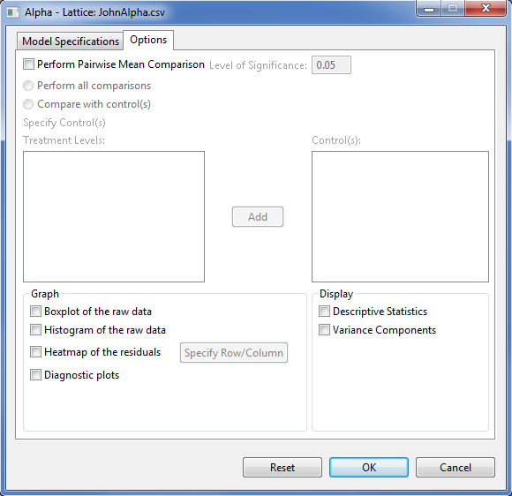

* Specify the required fields and appropriate options for the analysis.

**Model Specifications Tab**

**Response Variable(s)**

For the analysis to proceed, at least one item should be entered in the list box. The items to be entered should come from the **Numeric Variable(s)** list box.

**Set**

There are two options available, *perform analysis per set* (default) and *perform combined analysis*. If default option is selected and a **Set** variable is specified, STAR will perform analysis for each level of the **Set** variable. If the default option is selected and no **Set** variable is specified, STAR will perform the analysis as if the entire data came from only one set variable. If *perform combined analysis* is selected, a **Set** variable with at least two levels must be specified. Only one item can be added in this entry box and should come from the **Factor(s)** list box.

**Treatment**

This field is required. Only one item can be added in this entry box and should come from the **Factor(s)** list box.

**Block**

This field is required. Only one item can be added in this entry box and should come from the **Factor(s)** list box.

**Replicate**

This field is required. Only one item can be added in this entry box and should come from the **Factor(s)** list box.

**Options Tab**

**Perform pairwise mean comparisons**

If this option is selected, user can either choose *Perform all comparisons* or *Compare with control(s)*. The option *Perform all comparisons* is not recommended when the number of treatment levels is very large. For now, STAR executes this option if the treatment levels is at most fifteen. If the treatment has more than 15 levels, user can only choose the option *Compare with control(s)*. If the option *Compare with control(s)* was selected, the user should specify the control levels to be compared with the rest of the treatment levels. This can be done by selecting the level(s) of the treatment that are considered as the control(s) then click the **Add** button.

**Level of Significance**

This will be enabled if *Perform pairwise mean comparison* is selected. This will be the level of significance to be used when pairwise mean comparison is performed. Its default value is 0.05.

**Display Descriptive Statistics**

If selected, a summary table with number of missing observations, mean and standard deviation will be displayed.

**Display Variance Components**

If selected, a table with the variance estimates of the some model components will be displayed.

**Graph**

Graphs like boxplot, histogram, heatmap and diagnostic plots can be generated as part of the output of the analysis. If heatmap is selected, user needs to specify a row and a column variable.

For the example, the completed **Model Specification** tab and **Options** tabshould appear as illustrated:

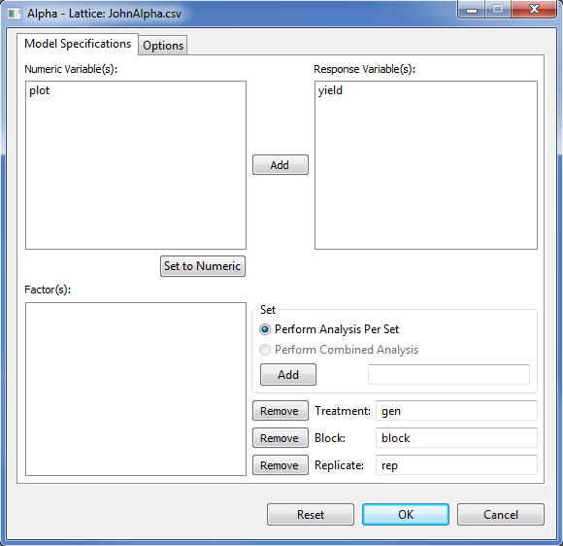

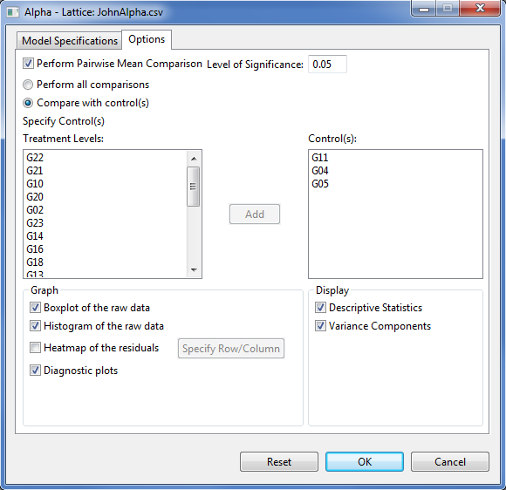

* Click **OK** button to perform the analysis. The **Alpha Lattice** dialog box will be minimized and STAR activates the **Output** page of the **Result Viewer** tab.

Sample text output of the analysis is shown below:

DESIGN: Alpha Lattice

==========================================

ANALYSIS FOR RESPONSE VARIABLE: yield

==========================================

Descriptive Statistics

-------------------------------------

Variable N\_NonMissObs Mean StdDev

-------------------------------------

yield 72 4.48 0.6098

-------------------------------------

Summary Information

------------------------------------------

FACTOR NO. OF LEVELS LEVELS

------------------------------------------

rep 3 R1, R2, R3

block 6 B1, B2, ..., B6

gen 24 G01, G02, ..., G24

------------------------------------------

Number of Observations Read and Used: 72

Estimates of Variance Components

----------------------------

Groups Variance StdDev

----------------------------

block:rep 0.0619 0.2489

rep 0.1139 0.3376

Residual 0.0852 0.2919

----------------------------

Testing for the Significance of Genotypic Effect

Models:

model2: yield ~ 1 + (1|rep/block)

model1: yield ~ 1 + gen + (1|rep/block)

----------------------------------------------------------------------

Source Df AIC BIC logLik Chisq Chi Df Pr(>Chisq)

----------------------------------------------------------------------

model2 4 125.9362 135.0428 -58.9681

model1 27 81.7070 143.1770 -13.8535 90.23 23 0.0000

----------------------------------------------------------------------

----------------------------------------------

Source Df Sum Sq Mean Sq F value Prob

----------------------------------------------

gen 23 10.68 0.4643 5.45 0.0000

----------------------------------------------

gen LSMeans and Standard Error

------------------------

gen LSMean StdErrMean

------------------------

G01 5.11 0.2761

G02 4.48 0.2761

G03 3.50 0.2761

G04 4.49 0.2761

G05 5.04 0.2760

G06 4.54 0.2760

G07 4.11 0.2761

G08 4.53 0.2761

G09 3.50 0.2760

G10 4.37 0.2761

G11 4.28 0.2761

G12 4.76 0.2761

G13 4.76 0.2760

G14 4.78 0.2760

G15 4.97 0.2760

G16 4.73 0.2761

G17 4.60 0.2760

G18 4.36 0.2761

G19 4.84 0.2760

G20 4.04 0.2760

G21 4.80 0.2760

G22 4.53 0.2760

G23 4.25 0.2760

G24 4.15 0.2761

------------------------

List of gen pairs that are significantly different using Dunnett at alpha = 0.05

Compare with control = G11

-------------------------------------

gen Control Estimate lwr upr

-------------------------------------

G01 G11 0.8244 0.0671 1.58

-------------------------------------

Compare with control = G04

--------------------------------------

gen Control Estimate lwr upr

--------------------------------------

G03 G04 -0.9909 -1.78 -0.1993

G09 G04 -0.9879 -1.78 -0.1962

--------------------------------------

Compare with control = G05

---------------------------------------

gen Control Estimate lwr upr

---------------------------------------

G03 G05 -1.54 -2.30 -0.7760

G07 G05 -0.93 -1.69 -0.1665

G09 G05 -1.54 -2.30 -0.7734

G20 G05 -1.00 -1.75 -0.2403

G24 G05 -0.88 -1.67 -0.0919

---------------------------------------

Sample graphical output:

|  |  |
| --- | --- |
| E:\AAGulles\BBI\PROGRAMS\ECLIPSE JUNO WORKSPACE\Star\Projects\Alaine Test Run\Output\JohnAlpha.csv(BalancedIncompleteBlockDesign_1366947159103)\boxplotSEA_yield.png | E:\AAGulles\BBI\PROGRAMS\ECLIPSE JUNO WORKSPACE\Star\Projects\Alaine Test Run\Output\JohnAlpha.csv(BalancedIncompleteBlockDesign_1366947159103)\diagPlotsSEA_yield.png |
| E:\AAGulles\BBI\PROGRAMS\ECLIPSE JUNO WORKSPACE\Star\Projects\Alaine Test Run\Output\JohnAlpha.csv(BalancedIncompleteBlockDesign_1366947159103)\histSEA_yield.png |  |

## Row-Column Design

The steps to perform analysis for Incomplete Block Design are listed below:

* On the **Project Explorer**, double-click the file to be used for the analysis to open and view it in the Data Viewer.

For the example, using the project named *My Project*, import the data *KemptonRowCol* from the package. To import the data from the package, see Importing from Package section of this user manual.

* Choose **Analyze | Incomplete Block | Augmented Latin Square…** from the main window. The **Row-Column** dialog box will appear.

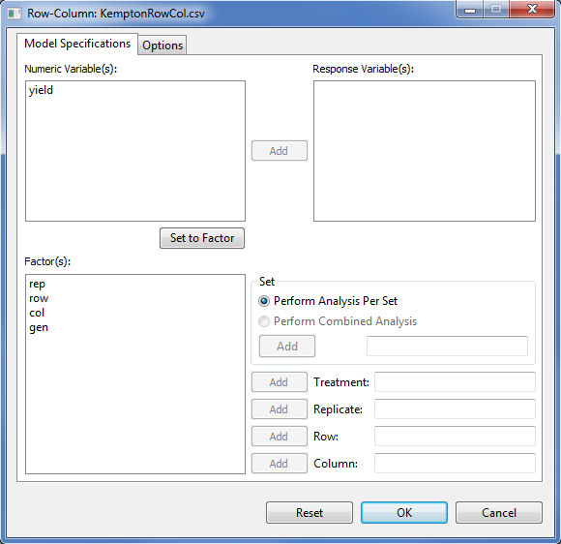

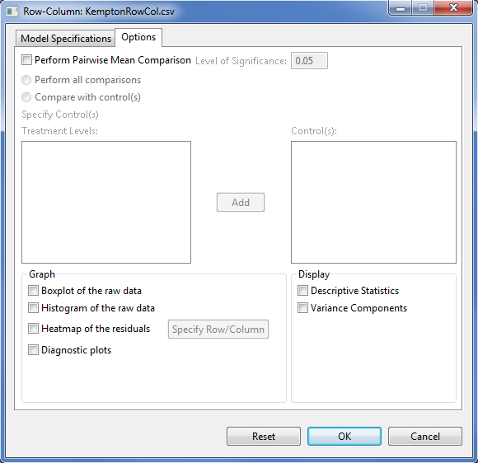

* Specify the required fields and appropriate options for the analysis.

**Model Specifications Tab**

**Response Variable(s)**

For the analysis to proceed, at least one item should be entered in the list box. The items to be entered should come from the **Numeric Variable(s)** list box.

**Set**

There are two options available, *perform analysis per set* (default) and *perform combined analysis*. If default option is selected and a **Set** variable is specified, STAR will perform analysis for each level of the **Set** variable. If the default option is selected and no **Set** variable is specified, STAR will perform the analysis as if the entire data came from only one set variable. If *perform combined analysis* is selected, a **Set** variable with at least two levels must be specified. Only one item can be added in this entry box and should come from the **Factor(s)** list box.

**Treatment**

This field is required. Only one item can be added in this entry box and should come from the **Factor(s)** list box.

**Replicate**

This field is required. Only one item can be added in this entry box and should come from the **Factor(s)** list box.

**Row**

This field is required. Only one item can be added in this entry box and should come from the **Factor(s)** list box.

**Column**

This field is required. Only one item can be added in this entry box and should come from the **Factor(s)** list box.

**Options Tab**

**Perform pairwise mean comparisons**

If this option is selected, user can either choose *Perform all comparisons* or *Compare with control(s)*. The option *Perform all comparisons* is not recommended when the number of treatment levels is very large. For now, STAR executes this option if the treatment levels is at most fifteen. If the treatment has more than 15 levels, user can only choose the option *Compare with control(s)*. If the option *Compare with control(s)* was selected, the user should specify the control levels to be compared with the rest of the treatment levels. This can be done by selecting the level(s) of the treatment that are considered as the control(s) then click the **Add** button.

**Level of Significance**

This will be enabled if *Perform pairwise mean comparison* is selected. This will be the level of significance to be used when pairwise mean comparison is performed. Its default value is 0.05.

**Display Descriptive Statistics**

If selected, a summary table with number of missing observations, mean and standard deviation will be displayed.

**Display Variance Components**

If selected, a table with the variance estimates of the some model components will be displayed.

**Graph**

Graphs like boxplot, histogram, heatmap and diagnostic plots can be generated as part of the output of the analysis. If heatmap is selected, user needs to specify a row and a column variable.

For the example, the completed **Model Specification** tab and **Options** tabshould appear as illustrated:

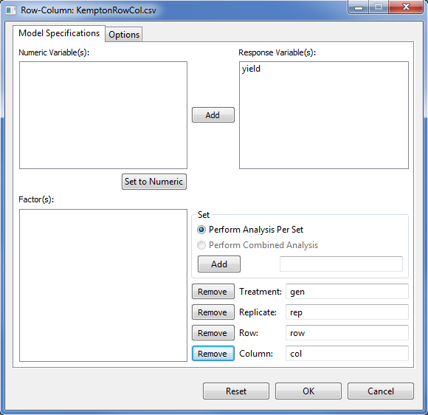

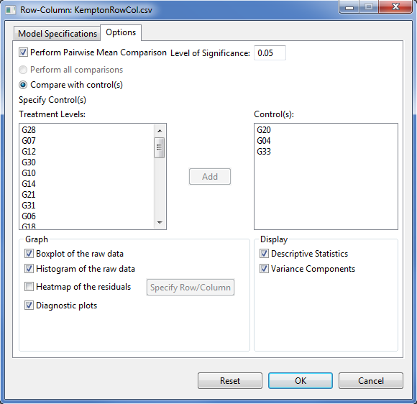

* Click **OK** button to perform the analysis. The **Row-Column** dialog box will be minimized and STAR activates the **Output** page of the **Result Viewer** tab.

Sample text output of the analysis is shown below:

DESIGN: Row-Column

==========================================

ANALYSIS FOR RESPONSE VARIABLE: yield

==========================================

Descriptive Statistics

-------------------------------------

Variable N\_NonMissObs Mean StdDev

-------------------------------------

yield 68 4.39 0.9997

-------------------------------------

Summary Information

------------------------------------------

FACTOR NO. OF LEVELS LEVELS

------------------------------------------

rep 2 R1, R2

row 5 1, 2, 3, 4, 5

col 7 1, 2, ..., 7

gen 35 G01, G02, ..., G35

------------------------------------------

Number of Observations Read and Used: 68

Estimates of Variance Components

---------------------------

Groups Variance StdDev

---------------------------

rep:col 0.1927 0.4389

rep:row 0.0639 0.2527

rep 0.7036 0.8388

Residual 0.0902 0.3003

---------------------------

Testing for the Significance of Genotypic Effect

Models:

model2: yield ~ 1 + (1|rep) + (1|rep:row) + (1|rep:col)

model1: yield ~ 1 + gen + (1|rep) + (1|rep:row) + (1|rep:col)

-----------------------------------------------------------------------

Source Df AIC BIC logLik Chisq Chi Df Pr(>Chisq)

-----------------------------------------------------------------------

model2 5 160.7747 171.8723 -75.3874

model1 39 100.3049 186.8657 -11.1524 128.47 34 0.0000

-----------------------------------------------------------------------

----------------------------------------------

Source Df Sum Sq Mean Sq F value Prob

----------------------------------------------

gen 34 15.02 0.4416 4.90 0.0000

----------------------------------------------

gen LSMeans and Standard Error

------------------------

gen LSMean StdErrMean

------------------------

G01 4.81 0.6625

G02 3.92 0.6641

G03 5.10 0.6649

G04 3.52 0.6629

G05 4.40 0.6643

G06 5.41 0.6653

G07 5.09 0.6629

G08 4.60 0.6654

G09 4.35 0.6634

G10 4.33 0.6644

G11 4.93 0.6638

G12 4.95 0.6676

G13 4.68 0.6653

G14 4.76 0.6631

G15 3.21 0.7270

G16 3.96 0.7254

G17 4.15 0.6655

G18 4.56 0.6646

G19 5.67 0.6650

G20 4.32 0.6623

G21 4.59 0.6627

G22 4.01 0.6647

G23 3.42 0.6628

G24 3.89 0.6623

G25 4.64 0.6647

G26 3.76 0.6666

G27 4.70 0.6651

G28 4.29 0.6646

G29 3.79 0.6638

G30 3.95 0.6630

G31 3.86 0.6643

G32 4.26 0.6638

G33 4.91 0.6653

G34 4.30 0.6623

G35 3.60 0.6644

------------------------

List of gen pairs that are significantly different using Dunnett at alpha = 0.05

Compare with control = G20

-------------------------------------

gen Control Estimate lwr upr

-------------------------------------

G19 G20 1.35 0.2005 2.50

-------------------------------------

Compare with control = G04

-------------------------------------

gen Control Estimate lwr upr

-------------------------------------

G01 G04 1.29 0.1485 2.44

G03 G04 1.58 0.4511 2.70

G06 G04 1.89 0.7015 3.08

G07 G04 1.56 0.4606 2.67

G11 G04 1.41 0.3262 2.49

G12 G04 1.43 0.3195 2.53

G13 G04 1.16 0.0313 2.29

G14 G04 1.24 0.1567 2.33

G19 G04 2.15 0.9890 3.31

G25 G04 1.12 0.0231 2.22

G27 G04 1.18 0.0044 2.35

G33 G04 1.39 0.2750 2.51

-------------------------------------

Compare with control = G33

--------------------------------------

gen Control Estimate lwr upr

--------------------------------------

G04 G33 -1.39 -2.51 -0.2784

G15 G33 -1.70 -3.23 -0.1696

G23 G33 -1.49 -2.67 -0.3130

G35 G33 -1.31 -2.52 -0.1095

--------------------------------------

Sample graphical output:

|  |  |
| --- | --- |
| E:\AAGulles\BBI\PROGRAMS\ECLIPSE JUNO WORKSPACE\Star\Projects\Alaine Test Run\Output\KemptonRowCol.csv(BalancedIncompleteBlockDesign_1366948123766)\boxplotSEA_yield.png | E:\AAGulles\BBI\PROGRAMS\ECLIPSE JUNO WORKSPACE\Star\Projects\Alaine Test Run\Output\KemptonRowCol.csv(BalancedIncompleteBlockDesign_1366948123766)\diagPlotsSEA_yield.png |
| E:\AAGulles\BBI\PROGRAMS\ECLIPSE JUNO WORKSPACE\Star\Projects\Alaine Test Run\Output\KemptonRowCol.csv(BalancedIncompleteBlockDesign_1366948123766)\histSEA_yield.png |  |

# Correlation Analysis

The **Correlation Analysis** is used to determine the strength of linear relationship between variables. The **Correlation Analysis** submenu performs bivariate correlation using the pearson’s correlation coefficient, spearman’s rho and kendall tau. By default, it uses the pearson’s correlation coefficient.

The steps to perform Correlation Analysis are listed below:

* On the **Project Explorer**, double-click the file to be used for the analysis open and view it in the Data Viewer tab.

For the example, using the project named *My Project*,import the data *Corr* from the package. To import the data from the package, see *Importing from Package* section of this user manual.

* Click **Analyze | Correlation…** from the main window. The **Correlation Analysis** dialog box will appear.

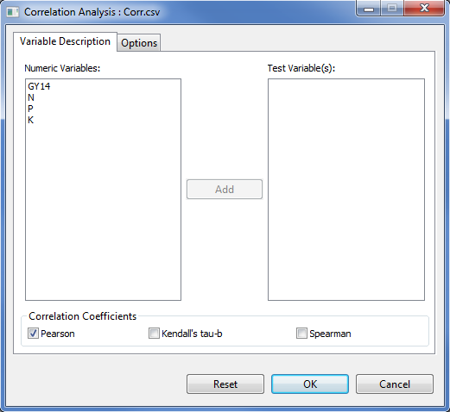

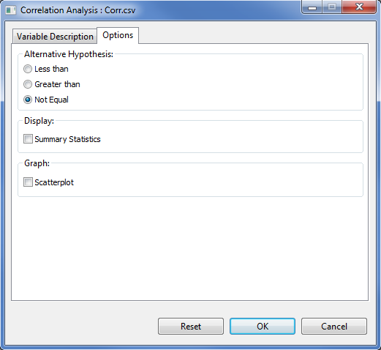

* Specify the required field and appropriate options for the analysis:

**Variable Description Tab**

**Test Variable(s)**

For the analysis to proceed, this list box should have at least two entries.

**Correlation Coefficient**

For the analysis to proceed, at least one method should be selected. By default, Pearson’s correlation coefficient is choosen. For quantitative and normally distributed variables, choose the Pearson correlation coefficient. If the data are not normally distributed or ordinal level, choose Kendall’s tau or Spearman, which measures the association between ranks. The correlation coefficient ranges from -1 to +1.

**Option Tab**

**Alternative Hypothesis**

User can select a one-tailed (less than or greater than) or two-tailed test (not equal). The default alternative hypothesis used is that for the two-sided test.

**Display Summary Statistics**

If this option is selected, a summary table with number of observations, minimum, maximum, mean and standard deviation will be displayed.

**Scatterplot**

If this option is selected, scatter plot for all pair of variables listed in the **Test Variable(s)** list box will be created.

For the example, the completed **Variable Description** tab and **Option** tab should appear as illustrated:

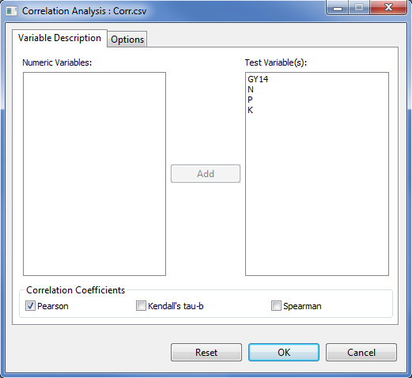

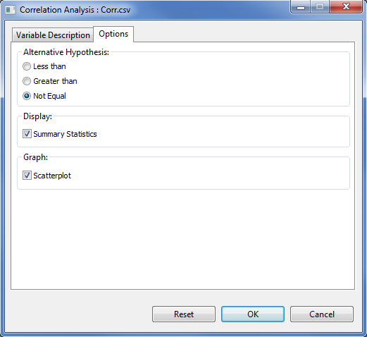

* Once all options have been specified, click the **OK** button. The **Correlation Analysis** dialog box will be minimized and STAR activates the **Result Viewer** tab which shows the results of the analysis.

Sample output of the Correlation Analysis using Pearson’s product-moment correlation is shown below.

Result of Correlation Analysis

DESCRIPTIVE STATISTICS

-----------------------------------------------------------

Variable N\_NonMissObs Min Max Mean StdDev

-----------------------------------------------------------

GY14 48 1678.00 7860.00 4788.67 1552.27

N 48 0.10 1.80 1.23 0.33

P 48 0.10 0.30 0.23 0.08

K 48 0.20 0.40 0.31 0.06

-----------------------------------------------------------

CORRELATION ANALYSIS

Pearson's product-moment correlation, Prob > |r|

GY14 N P K

GY14 coef 1.00 0.72 0.38 -0.40

p-value 0.0000 0.0080 0.0053

n 48 48 48 48

N coef 0.72 1.00 0.02 -0.34

p-value 0.0000 0.8686 0.0180

n 48 48 48 48

P coef 0.38 0.02 1.00 -0.35

p-value 0.0080 0.8686 0.0161

n 48 48 48 48

K coef -0.40 -0.34 -0.35 1.00

p-value 0.0053 0.0180 0.0161

n 48 48 48 48

If a scatter plot is requested, the graph can be viewed in the **Graph Viewer**. Sample generated graphs are shown below:

|  |  |
| --- | --- |
| scatterplot_K_GY14 | scatterplot_K_N |
| scatterplot_K_P | scatterplot_N_GY14 |
| scatterplot_P_GY14 | **scatterplot_P_N** |

# Linear Regression Analysis

Regression Analysis is the statistical technique used to determine the strength of linear relationship between variables.

The steps to perform Linear Regression Analysis are listed below:

* On the **Project Explorer**, double-click the file to be used for the analysis to open and view it in the Data Viewer tab.

For the example, using the project named *My Project*,import the data *soil\_redox* from the package. To import the data from the package, see *Importing from Package* section of this user manual.

* Click **Analyze | Regression …** from the main window. The **Regression** dialog box will appear.

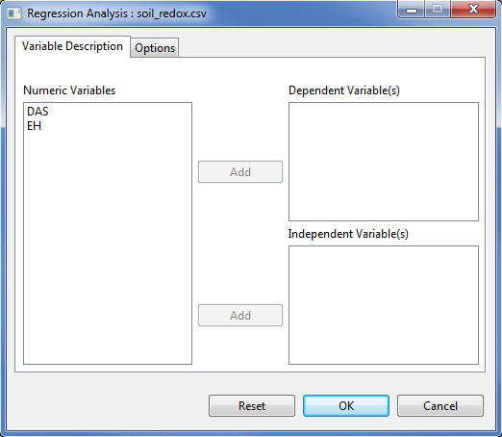

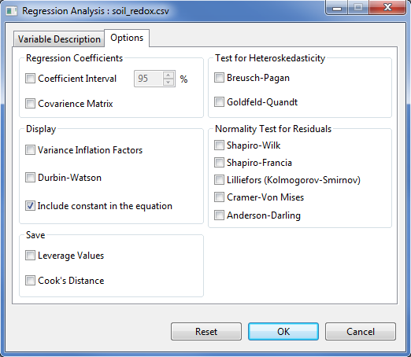

* Specify the required field and appropriate options for the analysis:

**Variable Description Tab**

**Dependent Variable**

For the analysis to proceed, this list box should have at least one entry.

**Independent Variables**

For the analysis to proceed, this list box should have at least one entry.

**Option Tab**

**Regression Coefficients**

User can choose to display the confidence interval and the covariance matrix. If at least one of this is selected, the result is embedded in the table of parameter estimates. For the confidence interval, the default value is 95%.

**Test for Heteroskedasticity**

There are two available procedures namely: Breusch-Pagar and Goldfeld-Quandt.

**Normality Test**

This option will perform normality test for the residuals. There are five procedures available, namely: Shapiro-Wilk, Shapiro-Francia, Lilliefors, Cramer-Von Mises and Anderson-Darling.

**Variance Inflation Factors**

If this is selected, it displays the variance inflation factors (VIF) which measures the Collinearity (or multicollinearity).

**Durbin-Watson**

If this is selected, it displays the Durbin-Watson test for serial correlation of the residuals.

**Include constant in the equation**

By default, the regression model includes a constant term in the equation. Deselecting this option forces regression through the origin, this is rarely done.

**Cook’s Distance**

If this is selected, it will include the cook’s distance in the data set.

**Leverage Values**

If this is selected, it will include the leverage values in the data set.

For the example, the completed **Variable Description** tab and **Option** tab should appear as illustrated below:

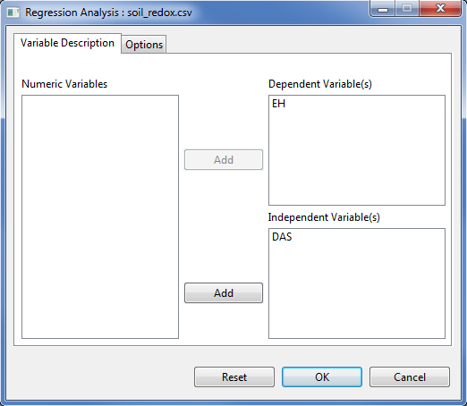

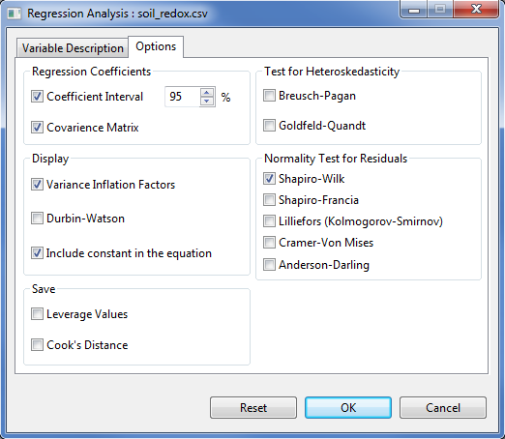

* Once all options have been specified, click the **OK** button. The **Regression Analysis** dialog box will be minimized and STAR activates the **Output** page of the **Result Viewer** tab.

The Linear Regression Analysis procedure in STAR saves all text output in the filename *LinearRegOutput.txt*. By default, the text output includes the Analysis of Variance table, a table of model summary and the parameter estimates. The output starts with the descriptive statistics, if this option was specified in the **Options** tab Sample text output of the analysis as shown in the **Output** page:

Descriptive Statistics

------------------------------------------------

Variable N\_NonMissObs Mean StdDev SE\_Mean

------------------------------------------------

EH 20 -71.36 124.17 27.76

DAS 20 73.50 41.41 9.26

------------------------------------------------

LINEAR REGRESSION ANALYSIS

Model Fitted: EH ~ DAS

Analysis of Variance Table

---------------------------------------------------------

Source DF Sum of Square Mean Square F Value Pr > F

---------------------------------------------------------

Model 1 269549.1605 269549.1605 207.43 0.0000

DAS 1 269549.1605 269549.1605 207.43 0.0000

Error 18 23390.0748 1299.4486

Total 20 562488.3959

---------------------------------------------------------

Model Summary:

-------------------------------------------------

Root MSE EH Mean Coeff Var R-Square Adj R-Sq

-------------------------------------------------

36.05 -71.36 -174.00 0.9202 0.9157

-------------------------------------------------

Parameter Estimates:

-------------------------------------------------------------------

Variable Estimate Std. Error t value LL CI\* UL CI\* Pr(>|t|)

-------------------------------------------------------------------

Intercept 140.03 16.75 8.36 104.85 175.21 0.0000

DAS -2.88 0.20 -14.40 -3.30 -2.46 0.0000

-------------------------------------------------------------------

\* At 95% Confidence Interval

Test for Normality

-------------------------------------------

Variable Method Statistics Prob

-------------------------------------------

residual Shapiro-Wilk 0.9604 0.5521

-------------------------------------------

By default, a *png* file is created for each dependent variable used in the analysis. The file follows the filename format as: *<dependent variable>\_DiagPlot.png.* Each *png* file contains two diagnostics plots. The *Residuals vs. Fitted* plotis for assessing the distribution of the residuals. An ideal plot should reveal that the points are distributed around 0. The residuals should not be affected by the size of the fitted values. Problematic data may result to a plot wherein the points increase as the fitted values increase, thus forming a “funnel-shaped” distribution. This will indicate a violation of the homogeneity of variances requirement for analysis of variance. The *Normal Q-Q* plot is used for assessing normality. The points should lie about the line. Sample generated graphs are shown below:

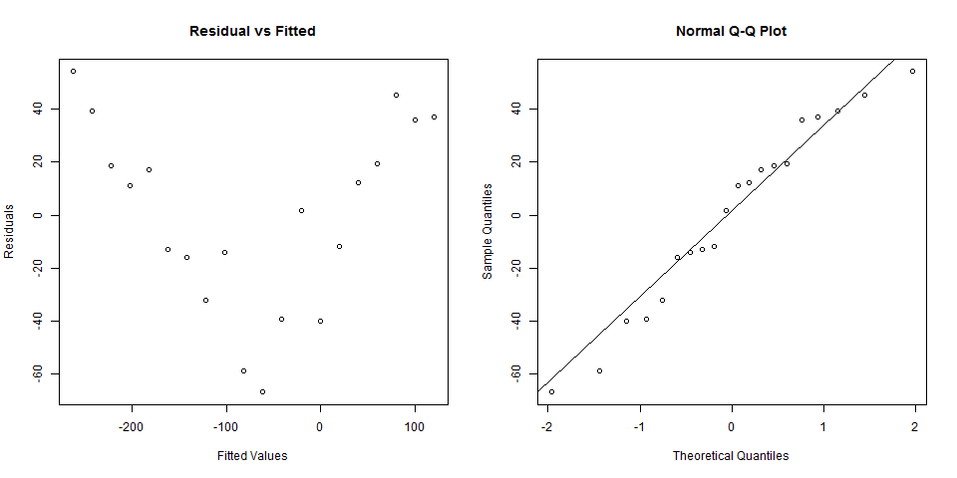

This procedure will also create the *LinearRegNewData.csv.* This file contains the original data with the residual and predicted values for each of the dependent variables used in the analysis. This file will also contain the *Leverage Values* and *Cooks’s Distance*, if user chooses to save these values.

# Nonparametric Tests

Nonparametric Tests procedure provides several tests that do not require assumptions about the shape of the underlying distribution.

## One Sample

## Two Related Samples

## Two Independent Samples

## Test for Several Related Samples

## Test for Several Independent Samples

The steps to perform Kruskal Wallis test are listed below:

* Locate the dataset *Insecticides.csv* from the *Data* folder of the project named *SampleProject* in the Project Explorer.
* Click **Analyze | Non-Parametric Test | Test for Several Independent Samples**…. The **Test for Several Independent Samples** dialog box will appear.
* Specify the required field and appropriate options for the analysis. The completed dialog box should appear as shown below:
* Sample output is shown below:

Rank Sums for Variable YIELD

Classified by Variable TREATMENT

----------------------------------------------

TREATMENT N Sum of Ranks Mean of Ranks

----------------------------------------------

Azodin 4 64 16.00

Control 4 12 3.00

DDT + phi-BHC 4 91 22.75

Dimercon-Boom 4 41 10.25

Dimercon-Knap 4 35 8.75

Dol-Mix (1kg) 4 66 16.50

Dol-Mix (2kg) 4 97 24.25

----------------------------------------------

\* Average scores are used for ties.

Kruskal-Wallis rank sum test

-----------------------------

Chi-Square 20.8522

DF 6

Pr > Chi-Square 0.0020

-----------------------------

# Appendix

## Data From STAR Package

### AugLS

**Description**

**Formats**

This data contains the following columns:

Row a factor with 15 levels (1 to 15) denoting the row

Column a factor with 5 levels (1, 2, 3, 4, 5) denoting the column

Entry a factor with 55 levels (1 to 55) denoting the treatment with levels 1 to 50 as the unreplicated entries and levels 51 to 55 as the replicated entries

Yield a numeric vector of grain yield

**Source**

<c/o lei>

### AugRCB

**Description**

**Formats**

This data contains the following columns:

BLOCK a factor with 4 levels (1, 2, 3, 4) denoting the block

ENTRY a factor with 55 levels (1, 2, …, and 66) denoting the treatment with levels 1 to 60 as the unreplicated entries and levels 61 to 66 as the replicated entries

YIELD a numeric vector of grain yield

**Source**

<c/o lei>

### CochranBIB

**Description**

This file contains data of corn from an experiment conducted in 1943 in North Carolina Agricultural Experiment Station, United States Department of Agriculture which uses balanced incomplete block design. Each location or block has 4 genotypes. The blocks are planted at different location.

**Formats**

This data contains the following columns:

loc a factor with 13 levels denoting the location or the blocking factor

gen a factor with 13 levels denoting the genotype

yield a numeric vector of grain yield (pounds per plot)

**Source**

Cochran, W.G. and Cox, G.M. (1957), Experimental Designs, 2nd ed., Wiley and Sons, New York, p. 448.

### Corr

**Description**

The example file contains data from an experiment conducted to investigate the relationship between grain yield (*GY14*, in kg/ha), the grain’s nitrogen (*N*), phosphorus (*P*) and potassium (*K*) content in percent. The data were collected from 48 experimental plots with grains adjusted to 14% moisture content.

**Formats**

This data contains the following columns:

GY14 a numeric vector of grain yields in kg/ha adjusted to 14% moisture continent

N a numeric vector of grain’s nitrogen

P a numeric vector of grain’s phosphorus

K a numeric vector of grain’s potassium content in percent

**Source**

BEDDA Training

### CropStatRCBDOverSite

**Description**

**Formats**

This data contains the following columns:

NTRT a factor with 6 levels (1, 2, 3, 4, 5, 6) denoting the nitrogen

SITE a factor with 3 levels (1, 2, 3) denoting the site

REP a factor with 3 levels (1, 2, 3) denoting the block

YIELD a numeric vector denoting the grain yield

**Source**

CropStat

#### 

### Dule\_AlphaGxE

**Description**

**Formats**

This data contains the following columns:

Env a factor with 6 levels (A01WSCM, A03WS-0, A03WS-1, AWS01-D, UWS02-2, UWS02-8) denoting the environment

Rep a factor with 3 levels (1, 2, 3) denoting the replication

Block a factor with 5 levels (1, 2, 3, 4, 5) denoting the block

Plot a numeric vector denoting the plot number

Geno a factor with 40 levels (AUS196, AZUCENA, B6144F-MR-6-0-0, C22, CT13370-12-2-M, CT13377-4-2-M, CT13382-8-3-M, CT6510-24-1-2, CT6516-24-3-2, DINORADO, IR47686-30-3-2, IR55419-04, IR55423-01, IR60080-46A, IR65261-09-1-B, IR65907-116-1-B, IR66417-18-1-1-1, IR66421-062-1-1-2, IR66424-1-2-1-5, IR68702-072-1-4-B, IR70358-84-1-1, IR70360-38-1-B-1, IR71524-44-1-1, IR71525-19-1-1, IR72768-15-1-1, IRAT170, IRAT177, IRAT212, IRAT216, MARAVILHA, PALAWAN, PRIMAVERA, UPLRI-5, UPLRI-7, VANDANA, WAB181-18, WAB56-125, WAB638-1, WAB96-1-1, WAYRAREM)

FLOWER a numeric vector

Duration a numeric vector

PlantHt a numeric vector

CropBF a numeric vector

HI a numeric vector

YLD a numeric vector

**Source**

*<c/o lei>*

### Fertilizer

**Description**

**Formats**

This data contains the following columns:

Fertilizer a factor with two levels (A and B) denoting the fertilizer used

NumFruit a numeric vector of number of fruits

**Source**

### Gerua

**Description**

**Formats**

This data contains the following columns:

REP a factor with three levels (1, 2 and 3) denoting the blocks

TPL a factor with two levels (D and N) denoting the transplanting method; considered as the main plot factor

CULT a factor with 26 levels denoting the cultivar; considered as the subplot factor

DFF a numeric vector denoting the number of days after flowering

PLHT a numeric vector denoting the plant height in cm

PNCLE a numeric vector denoting the panicle number

GRNYLD a numeric vector denoting the grain yield in kg/ha

**Source**

BEDDA Training

### GomezMaizeCross

**Description**

“A plant breeder is studying a cross between a sweet maize inbred line with yellow kernels and a flint maize inbred line with white kernels. He would like to know whether the ratio of kernel type and color in the F2 population follows the normal di-hybrid ratio of 9:3:3:1. From the F1 plants produced by crossing the two inbred lines, he obtain F2 kernels and classifies them into four categories according to kernel color (yellow or white) and kernel type (flint or sweet) as follows: yellow flint, yellow sweet, white flint and white sweet.” -- Gomez, Kwanchai A. and Arturo A. Gomez. (1984) *Statistical Procedures for Agricultural Research 2nd Edition*. John Wiley & Sons, Inc. Page 460.

**Formats**

This data contains the following columns:

KernelNumber a numeric vector denoting the kernel id number

KernelColor a factor with 2 levels (white and yellow) denoting the color of the kernel

KernelType a factor with 2 levels (flint and sweet) denoting the kernel type

KernelCategory a factor with 4 levels (white flint, white sweet, yellow flint, and yellow sweet) denoting the kernel type and color

YellowKernel a numeric vector of values 0 and 1, with 1 denoting that the kernel is of color yellow

WhiteKernel a numeric vector of values 0 and 1, with 1 denoting that the kernel is of color white

FlintType a numeric vector of values 0 and 1, with 1 denoting that the kernel is of type flint

SweetType a numeric vector of values 0 and 1, with 1 denoting that the kernel is of type sweet

**Source**

Gomez, Kwanchai A. and Arturo A. Gomez. (1984) *Statistical Procedures for Agricultural Research 2nd Edition*. John Wiley & Sons, Inc. Page 460.

### GomezMaizeCrossSummary

**Description**

This data is a summary of *GomezMaizeCross*.

**Formats**

This data contains the following columns:

KernelCategory a factor with 4 levels (white flint, white sweet, yellow flint, and yellow sweet) denoting the kernel type and color

Frequency a numeric vector denoting the number of observation in that follows in that kernel category

**Source**

Gomez, Kwanchai A. and Arturo A. Gomez. (1984) *Statistical Procedures for Agricultural Research 2nd Edition*. John Wiley & Sons, Inc. Page 460.

### GomezSplitRCBD

**Description**

Grain Yield of Data of Four Rice Varietues Grown in Six Levels of Nitrogen in a Split-Plot Design with three replications.

**Formats**

This data contains the following columns:

Rep a factor with 3 levels (1 to 3) denoting the blocks

Nitrogen main plot factor with 6 levels (0, 60, 90, 120, 150 and 180, in kg N/ha) denoting the Nitrogen Levels

Variety subplot factor with 4 levels (C4-63, IR5, IR8 and Peta) denoting the Rice Variety

Yield a numeric vector of grain yield in kg/ha

**Source**

Gomez, Kwanchai A. and Arturo A. Gomez. (1984) *Statistical Procedures for Agricultural Research 2nd Edition*. John Wiley & Sons, Inc. Page 102.

### GomezSplit2RCBD

**Description**

Grain Yield of Three Rice Varieties Grown under Three Management Practices and Five Nitrogen Levels; in a split-split plot design in RCBD with three replications.

**Formats**

This data contains the following columns:

Rep a factor with 3 levels (1 to 3) denoting the blocks

Nitrogen main plot factor with 5 levels (N1, N2, N3, N4, and N5) denoting the Nitrogen Levels

N1 0 kg N/ha

N2 50 kg N/ha

N3 80 kg N/ha

N4 110 kg N/ha

N5 140 kg N/ha

Management subplot factor with 3 levels (M1, M2 and M3) denoting the Management Practices

M1 Minimum

M2 Optimum

M3 Intensive

Variety sub-subplot factor with 3 levels (V1, V2 and V3) denoting the Rice Variety

GY a numeric vector of grain yield in t/ha

**Source**

Gomez, Kwanchai A. and Arturo A. Gomez. (1984) *Statistical Procedures for Agricultural Research 2nd Edition*. John Wiley & Sons, Inc. Page 143.

### GomezStrip

**Description**

Grain Yield of Six Varieties of Rice, Broadcast Seeded and Grown with Three Nitrogen Rates in a Strip-plot Design with Three Replications

**Formats**

This data contains the following columns:

REP a factor with 3 levels (1 to 3) denoting the blocks

NITROGEN vertical factor with 3 levels (0, 60 and 120, kg N/ha) denoting the Nitrogen Levels

VARIETY horizontal factor with 6 levels (V1, V2, V3, V4, V5 and V6) denoting the Rice Variety

V1 IR8

V2 IR127-80

V3 IR305-4-12

V4 IR400-2-5

V5 IR665-58

V6 Peta

GRNYLD a numeric vector of grain yield in kg/ha

**Source**

Gomez, Kwanchai A. and Arturo A. Gomez. (1984) *Statistical Procedures for Agricultural Research 2nd Edition*. John Wiley & Sons, Inc. Page 110.

### GomezStripSplit

**Description**

Grain yield of six rice varieties tested under two planting methods and three nitrogen rates in a Strip-Split plot Design with three replicates.

**Formats**

This data contains the following columns:

REP a factor with 3 levels (1 to 3) denoting the blocks

NITROGEN vertical factor with 3 levels (0, 60 and 120, kg N/ha) denoting the Nitrogen Levels

VARIETY horizontal factor with 6 levels (V1, V2, V3, V4, V5 and V6) denoting the Rice Variety

V1 IR8

V2 IR127-80

V3 IR305-4-12

V4 IR400-2-5

V5 IR665-58

V6 Peta

PLANTING subplot factor with two levels (Broadcast and Transplanted) denoting the planting methods

YIELD a numeric vector of grain yield in kg/ha

**Source**

Gomez, Kwanchai A. and Arturo A. Gomez. (1984) *Statistical Procedures for Agricultural Research 2nd Edition*. John Wiley & Sons, Inc. Page 155.

### GomezTenureStatus

**Description**

“An agricultural economist studying factors affecting the adoption of the newly introduced high-yielding rice varieties wishes to know if adoption is affected by the tenure status of farmers. With three distinct classes of tenure status (the first classification criterion) – owner operator, share-rent farmer, and fixed-rent farmer – and two classes of adoption status (the second classification criterion) – adopter and nonadopter – the resulting data form a 3 x 2 contingency table.” -- Gomez, Kwanchai A. and Arturo A. Gomez. (1984) *Statistical Procedures for Agricultural Research 2nd Edition*. John Wiley & Sons, Inc. Page 462.

**Formats**

This data contains the following columns:

TenureStatus a factor with 3 levels (fixed-rent, owner, and share-rent)

FarmerClassif a factor with 2 levels (adopter and nonadopter)

**Source**

Gomez, Kwanchai A. and Arturo A. Gomez. (1984) *Statistical Procedures for Agricultural Research 2nd Edition*. John Wiley & Sons, Inc. Page 463.

### GomezTwoCropSeasonRCB

**Description**

Grain yield of rice tested with five rates of nitrogen in two crop seasons.

**Formats**

This data contains the following columns:

Season a factor with 2 levels (Dry and Wet) denoting the season

Rep a factor with 3 levels (I, II and III) denoting the block

NitrogenRate a factor with 5 levels (0, 60, 90, 120 and 150 kg/ha) denoting the Nitrogen Rate

GrainYield a numeric vector of grain yield, t/ha

**Source**

Gomez, Kwanchai A. and Arturo A. Gomez. (1984) *Statistical Procedures for Agricultural Research 2nd Edition*. John Wiley & Sons, Inc. Page 318.

### grp\_pss

**Description**

Three (3) varieties, a traditional variety (A) and two new varieties B and C, were tested to determine if their yield means are equal. Analysis of variance showed that difference among the varieties exists. The researcher would like to know the nature of the differences among the groups.

**Formats**

This data contains the following columns:

VARIETY a factor with three levels denoting the variety

REP a factor with four levels (1 to 4) denoting block

YIELD a numeric vector of grain yield

**Source**

**<BEDDA TRAINING>**

### IASRICorrReg

**Description**

The data was colledc through a pilot survey on Hybrid Jowar crop on yield and biometrical characters.

**Formats**

This data contains the following columns:

sampleNum a numeric vector denoting the identification number of the sample

PP a numeric vector denoting the average plant population

PH a numeric vector denoting the average plant height

NGL a numeric vector denoting the average number of green leaves

Yield a numeric vector denoting the yield (kg/plot)

**Source**

Design Resources Server. *Indian Agricultural Statistics Research Institute (ICAR), New Delhi 110 012, India*. [www.iasri.res.in/design](http://www.iasri.res.in/design) (accessed lastly on January 28, 2013).

### IASRILSD

**Description**

An experiment was conducted at Agricultural Research Station, Kopurgaon, Maharashtra on cotton during the year 1969 – 1970 using a Latin Square design to study the effects of foliear application of urea in combination with insecticidal sprays on the cotton yield.

**Formats**

This data contains the following columns:

row a factor with six levels (1 to 6) denoting the row

col a factor with six levels (1 to 6) denoting the column

trt a factor with six levels denoting the treatment

T1 Control (No nitrogen and no insecticides)

T2 100 kg N/ha as urea (half at final thinning and half at flowering as top dressing)

T3 100 kg N/ha as urea (80 kg N/ha in 4 equal split does as spray and 20 kg N/ha at final thinning)

T4 100 kg N/ha as CAN (half at final thinning and half at flowering as top dressing)

T5 T2 + six insecticidal sprays

T6 T4 + six insecticidal sprays

yield a numeric vector denoting the yield in kg

**Source**

Design Resources Server. *Indian Agricultural Statistics Research Institute (ICAR), New Delhi 110 012, India*. [www.iasri.res.in/design](http://www.iasri.res.in/design) (accessed lastly on January 28, 2013).

### IASRITomar

**Description**

An experiment was conducted to study compare the effect of natural pollination and hand pollination under open field conditions.

**Formats**

This data contains the following columns:

group a factor with two levels (1 and 2) denoting the type of pollination used

1. natural pollination
2. hand pollination

fs45 a numeric vector of number of fruit set for the period of 45 days

fw a numeric vector of fruit weight in kilograms (kg)

syp a numeric vector of seed yield per plant in grams

sl a numeric vector of seedling length in cm

**Source**

Tomar, B.S. Descriptive Statistics: Design Resources Server. *Indian Agricultural Statistics Research Institute (ICAR), New Delhi 110 012, India*. [www.iasri.res.in/design](http://www.iasri.res.in/design) (accessed lastly on January 28, 2013).

### IASRITomar2

**Description**

An experiment was conducted to study compare the effect of hand pollination on hybrid of seed production in bottle gourd under open field and poly house conditions.

**Formats**

This data contains the following columns:

Group a factor with two levels (2 and 3) denoting the type of conditions

2 hand pollination in open field condition

1. hand pollination in poly house condition

nmfp a numeric vector of total number of male flowers per plant

fs45 a numeric vector of number of fruit set for the period of 45 days

fweight a numeric vector of fruit weight in kilograms (kg)

flength a numeric vector of fruit length in centimeter (cm)

slyp a numeric vector of seed yield per plant in grams

sl a numeric vector of seedling length in centimeter

**Source**

Tomar, B.S. Descriptive Statistics: Design Resources Server. *Indian Agricultural Statistics Research Institute (ICAR), New Delhi 110 012, India*. [www.iasri.res.in/design](http://www.iasri.res.in/design) (accessed lastly on January 28, 2013).

### Inoculation

**Description**

An experiment was conducted on the effect of 6 times of inoculation of *S. linicola* on the oil content of Redwing Flaxseed. The experiment was conducted using an RCB design with 4 replications.

**Formats**

This data contains the following columns:

Rep a factor with three levels (1, 2 and 3) denoting the blocks

InoculationTime a factor with six levels (Seedling, Early Bloom, Full Bloom, Full Bloom (1/100), Ripening and Uninoculated) denoting the time of inoculation

OilContent a numeric vector denoting the oil content

**Source**

Steel, R.G.D., J.H. Torrie, and D.A. Dickey. Principles and Procedures of Statistics: A Biometrical Approach.

### Insecticides

**Description**

Grain yield of rice resulting from use of different foliar and granular insecticides for the control of brown planthoppers and stem borers from a Completely Randomized Design Experiment with Four Replicates and 7 treatments. The data contains 28 rows and 3 columns.

**Formats**

This data contains the following columns:

Treatment a factor with 7 levels (Azodin, DDT + γ-BHC, Dimercon-Boom, Dimercon-Knap, Dol-Mix (1 kg), Dol-Mix (2 kg) and Control) denoting the Different Foliar and Granular Insecticides

Rep a factor with 4 levels (1 to 4) denoting the replicates

GrainYield a numeric vector of grain yield in kg/ha

**Source**

Gomez, Kwanchai A. and Arturo A. Gomez. (1984) *Statistical Procedures for Agricultural Research 2nd Edition*. John Wiley & Sons, Inc. Page 14.

### KemptonRowCol

**Description**

Wheat yields of 35 genotypes, 2 reps, planted in a row-column design. Two plots are missing.

**Formats**

This data contains the following columns:

rep a factor with 2 levels (R1 and R2) denoting the replicate

row a factor with 5 levels (1 to 5) denoting the row

col a factor with 7 levels (1 to 7) denoting the column

gen a factor with 35 levels (G01, G02, G03, G04, G05, G06, G07, G08, G09, G10, G11, G12, G13, G14, G15, G16, G17, G18, G19, G20, G21, G22, G23, G24, G25, G26, G27, G28, G29, G30, G31, G32, G33, G34, G35)

yield a numeric vector denoting the yield

**Source**

R agridat package.

### Maize

**Description**

Grain yield of three promising maize hybrids and a check variety from an experiment using Latin Square design. The data contains 24 rows and 3 columns.

**Formats**

This data contains the following columns:

Maize a factor with 4 levels denoting the Maize Hybrids (A, B, and D) and a Check Variety (C)

Row a factor with 4 levels (1 to 4) denoting the row blocking factor

Column a factor with 4 levels (1 to 4) denoting the column blocking factor

GrainYield a numeric vector of grain yield in kg/ha

**Source**

Gomez, Kwanchai A. and Arturo A. Gomez. (1984) *Statistical Procedures for Agricultural Research 2nd Edition*. John Wiley & Sons, Inc. Page 33.

### Nurul2012

**Description**

**Formats**

This data contains the following columns:

Block a factor with levels I II

Variety a factor with levels Azucena112854 Azucena47125 Azucena52992 Chadungda IR20 IR64 IR74 Pokalli

Aluminum a factor with levels 0 540 750 1300

RL a numeric vector

RE a numeric vector

RRE a numeric vector

**Source**

Gomez, Kwanchai A. and Arturo A. Gomez. (1984) *Statistical Procedures for Agricultural Research 2nd Edition*. John Wiley & Sons, Inc. Page 33.

### OP\_pss

**Description**

Grain yield of three promising maize hybrids and a check variety from an experiment using Latin Square design. The data contains 24 rows and 3 columns.

**Formats**

This data contains the following columns:

NITROGEN a factor with levels 0 60 90 120

REP a factor with levels 1 2 3

YIELD a numeric vector

**Source**

Gomez, Kwanchai A. and Arturo A. Gomez. (1984) *Statistical Procedures for Agricultural Research 2nd Edition*. John Wiley & Sons, Inc. Page 33.

### PGTYPIC

**Description**

**Formats**

This data contains the following columns:

Block a factor with levels 1 2 3 4

Geno a factor with levels 1 2 3 4 5 6 7 8

X1 a numeric vector

X2 a numeric vector

X3 a numeric vector

X4 a numeric vector

**Source**

### SeedingRate

**Description**

A hypothetical data of grain yield in Randomized Complete Block Design.

**Formats**

This data contains the following columns:

Rep a factor with levels 1 2 3 4

SeedingRate a factor with levels 25 50 75 100 125 150

GrainYield a numeric vector

**Source**

#### 

### Sensors

**Description**

**Formats**

This data contains the following columns:

REP a factor with three levels (1, 2 and B) denoting the blocks

GRNYLD a numeric vector denoting the grain yield in kg/ha

**Source**

BEDDA Training

### soil\_redox

**Description**

The file contains the data of number of days after seeding (DAS) as independent variable and soil redox potential (EH) as dependent variable. Based on this data, simple linear regression analysis is to be conducted to assess how the days after seeding linearly affects soil redox potential, on the average.

**Formats**

This data contains the following columns:

DAS a numeric vector denoting the number of days after seeding

EH a numeric vector denoting the soil redox potential

**Source**

BEDDA Training

### soil\_var

**Description**

**Formats**

This data contains the following columns:

REP a factor with three levels (1, 2 and B) denoting the blocks

GRNYLD a numeric vector denoting the grain yield in kg/ha

**Source**

BEDDA Training

### Survival

**Description**

**Formats**

This data contains the following columns:

REP a factor with three levels (1, 2 and B) denoting the blocks

GRNYLD a numeric vector denoting the grain yield in kg/ha

**Source**

BEDDA Training

### tf\_rcb

**Description**

**Formats**

This data contains the following columns:

REP a factor with three levels (1, 2 and B) denoting the blocks

GRNYLD a numeric vector denoting the grain yield in kg/ha

**Source**

BEDDA Training

### upland

**Description**

**Formats**

This data contains the following columns:

Env a factor with three levels (UDSO2-14, UDSO2-6 and UDSO2-6) denoting the environments

Rep a factor with three levels (1, 2 and 3) denoting the replicate

Block a factor with four levels (1, 2, 3 and 4) denoting the blocks

Plot a numeric vector denoting the plots

Geno a factor with 44 levels (1, 2 and B) denoting the genotypes

Yield a numeric vector denoting the grain yield

**Source**

BEDDA Training

### White\_heads

**Description**

**Formats**

This data contains the following columns:

REP a factor with three levels (1, 2 and B) denoting the blocks

GRNYLD a numeric vector denoting the grain yield in kg/ha

**Source**

BEDDA Training

### Year

**Description**

**Formats**

This data contains the following columns:

REP a factor with three levels (1, 2 and B) denoting the blocks

GRNYLD a numeric vector denoting the grain yield in kg/ha

**Source**

BEDDA Training

### Yield94

**Description**

**Formats**

This data contains the following columns:

REP a factor with three levels (1, 2 and B) denoting the blocks

GRNYLD a numeric vector denoting the grain yield in kg/ha

**Source**

BEDDA Training

**Description**

**Formats**

This data contains the following columns:

REP a factor with three levels (1, 2 and B) denoting the blocks

GRNYLD a numeric vector denoting the grain yield in kg/ha

**Source**

BEDDA Training